REPORT ON CONSULTATIVE WORKSHOP ON THE FORMATION OF INNOVATIVE PLATFORM FOR AFLATOXIN MANAGEMENT IN GHANA
VENUE: FARA SECRETARIAT CONFERENCE HALL

DATE: 17TH JUNE, 2015

RAPPORTEURS: Dr. Rose Omari, CSIR-STEPRI
Philip Amoah, ECASARD.

Contents
List of Acronyms and Abbreviations 2
Executive summary 3
1.0 Introduction 5
2.0 Opening Session 6
3.0 Technical Session 8
3.1 Situational analysis of the aflatoxin problem in Ghana 8
3.2 Perspectives and continental activities on aflatoxin 9
3.3 How to form innovation platform to address aflatoxin issues in Ghana 10
4.0 Group discussion (World Café) Reports 11
4.1 Group 1: Strategies for local awareness creation on aflatoxin problem 11
4.2 Group 2: Aflatoxin mitigation approaches with potential for adoption by farmers and other value chain actors 13
4.3 Group 3: Institutional arrangements and partnerships for aflatoxin management in Ghana 14
4.4 Group 4: Funding of local activities on aflatoxin management 15
5.0 Plenary Session: Formation of Ghana aflatoxin management innovation platform 16
Vision 16
Mission 16
Objectives 16
Main thrust 16
Location of the innovation platform 17
Lead organization 17
Identification / prioritization of constrains 17
Stakeholder analysis 18
Way forward 24
6.0 Conclusion 24
Appendices 24
List of Participants 24
Presentations 26
Situational analysis of the aflatoxin problem in Ghana 26
Perspectives and continental activities on aflatoxin 27
How to form innovation platforms to address aflatoxin problems in Ghana 33

List of Acronyms and Abbreviations
ARD Agricultural Research and Development
AR4D Agricultural Research for Development
ASARECA Association for Strengthening Agricultural Research in Eastern and Central Africa
CAADP Comprehensive Africa Agriculture Development Programme
CORAF Conseil ouest et centre africain pour la recherche et le développement agricoles
WECARD West and Central African Council for Agricultural Research and Development
ECASARD Ecumenical Association for Sustainable Agriculture and Rural Development
FANR Food Agriculture and Natural Resources
FARA Forum for Agricultural Research in Africa
FBO Farmer Based Organisation
FIs Financial Institutions
GES Ghana Education Service
GFAP Ghana Federation of Agricultural Producers
GFAR Global Forum on Agricultural Research
GHS Ghana Health Service
IFPRI International Food Policy Research Institute
IP Innovative Platform
MoFA Ministry of Food and Agriculture
MoE Ministry of Education
SADC South African Development Community
SPAAR Special Programme for African Agricultural Research
SSA CP Sub Sahara Africa Challenge Programme
WFP World Food Programme

Executive summary
Aflatoxins are potent carcinogens produced by certain strains of fungi that infest food crops. Aflatoxin contamination poses a threat to human and animal health, food security and trade in the African continent. At the Continental level, the African Union has facilitated the establishment of the Partnership for Aflatoxin Control in Africa (PACA) as a community-based approach to mitigate the harmful effects of aflatoxin. Across the African continent and Ghana in particular, awareness about the aflatoxin problem and its mitigation approaches is low hence a group of farmers approached the Forum for Agricultural Research in Africa (FARA) to support the formation of an innovation platform for the management of aflatoxin in Ghana. A workshop was thus organized to initiate the formation of the platform. The workshop was attended by participants from various sectors and organizations including agricultural and trade sectors, research and academia, farmers’ organizations, NGOs and civil society organizations, Development partners, standards and regulatory agencies, Ghana’s Parliament and the PACA Secretariat of the African Union.
The Executive Director of FARA, Dr. Yemi Akinbamijo in his welcome address called for more efforts in raising awareness and sensitizing key actors and stakeholders on the challenges of aflatoxin. He gave assurance that FARA will support and encourage the platform to identify effective ways of controlling and managing Aflatoxin in Ghana. Hon Gabriel Essilfie, a member of Parliament and the Chairman for the Parliamentary Select Committee on Agriculture and Cocoa noted that aflatoxin is a food safety and food security issue of importance to his Committee hence they will facilitate the enactment of relevant policies and legislations for managing the aflatoxin menace.
Background presentations were made to highlight the situation of the aflatoxin problem in Ghana, perspectives and continental activities on aflatoxin and how to form innovation platforms to address aflatoxin problems. The presentations revealed that studies conducted in Ghana have shown low to high levels of aflatoxin in various food products and human body fluids. Despite this, level of awareness and knowledge on aflatoxin has been found to be low among various professionals and the general public. Studies have also shown the possibility of reducing aflatoxin levels in food using plant products such as syzygium powder, packaging and storage in appropriate materials and irradiation. The PACA Secretariat is currently supporting activities in six pilot countries namely, the Gambia, Uganda, Tanzania, Malawi, Senegal and Nigeria to manage aflatoxin contamination in food and feed. Although the aflatoxin problem is enormous, technologies are available to deal with the problem. However, there still exist a wide gap between research and farmers and this gap can be bridged through the innovation platform approach. The platform has been effective in eliminating institutional barriers that affect technology development, dissemination and adoption in Africa.
Group discussions were held whereby participants discussed a) strategies for local awareness creation on aflatoxin problem; (b) aflatoxin mitigation approaches with potential for adoption by farmers and other value chain actors; (c) institutional arrangements and partnerships for aflatoxin management in Ghana; and (d) funding of local activities on aflatoxin management. The formation of Ghana aflatoxin management innovation platform was initiated and participants set the mission, vision, objectives and thrust of the platform. It is expected that a core group will be formed to refine the objectives of the platform and to prepare an action plan after which the platform will be launched followed by sensitization of stakeholders.
To conclude, aflatoxin contamination of food and feed is a major development challenge that negatively impacts health, food security and trade. Multi-sectoral approach and effective mitigation strategies are required to deal with the problem. The effective and active participation of participants at this workshop is an indication that Ghana is ready to fight the battle against aflatoxin. Together, we shall win this battle and Ghana and the entire African continent will be assured of aflatoxin-safe food and feed.

1.0 Introduction
Aflatoxins are naturally occurring harmful toxins produced by the fungi Aspergillus flavus and Aspergillus parasiticus Speare, which are highly toxic to humans and animals. The toxins are known to cause a number of human and animal health problems such as immunosuppression, kwashiorkor, impairment of liver function, and reduced growth rate or stunting. They are also potent liver carcinogens. Aflatoxin-producing moulds affect grain and other food crops – maize and groundnuts in particular. Millions of people living in Africa are exposed to high, unsafe levels of aflatoxins through their diet. Meanwhile, farmers miss out on export opportunities since their products do not meet international food safety standards. The commodity value chains most prone to aflatoxin infection include maize, millet, sorghum, groundnut and rice. These are among the most important staple foods in many African countries, including Ghana. Once such contaminated foods are eaten, the toxins get into the blood and cause a variety of health problem such as indicated above. Further, when feeds contaminated by aflatoxins are consumed by livestock, the toxins may appear in processed animal product such as the milk and cheese. Products prepared from food containing aflatoxins also contain the toxins since the toxins are relatively heat stable and are not destroyed by processing. In Ghana, aflatoxins are known to be present in Kenkey, corn dough, groundnut butter, groundnut oil etc. Aflatoxins are also reported to be present in human semen where they affect the morphology of the sperms and this could lead to male sterility problems.
Aflatoxins contamination in food and feed is an agricultural, health and trade issue which needs to be tackled with urgency. For this reason, African stakeholders led by the African Union Commission formed the Partnership for Aflatoxin Control in Africa (PACA) during the 7th CAADP Partnership Platform meeting in 2011 as an innovative consortium that aims at coordinating aflatoxin mitigation and management across the agriculture, health and trade sectors. By combating these toxins, PACA will contribute to improving food security, health, and trade across the African continent. PACA has elaborated a 10-year Strategy (2013-2022) to guide its actions. Currently, five pilot countries (Gambia, Malawi, Senegal, Tanzania, Uganda and Nigeria) have been selected for three early actions areas: 1) establish Africa Aflatoxin Information Management System (AfricaAIMS); 2) support country‐led aflatoxin situation analysis and action plan (C‐SAP); and 3) mainstream food safety and aflatoxin control through the PACA initiative in CAADP National Agriculture and Food Security Investment Plans. Due to PACA’s activities, awareness on the deleterious effects of aflatoxin is fast rising and there is increasing demand by country stakeholders for action.
To complement PACA’s efforts, a group of Ghanaian agricultural sector stakeholders led by Farmers Organization Network of Ghana (FONG) approached the Forum for Agricultural Research in Africa (FARA) in Accra, Ghana to assist in instigating collaborative action to help raise awareness on aflatoxins in Ghana, put in place management measures and most importantly help local farmers address the problem of aflatoxin.
This consultative workshop was organized with the purposes of raising the consciousness of participants on the subject of aflatoxin contamination of food and feed, brainstorming on possible mitigation strategies and forming a national platform for aflatoxin management and control in Ghana.
The main objectives of the workshop were to:
- Discuss key issues relating to aflatoxin contamination in Ghana
- Develop aflatoxin mitigation strategies with potential of adoption by farmers and other stakeholders
- Table and discuss the formation of Ghana Aflatoxin and Aflasafe Platform (GAAP)
- Plan aflatoxin/aflasafe awareness campaigns nationwide
- Discuss the way forward

2.0 Opening Session
The opening session commenced with self-introduction of participants. Participants represented various sectors and organizations including agricultural and trade sectors, research and academia farmers’ organizations, NGOs and civil society organizations, Development Partners, standards and regulatory agencies, Ghana’s Parliament and the PACA secretariat of the African Union.
In his welcome address, the Executive Director of FARA, Dr. Yemi Akinbamijo stated that FARA, the apex organization for agricultural research for development considers aflatoxin contamination of crops an important threat to food security, health and trade. For this reason, FARA is a member of PACA steering committee where important decisions are made concerning aflatoxin management in Africa. Dr. Akinbamijo reiterated that his interest in aflatoxin management dated way back during his career at the African Union where he was the first person to manage the PACA Programme. He also commended the high level of commitment of the African Union since 2011, which led to the establishment of PACA. He emphasized that the level aflatoxin in various food across Africa are high with levels exceeding acceptable limits. This, he noted has negative impact on health, food security and both regional and international trade. One important challenge that hinders aflatoxin management efforts is the difficulty in directly linking its health impact to particular foods since most of the symptoms such as cancers are delayed. This notwithstanding, the health impacts of aflatoxin have been well documented hence there is the need to control the toxin to improve health and reduce postharvest losses, which is in line with the Comprehensive Africa Agricultural Development Programme.
Dr. Akinbamijo was content that although the challenge of aflatoxin contamination is enormous, technologies are now available and still being developed to mitigate the problem. The challenge however has been to get the technologies to farmers and other commodity chain actors. He expressed concern about the wide gap between research and farmers/technology users, which slows down technology uptake and adoption. Dr. Akinbamijo noted that this slow uptake of technology is of concern to FARA hence the Integrated Agricultural Research for Development (IAR4D) concept was developed and is being promoted across the African continent. The IAR4D approach, which has its roots from the concept of innovation systems, has proven to be effective in bridging research-farmer gap. He was happy with presence of the Chairman of the Parliamentary Select Committee on Agriculture at the workshop, which he said was an indication of higher level commitment to the fight against aflatoxin. He concluded by calling for more efforts in raising awareness and sensitizing key actors and stakeholders and assuring participants that FARA will support and encourage the platform as members brainstorm on effective ways of controlling and managing Aflatoxin in Ghana.
In the opening statement, Hon. Gabriel Essilfie, the Member of Parliament for Shama constituency and the Chairman for the Parliamentary Select Committee on Agriculture and Cocoa expressed his joy to be part of the meeting that would identify strategies for controlling aflatoxin contamination in foods. He recalled his childhood experience where moulds on maize were just washed off before being used for food. This practice he indicated could have been responsible for some health conditions in most rural communities. He stressed the fact that most people including him have inadequate information about aflatoxin and its effects so the workshop was relevant. He was hopeful that the aflatoxin challenge would be made known to Ghana’s parliament and his constituency and promised to facilitate the process. Hon. Essilfie concluded by stating that aflatoxin is a food safety and food security issue of importance to his Committee hence they will do what is possible particularly in terms of policies and legislations to manage the aflatoxin menace.
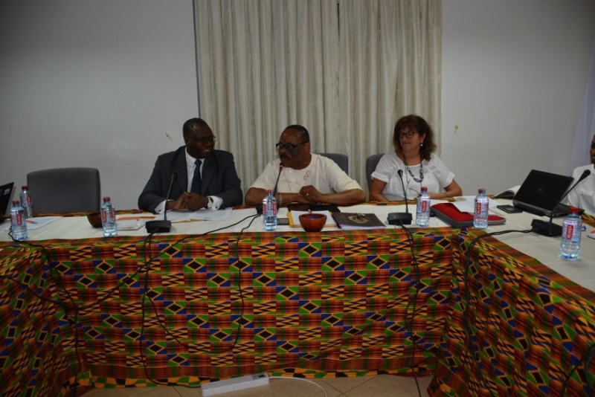
Dignitaries at the high table: From left Dr. Yemi Akinbamijo, Hon Gabriel Essilfie, Mariella Sandini.

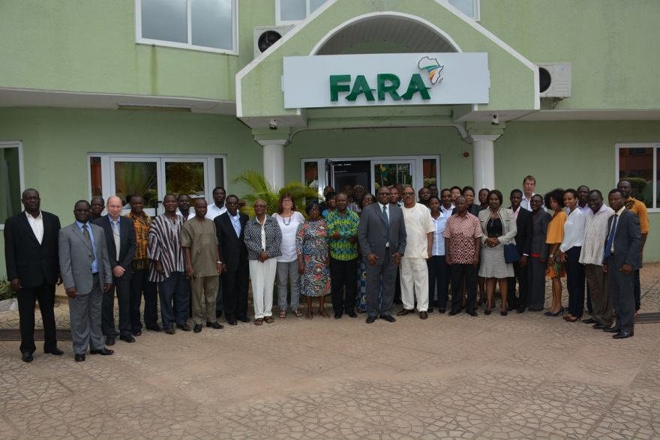
A group photograph of all participants

3.0 Technical Session
During the technical session, three background presentations were made to highlight the situation of aflatoxin problem in Ghana, perspectives and continental activities on aflatoxin and how to form innovation platforms to address aflatoxin problems in Ghana. Summaries of the presentations are presented in the following sections but the full presentations are shown in the appendices.

3.1 Situational analysis of the aflatoxin problem in Ghana
This presentation was made by Prof. Richard Awuah from Kwame Nkrumah University of Science and Technology (KNUST), Kumasi, Ghana. In this presentation, it was reiterated that various type of aflatoxin including B1, B2, G1, and G2 have been detected in some food products in Ghana however it is the B1 that is most important since it is the most potent. Contamination have been found to occur both at pre-harvest and postharvest stages. Most studies have however shown that most of the aflatoxin contamination in Ghana occur at the postharvest stages mainly due to bad food handling practices. In relation to aflatoxin research in Ghana, it was revealed that most of the research over the years since the 1960s have focused on aflatoxin detection in food and in human body fluid such as blood, breast milk, and semen. These studies have shown low to high levels of aflatoxin in various foods including maize and groundnut and their derived products as well as human body fluids. Studies have also been conducted to assess the level of awareness and knowledge of farmers, scientists, agriculturists and health professionals on aflatoxin issues. Findings from these studies showed low level of awareness and knowledge.
Research on aflatoxin management has also been initiated. Notable among them is the use of Syzygium powder, which is a plant product, to reduce the growth of moulds that produce aflatoxin during storage. This study showed promising results when the moisture content of groundnuts was reduced to 6% and then stored in IPPB bag (fertilizer sacks) containing Syzygium powder. Research has also been done at the Ghana Atomic Energy Commission whereby ionising radiation was used to reduce mould growth and inhibit production of aflatoxin B1. Cooking has also been used to reduce aflatoxin, for example, when koko (maize based porridge) was boiled for 25 minutes, which is longer than its usual cooking time, the level of aflatoxin decreased by about 70%. The level of aflatoxin in human blood and urine was found to reduce when people ingested Novasilclay. These studies have shown promising results and may need to be further explored. Research is currently ongoing between KNUST and IITA to develop Aflasafe, which has been shown to compete with and outgrow aflatoxin-producing moulds. A PhD student from KNUST is working on this project and already, 12 atoxigenic strains have been identified. Various trials and experiments will be performed and then by 2017, Aflasafe is expected to be registered in Ghana as a product that can reduce Aspergillus sp. infestation on farms. As the way forward, Prof Awuah called for increased awareness creation at all levels as well as continuous monitoring of aflatoxin contamination in food and feed.

3.2 Perspectives and continental activities on aflatoxin
This presentation was made by Winta Sintalehu from the Partnership for Aflatoxin Control in Africa (PACA) Secretariat in Addis Ababa. Winta is also the coordinator for the PACA’s ECOWAS Pilot countries’ activities. This presentation provided the genesis of PACA and progress made so far. The PACA Community was established and launched in 2012 as a community-based approach to mitigate the harmful effects of aflatoxin. PACA is overseen by a multi-stakeholder steering committee that provides overall leadership and drives the strategic direction of PACA. PACA developed the 10-year strategy for aflatoxin control in 2013 but this strategy was refined in 2014 to have more focus on country governments. This became necessary due to the fact that governments have widespread impacts and have the responsibilities of enacting policies and legislations. Country level activities are being piloted in six countries namely, The Gambia, Malawi, Tanzania, Uganda, Senegal and Nigeria, which was recently added as the sixth pilot country. Activities in these countries focus on (1) establishing Africa Aflatoxin Information Management System (AfricaAims) (2) supporting Country-led food safety and aflatoxin Situation Analysis and Action Planning (C-SAAP) (3) validating national aflatoxin control plans and mainstreaming through CAADP NAFSIPs and other frameworks. This presentation was concluded by emphasising the fact that aflatoxin is a developmental challenge to Africa and there is the moral, economic and social reason to mitigate the aflatoxin problem. This will however require partnership, multi-sectoral and integrated approach, coherent strategies and evidence based plans for greater impact.

3.3 How to form innovation platform to address aflatoxin issues in Ghana
This presentation was given by Dr. Oluwole Fatunbi from FARA Secretariat, Accra. The presentation indicated that an innovation platforms (IP) is a physical or virtual forum established to facilitate interactions, and learning among stakeholders selected from a commodity chain leading to participatory of problems; joint exploration of opportunities and investigation of solutions leading to the promotion of agricultural innovation along the targeted commodity chain. Innovation platforms are necessary for converting research efforts into socioeconomic developments. Innovation platform approach was developed by FARA to address most barriers to technology development, dissemination and adoption in Africa. Innovation platforms came as a response to the failures of the previous linear methods of technology transfer. These methods failed to address institutional barriers such as land tenure system and access to finance, information and seed, which constrain technology transfer and adoption. The innovation platform approach however addresses these barriers and is effective in strengthening the linkages not only between researchers and farmers but among several stakeholders along the commodity value chain and policy makers. The IP approach emphasizes stakeholder engagement and involvement. The platform enables diagnosis of problems, identification of solutions and implementation of solutions for the benefit of all stakeholders. The formation of an IP involves nine steps as follows:
- Establish the location of the IP
- Identify the commodity of focus and perform market analysis
- Identify an validate stakeholders
- Engage researchers
- Develop governance and management system
- Facilitate stakeholders’ interaction
- Develop implementation and business plan
- Develop monitoring and evaluation framework and draw lessons
- Review of implementation and lesson learning

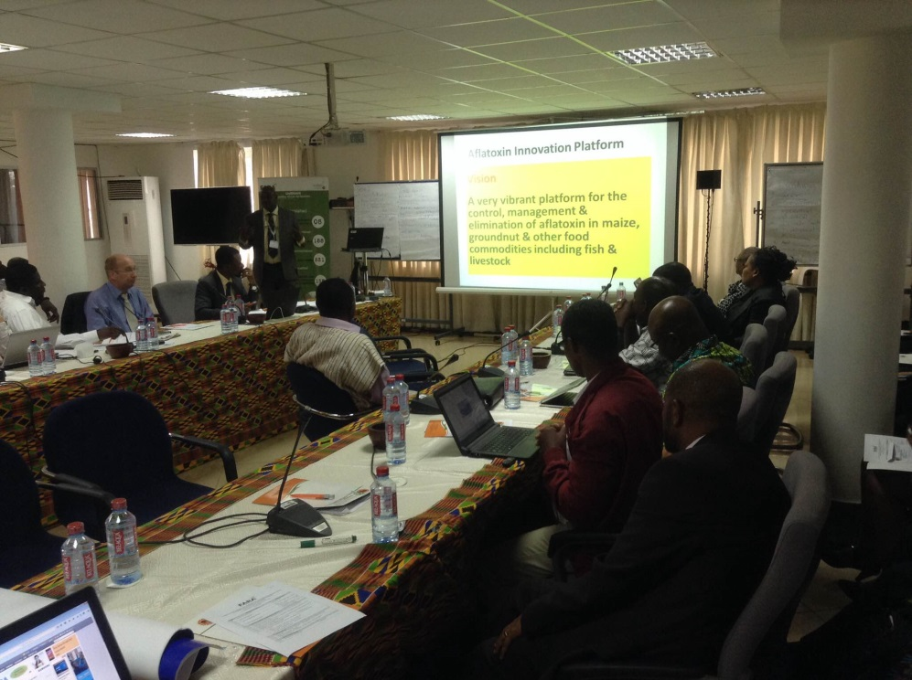
Dr. Oluwole Fatunbi making a presentation on innovation platform formation

4.0 Group discussion (World Café) Reports
Four Groups were formed to discuss (a) Strategies for local awareness creation on aflatoxin problem; (b) Aflatoxin mitigation approaches with potential for adoption by farmers and other value chain actors; (c) Institutional arrangements and partnerships for aflatoxin management in Ghana; (d) Funding of local activities on aflatoxin management. The World Café approach enabled every participant to participate in the discussions in all the four Groups. The highlights of the group presentations are presented as follows:

4.1 Group 1: Strategies for local awareness creation on aflatoxin problem
The group was facilitated by Gladys Serwaa Adusah. The key issues discussed are as follows:
- There is the need to create awareness of the aflatoxin problem among all stakeholders hence stakeholder identification and analysis is required. Stakeholders include Farmers (Crop, fisheries and livestock farmers)
  - Processors
  - Aggregators
  - Traders
  - Consumers
  - Professionals (Health, Media, Agricultural etc.)
  - Students
- Baseline study on the knowledge of stakeholders on aflatoxin (to help in message development and assessment of impact of awareness creation)
- Training of trainer’s workshop for all food handlers including farmers, processors, millers, traders, general consuming public on measures of mitigating aflatoxin in food and feed
- There is the need to adopt a local name for aflatoxin since the name as it is now could be ‘scary’. The local name will also help in easily conveying the message in the local Ghanaian languages.
- Various communication channels were identified including
  - Audio visual Aids
  - District policy dialogue
  - Media (electronic e.g. radio, TV, and print)
  - Drama and live role-play by traditional groups in the communities
  - Documentaries
  - Community workshops/town meetings
  - Information service (e.g. using information vans)
  - Talks at religious or festival gatherings
  - Community meetings
  - Demonstrations
  - Focus group talks with opinion leaders
  - National quiz competitions
  - Extension programs (food safety, nutrition, agricultural, health)
  - Websites
  - Emails
  - Printed materials (publications, fact sheets, t-shirts and caps, car stickers, key holders, posters, billboards etc.)
  - Digital publications
  - Meetings, workshops, focus groups
  - Public consultations
  - Partners/stakeholder network
  - Social media (Facebook, Twitter, LinkedIn, etc.)
  - Blogging
  - Podcasts
  - Webinars
  - Information days/meetings
- There is also the need to engage parliamentarians, opinion leaders and other influential people in society to champion aflatoxin campaign and advocacy.
- Monitoring and Evaluation is required
- Higher price should be set for Aflatoxin free produce to motivate producers
It was suggested that the International Food Policy institute (IFPI) has some videos (on how to improve storage of some food crops) which could be translated into the local languages for use in the educational campaigns.
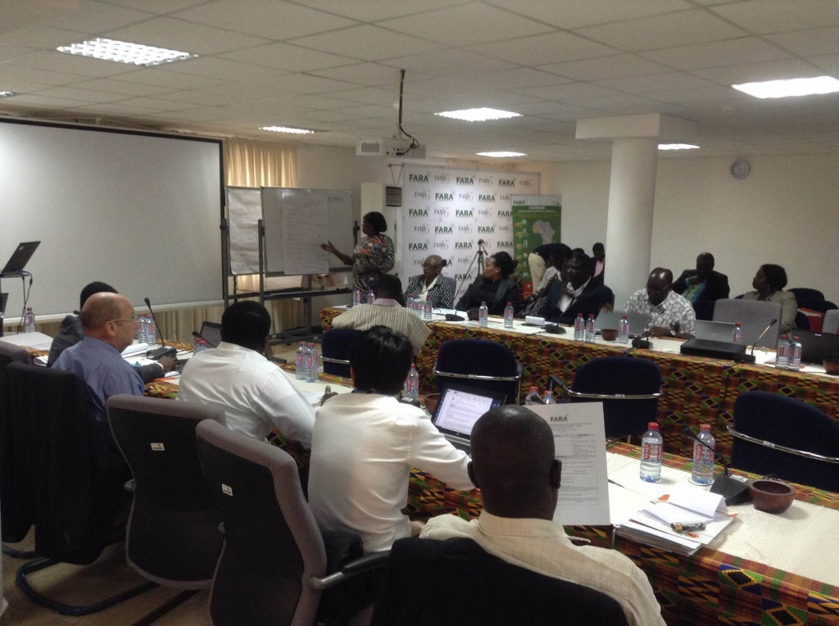
Facilitator for Group 1 presenting the outcome of the Group discussion

4.2 Group 2: Aflatoxin mitigation approaches with potential for adoption by farmers and other value chain actors
The facilitator of the Group was Prof. Richard T. Awuah. The group identified two stages at which mitigation measures can be implemented.
  - Pre-harvest stage : Activities that can help reduce aflatoxin contamination include:
    - Awareness creation of the aflatoxin problem and its mitigation measures among all stakeholders
    - Ensuring Good Agricultural Practices (including selecting soils free from termites and arthropods and avoiding lands with previous history of aflatoxin,
    - Planting resistant crop varieties and certified and treated seeds
    - Conducting soil testing and analysis
    - Bio-control measures e.g. Aflasafe
    - Enforcement of regulations/standards
  - Postharvest: Activities that can help minimize aflatoxin in food and feed include:
    - Timely and proper method of harvesting
    - Timely and rapid Drying
    - Packaging in appropriate materials
    - Storage at appropriate conditions (e.g. using pallets
    - Sorting of mouldy grains
    - Establishment of agribusiness service centres for post-harvest handling
    - Promote relevant post-harvest equipment/machinery (e.g. shellers, dehuskers, etc)
    - Providing testing kits
    - Treatment with plant products e.g. syzygium powder
    - Immunization of farm animals against aflatoxin contamination
    - Developing markets for aflatoxin-safe products
    - Adopting Codex guidelines for aflatoxin control
    - Appropriate disposal of contaminated products to avoid the spread of spores and ingestion by other animals
Issues that were suggested after the presentation were
• Use of sensors to monitor moisture content and send alerts to store-keepers
• Research should be conducted to develop vaccines for immunizing humans and animals against aflatoxin

4.3 Group 3: Institutional arrangements and partnerships for aflatoxin management in Ghana
The Group was facilitated by Isabella Mansa Agra. Key players/Partnerships in the management of aflatoxin include:
- Researchers
- Farmer Based Organization (FBOs)
- Ministries, Departments and Agencies (e.g. Ministry of Food and Agriculture, Ministry of Health, Ministry of Trade, etc.)
- Processors (Feed / food), Millers
- Media
- Aggregators
- Financial Institutions
- Association of Ghana Industries
- Private Enterprise Foundation
- APPDF
There is the need to conduct gap analysis and needs assessment and to develop policies and legislation as well as implementation and action plan for aflatoxin management and control. As a starting point, there is the need to
    - Create the innovation platform (IP) for aflatoxin control
    - Identify lead institutions to lead the IP – some proposed institutions are the Council for Scientific and Industrial Research (CSIR), Food and Drug Authority (FDA), Plant Protection and Regulatory Services Directorate (PPRSD), and FBOs.
    - Establish aflatoxin Secretariat

4.4 Group 4: Funding of local activities on aflatoxin management
The Group facilitator was Agyarko Mintah. The Group identified the following sources of funding:
    - Government (Central, local)
    - Private sector
    - Development partners
    - NGOs
    - Specialty markets (paying premium for aflatoxin-free products)
The following were also identified as the funds recipients
    - FBOs,
    - Researchers,
    - NGOs,
    - local governments,
    - Agro-processors,
    - crop & livestock producers
The funding mechanisms identified were:
• Grants to Researchers
• Grants to Small scale crops and livestock farmers
• Matching grant concept
• FBO levies (Agricultural fund to be instituted by levying High quality products)
While striving to look source for funding it is also important to set guidelines for aflatoxin mitigation and ensure compliance.

Comments made after this presentation are as follows:
- The group was tasked to include “what needed to be done and by who” in their presentation.
- Donors are beginning to understand the seriousness of aflatoxin so there is the need to engage them
- Researchers have failed in the past to inform Donor partners about the seriousness of the Aflatoxin menace
- It will be beneficial to target Swedish “SPIDER” donors

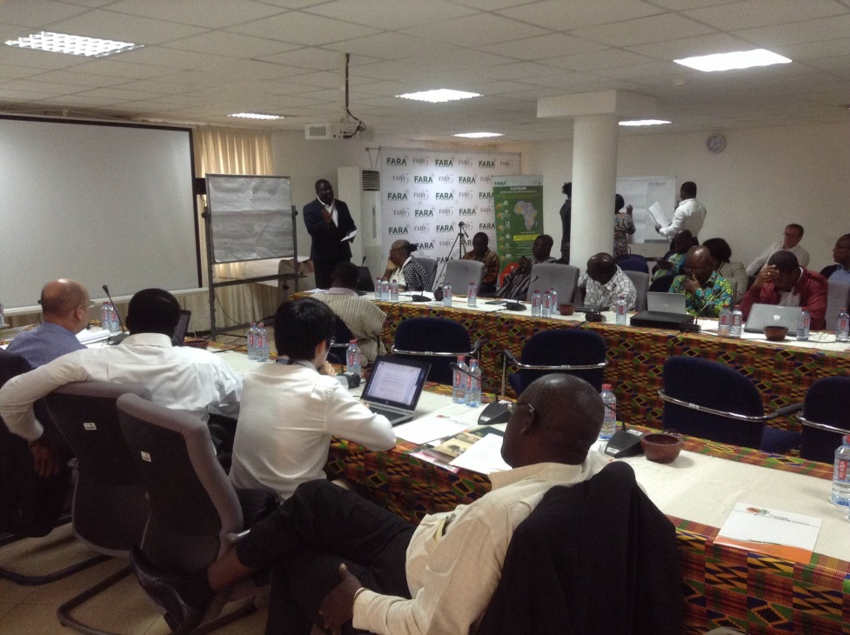
Facilitator for Group 4 presenting the outcome of the group discussion

5.0 Plenary Session: Formation of Ghana aflatoxin management innovation platform
This session was led by Dr. Oluwole Fatunbi. Participants were guided to set the vision, mission, objectives and main thrust of the innovation platform.

Vision
To manage Aflatoxin levels in food and feeds to acceptable levels

Mission
To create awareness and education among stakeholders and the general public about Aflatoxin menace in Ghana (To be modified by a core group)

Objectives
- To increase awareness on Aflatoxin problems in Ghana;
- To develop mitigation strategies for Aflatoxin
- To strengthen partnership for Aflatoxin management and control in Ghana
- To advocate for good legislation & policy on Aflatoxin control & management
- To enhance stakeholders capacity in the management and control of Aflatoxin
- To facilitate trade in acceptable levels of Aflatoxin in maize, groundnut & other food commodities in the sub-region & international markets.

Main thrust
- Social Accountability
- Wealth Creation
- Integrity
- Innovation
- Team work

Location of the innovation platform
Techiman/Ejura was chosen as the location of the first IP. Many more locations will be included subsequently.

Lead organization
Ghana Federation of Agricultural Producers was chosen to lead the IP formation and other activities.

Identification / prioritization of constrains
- Awareness creation
- Training on Good Agricultural Practices
- Facilitate private sector participation in service provision (shelling, drying etc)
- Market identification and linkages / certification
- Policy and Advocacy
- Research

Stakeholder analysis
The result of stakeholder analysis of participants at the workshop is shown in Table 1.

No | Name | Stakeholder Group | Personal Contribution | Expectation
1 | Amponsah Daniel Kwarteng | Farmers’ Organization (GFAP) | - Mobilizing agricultural producers to adopt innovation of the platform  - Dissemination of readily available aflatoxin information to the farmers | - At least 90% of smallholder farmers will be able to adopt innovation by the platform  - To see the platform functioning as the wi
2 | Daniel Ninson | Public Sector, Agribusiness Development | - Provide technical knowledge on the production of cereals and legumes  - Train value chain actors on good agricultural practices (GAPs)  - Facilitate market linkages between commodity value chain actors | - Learn / appreciate the challenge of value chain actors  - Strengthen linkage and collaboration between stakeholders
3 | Frederick Q. Ayeh | Federation of Association of Ghana Exporters | My contribution to the platform activity:  - To facilitate awareness creation among the exporters to participate in the platform activities  - Farmers/exporters | What I expect from this platform:  - I expect to see the platform as an innovation for networking with all stakeholders in the Agric / fishery sector  - Input sellers  - Researchers  - Policy makers  - Transporters  - Packaging dealers  - Freight forwarders etc.
4 | Ayesha Hakeem | Farmer (Aggregate groundnuts, maize, tilapia) | My contribution:  - Work with FBOS and other small scale farmers to improve awareness and increase practices to reduce aflatoxins | What African connections expects:  - The development of a platform which can facilitate a process to reduce aflatoxins in Ghana
5 | Winta Sintayehu | International Governmental Organization | - PACA through AUC can support Ghana and this platform to advocate for Policy change and awareness creation  - Facilitate linkages with other projects and experiences across the continent | - PACA AUC expects to see Ghana control aflatoxins and improve human health as part of the Broader PACA vision of an Africa free from the harmful effects of afaltoxins  - PACA would also like to see the linkages of the activities of this platform to the broader continental effort of aflatoxin control through PACA
6 | Samuel Ayobi | MOFA- Extensionist | - Awareness creation  - Training of good agricultural practices | - My expectation is for farmers to produce an AFS free products
7 | Tuolong Paul D.K. | MoFA-Extensionist | - To bring farmers issues on Aflatoxin and post-harvest losses to the Innovative Platform and vice versa i.e. educating of farmers on aflatoxin | - I expect to see improved living standard of farmers through increased income
8 | Philip Amoah | NGO – ECASARD | - Create awareness and train farmers group on good agricultural practices | - Share experiences on networking  - Meeting the goal of my organization which is enhanced food security
9 | Vincent Kyei Baffour | Researcher/ Technologist | - I will conduct analyses on maize and groundnut to help regulate aflatoxin levels  - I will help create awareness by educating farmers on the issues on aflatoxin | - I expect the country to produce aflatoxin free food which will go a long way to facilitate trade and improve health of the citizens
10 | Derry P.A. Dontoh | Standards organization (Laboratory testing and standards Development) | - Reliable and affordable laboratory results on commodities to ascertain if interventions have been effective | - Improve on the education in the aflatoxin menace  - Facilitates trade since EU alerts are rampant on aflatoxin prone commodities  - Reduction in levels of aflatoxins stated in Ghanaian standards
11 | Simon Ogah | Fish Farmer (Tilapia, Catfish) | - Education and training of farmers on good production and post-harvest management | - Aflatoxin free feed  - Aflatoxin free farmed fish  - Entry to foreign market
12 | Hon Gabriel K. Essilfie | Legislator | - Legislative advocacy and public awareness to influence policy | - Growth in Agric Trade  - Healthy constituents  - Decrease in poverty levels of my constituents  - Consumption of quality foods
13 | Daniel Nyarko | Private Sector (Input, processing and extension) | - Transfer knowledge /training of farmers and provision of processing and storage  - Facilities to reduce aflatoxin levels | - Increasing profitability for farmers through premiums on grains and produce
14 | Agnes Simpson Budu | Lecturer/researcher | - To conduct research to find aflatoxin levels in various food products to identify problem areas.  - Make awareness to aflatoxin in various food products  - Conduct training to food processors to reduce intake of aflatoxin in foods | - To have access to research and dissemination by collaborating with other stakeholders  - To be able to contribute to the reduction of aflatoxin in food products in Ghana
15 | Daniel Agbetiameh | Researcher | - To develop Aflasafe, a biocontrol product for the mitigation of aflatoxin contamination in maize and groundnut | - To see farmers produce food that meets acceptable aflatoxin standards and the quality of lives improved
16 | Afia Owusu-Nyantakyi | Private Sector (Input dealer and Postharvest, Storage and Marketing) | - Bringing in my expertise on post-harvest handling in the area of shelling, drying, cleaning, storage and marketing of maize.  - Good supply and application of agro-chemicals | - Cleaning, storage and marketing with timely supply and correct application of agro inputs  - Networking better for improvement in my business
17 | Prof Richard T Awuah | Lecturer / Researcher | - Awareness of aflatoxin (i.e. training of stakeholders)  - Research on aflatoxin mitigation in foods  - Advisory role | - Connection with relevant stakeholders in the aflatoxin  - Develop my expertise in training of farmers and farmer-based groups on aflatoxin
18 | Neans Nii Chinery | Private Sector (Grains value chain association) | - Policy and advocacy | - Trading in graded grains for GCC members
19 | John Awuku Dziworkwu | Farmer (maize and rice) | - To contribute information and knowledge on GND agriculture practices to the platform | - To produce quality and marketable grains as a result of organization being on the platform
20 | Firibu Kwesi Saalia | Researcher / Professor | - Research expertise and experience on aflatoxin foods | - Learn from other stakeholders and look for research opportunities
21 | Dokurugu Salifu Ziba | Agric Advisor / Spring Project | - Share materials on aflatoxin control and management in groundnut | - To research materials on aflatoxin management and control in maize and groundnut
22 | Nashiru Kadri | Farmer (maize, rice, soya beans) | - Produce maize, rice and soya beans for the markets | - To get ready market and better prices for my produce
23 | Paul K. Ntaanu | Private sector (farmer based organization) | - Contribute in awareness creation / education among farmers  - Facilitate linkages with other stakeholders | - I expect to be better equipped with the knowledge and skills to control aflatoxin
24 | Mumuni Abudulai | Researcher (CSIR) | - Expertise on GAP (training) | - Learn with other stakeholders  - Help reduce aflatoxin levels in food and feeder
25 | Eric Hudson Asamani | Agriculture Extension | - Create awareness and educate farmers / fishers on aflatoxin control and management to an acceptable level  - Train farmers on good agricultural practices  - Link farmers (FDOS) to markets | - Reduced level of contamination of aflatoxin on farmers produce in order to enhance trade
26 | Gladys Serwaah | DRG – ECASARD / Farmer (maize, yam) | - To have more insight on aflatoxin management | - To be trained to become an advocate on aflatoxin management  - Produce high quality maize  - Raise income
27 | Daniel Adotey | Policy research and Advocate (CSO) | - Assist in mobilizing farmers  - Assist in developing policy papers | - Networking opportunities shared learning
28 | King David Amoah | GFAP/FONG | - Mobilize farmers and FBOs (farmer linkages) | - Networking for aflatoxin control in Ghana
29 | Mark Kwame Offei | Development partner, FAO | - Expertise  - Funding  - Contribution to existing initiative | - Platform is efficiently able to manage aflatoxin issues in Ghana
30 | Agyarko Minteh | Development cooperation (GIZ) | - Facilitate market linkages  - Facilitate linkage to other partner institutions | - Extra funding for new activities
31 | Bruno Telemans | Development partner | - Experience in support of farmers and value chains extension, techniques, projects development, fundraising. | - Partnerships  - Networking
32 | Vivian Anagbonu | Agribusiness /Aggregator / Farmer (cassava) | - To help create awareness of aflatoxin food dangers to our health and to the farmers in my community | - I expect to gain more insight into the dangers of aflatoxin food  - To get funding for my cassava project
33 | Rose Omari | Policy researcher (science, technology, and agriculture policy, technology adoption studies)  Food safety educator and advocate | - Can conduct policy studies and develop policy documents and policy briefs  - To bridge the gap between research and policy for researchers and technology users  - Can help train stakeholders on safe food handling practices  - Can be an advocate playing key role in developing advocacy, information, education and communication materials | - To get more opportunities to do what I like doing- research and food safety risk communication

Way forward
ACTIVITY | BY WHO | WHEN
- Prepare Action plan | GFAP secretariat – King David
- Launching of the platform / developing business plan | FARA | End of July
- Sensitisation of stakeholders

6.0 Conclusion
Aflatoxin contamination of food and feed is a major development challenge that negatively impacts health, food security and trade. Multi-sectoral approach and effective mitigation strategies are required to effectively deal with the problem. The effective and active participation of participants at this workshop is an indication that Ghana is ready to fight the battle against aflatoxin. Together, we shall win this battle and Ghana and the entire African continent will be assured of aflatoxin-safe food and feed.

Appendices

List of Participants
A CONSULTATIVE WORKSHOP ON THE ESTABLISHMENT OF AN INNOVATION PLATFORM FOR AFLATOXIN MANAGEMENT IN GHANA

held at the FARA Secretariat, Accra, Ghana, on 17th June, 2015

List of Participants
No. | Name | Organization | Email | Phone number
1 | Simon Ogah | Fishereies Alliance Network Ghana(FANG)/PFAG | simonogah@yahoo.com | 0204921790 /  0543233922
2 | Amoah Philip | ECASARD | info.ecasard@gmail.com
3 | King David Amoah | GFAP/FONG | kdkamoah@yahoo.com; gfapsecretariat@gmail.com | 0243863567
4 | Kaz Fujiwara | UNWFP | kazuyuki.fujiwara@wfp.org | 0540200759
5 | Gladys Serwaah | ECASARD | adashg@gmail.com
6 | Daniel Nyarko | African Connections | daniel.nyarko@africanconnections.biz | 0244248900
7 | Agnes S. Budu | University of Ghana | asbudu@ug.edu.gh | 0277846628
8 | Gloria Essilfie | University of Ghana | gessilfie@ug.edu.gh; gloriawfp@yahoo.com | 0244844084
9 | Ayesha Hakeem | Africa Connections | hakeem@africanconnections.biz | 0242529627
10 | Afia Owusu Nyantekyi | GAIDA | feliseed@yahoo.com | 0208138206
11 | Vincent Kyei-Baff | FRI | vok-baffour@yahoo.com | 0249687888
12 | Isabella Mansa Agra | FDA | isabella.agra@fdaghana.gov.gh | 0244337249
13 | Daniel Ninson | DCS-MOFA | kwameninson@gmail.com | 0243672961
14 | Paulina Armah | FONG | fongsecretariat@gmial.com | 0269416988
15 | Amponsah Daniel K. | GFAP/FONG | gfapsecretariat@gmail.com | 0241885266
16 | Daniel Agbetiameh | KNUST & IITA | D.Agbetiameh@cgiar.org | 0246782603/  +2348160618663
17 | Derry P.A. Dontoh | Ghana Standards Authority | ddontoh@gsa.gov.gh; ddontoh@rocketmail.com | 0244765964/  0209117166
18 | Mumuni Abdulai | CSIR-SARI | mabudulai@yahoo.com | 0203862844
19 | Salifu D. Ziba | USAID-SPRING | zdokurugu@spring-nutrition.org | 0244806910
20 | Nashiru Kadri | Apex Farmers Organization, Ghana | nakadri@ymail.com | 0243665458
21 | Eric Hudson Asamani | MOFA-PRU | Ehaja2001@yahoo.co.uk | 0243189965
22 | Paul K. Ntaanu | Slri Assoiciation | ntaany@yahoo.com | 0244094221 /0200717415
23 | Agyarko Mintah | GIZ-ACI | agyarko.mintah@giz.de | 0244329734
24 | John Awuku Dziwornu |  | dzijo@gmail.com | 0244115537
25 | Rose Omari | STEPRI-CSIR | Rose.omari@yahoo.com | 0244158896
26 | Orleans Nii Cliver | Ghana Grains Council | o.chiney@ghanagrainscouncil.org | 0277803700
27 | Uwe Ohmstedt | GIZ Mexp | uwe.ohmstedf@giz.de | 0544339771
28 | Bruno Telemans | FAO | bruno.telemans@fao.org | 0548799801
29 | Mark Kwame Offei | FAO | mark.offei@fao.org | 0269137563
30 | Mariella Sandini | TRAQUE-MOTI | mariella@sandini.info | 0260968383
31 | Vivian Anagbonu | Women Aid Fountain | Vivian.anagbonu@gmail.com | 0507903668
33 | Firibu K. Saalia | University of Ghana | fsaalia@ug.edu.gh; fsaalia@yahoo.com | 0243125566
34 | Adotey Daniel Akwei | SEND-Ghana | adoteyd@ymail.com;danotey@yahoo.co.uk | 0248095421
35 | Audrey Dekalu | GNA | audreydekalu@yahoo.co.uk | 0277185884
36 | Awuah Richard Tuyee | KNUST | awuahrt@yahoo.com | 0244897063
37 | Winta Sintayelu | PACA-AUC | wintas@africa-union.org | +251911393856
38 | Tuolong Paul | MOFA-Techiman North | pauldktuolong@yahoo.com | 0206987210
39 | Samuel Ayobi |  | samuel.ayobi@yahoo.com | 0244094221/  0200717415
40 | Hon. Gabriel Essilfie | Parliament -Agric Comm. | gkessilfie@comcast.net | 0240975514
41 | Dr. Oseyemi Akinbamijo | FARA | yakinbamijo@faraafrica.org
41 | Dr. Fatunbi Oluwole | FARA | ofatunbi@faraafrica.org
42 | Dr. Nelson Ojijo | FARA | nojijo@faraafrica.org
43 | Ms. Debbie Nwaozo | FARA | dnwaozo@faraafrica.org
44 | Mr. Francois Stepman | Platform for African - European Partnership in ARD (PAEPARD)  c/o CTA Brussels Office  39 rue Montoyer. 1000 Brussels. | fstepman@gmail.com | Mobile: 00-32-474627686 (Belgium)

Presentations
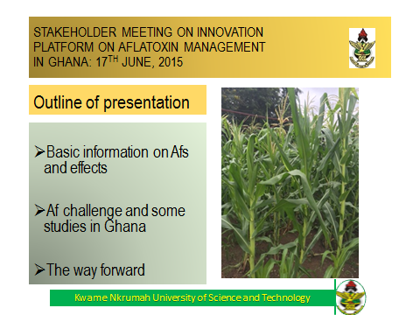
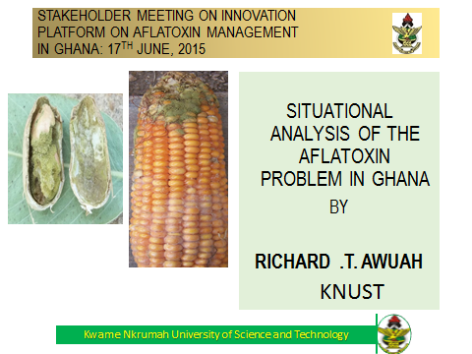
Situational analysis of the aflatoxin problem in Ghana
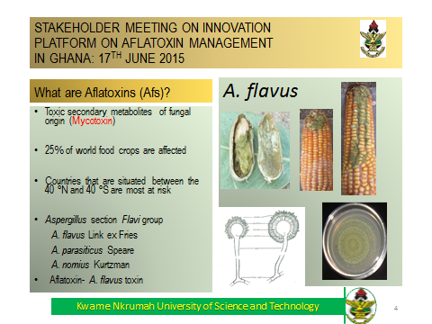
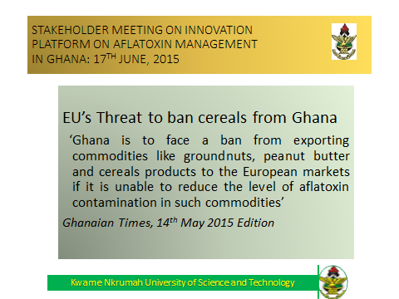

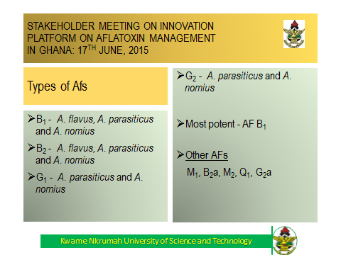

Perspectives and continental activities on aflatoxin

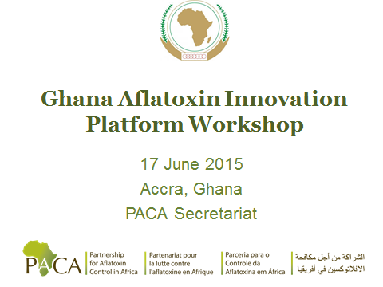

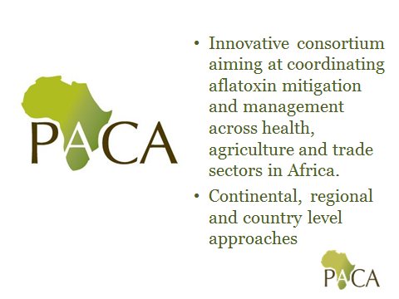

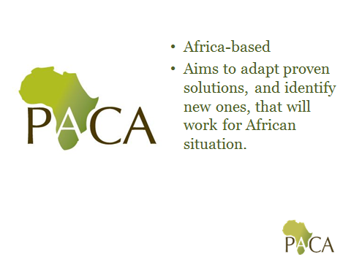

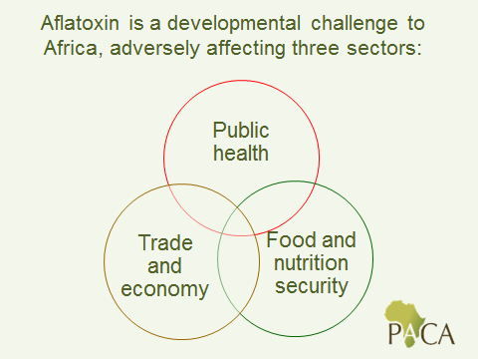

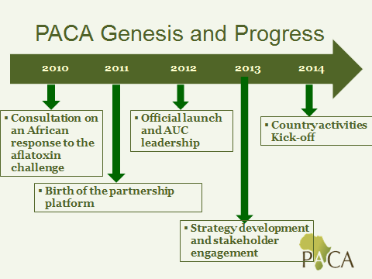

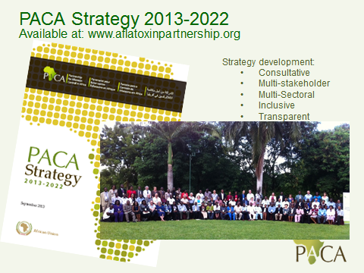

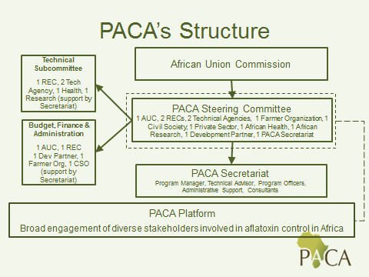
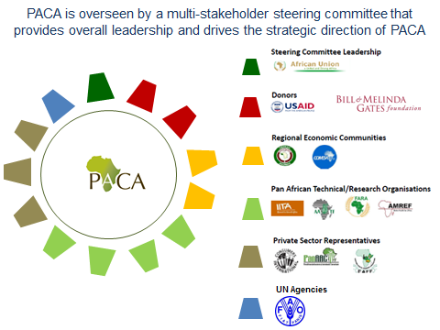

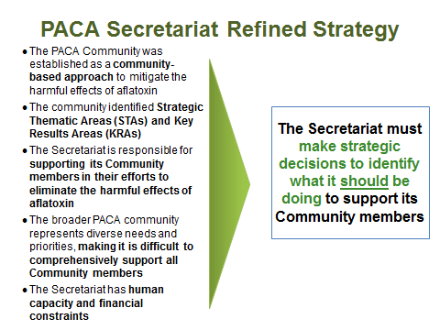

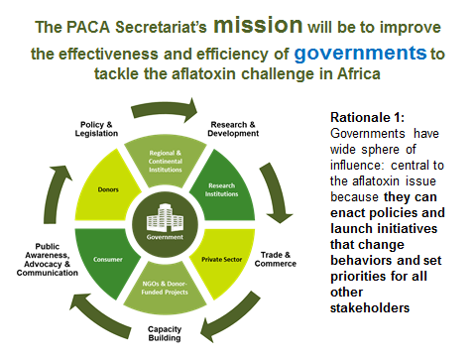

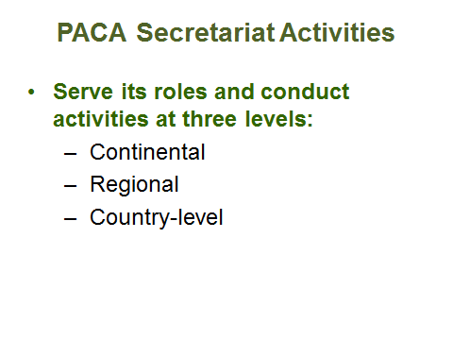

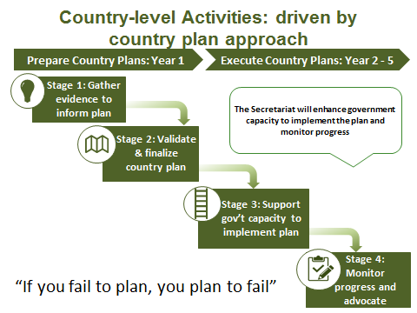

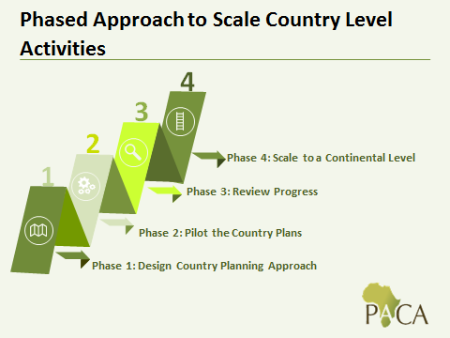

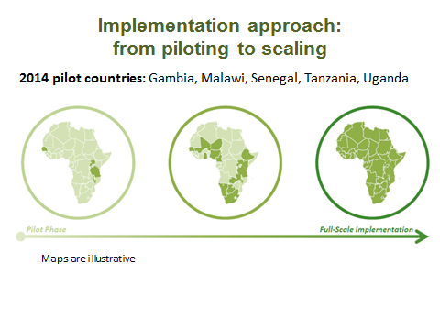

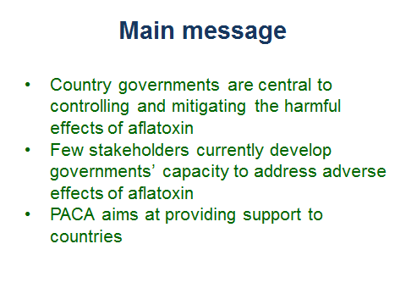

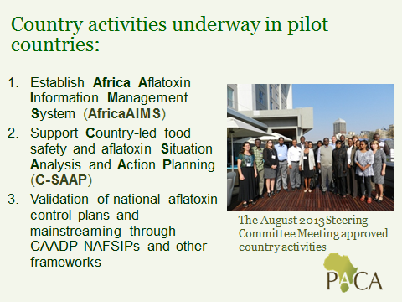
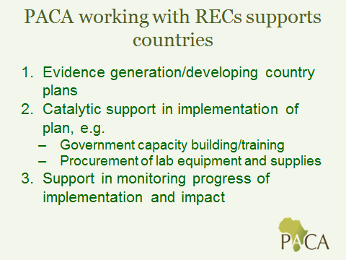
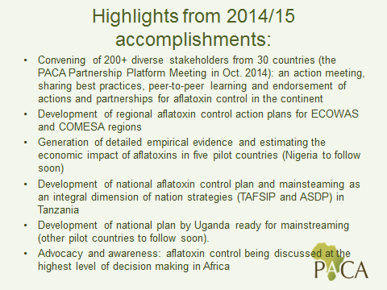
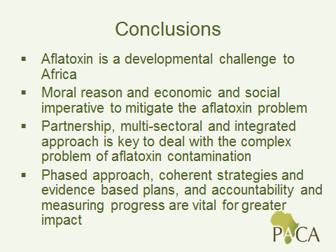
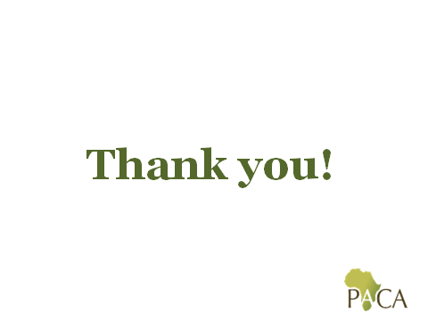

How to form innovation platforms to address aflatoxin problems in Ghana

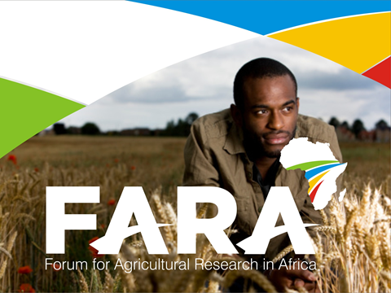
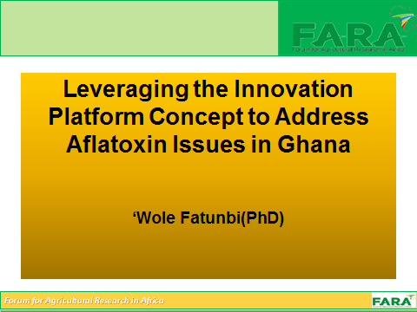
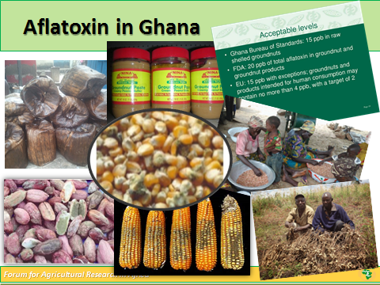
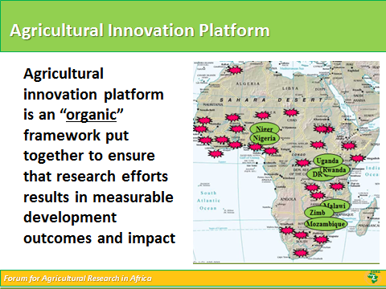
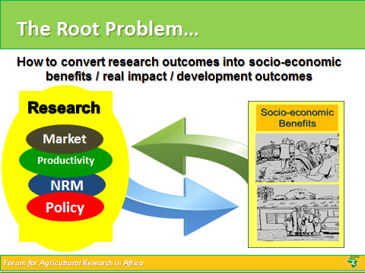

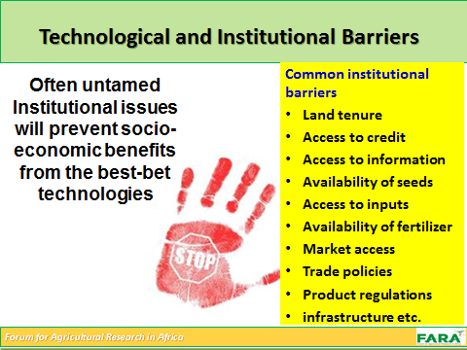
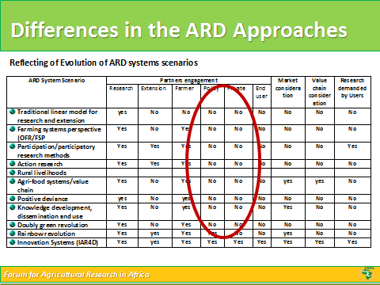
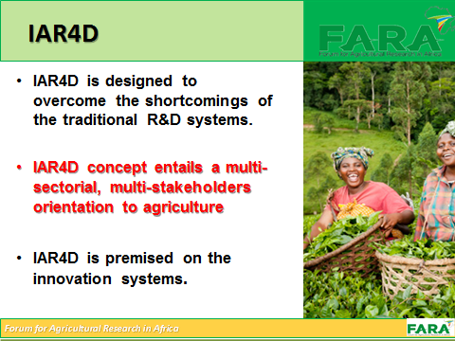
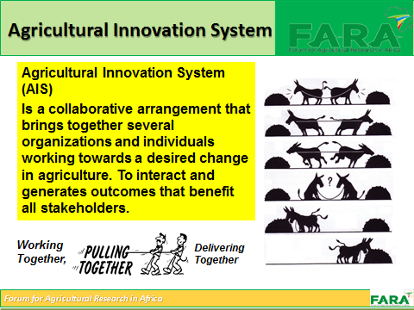
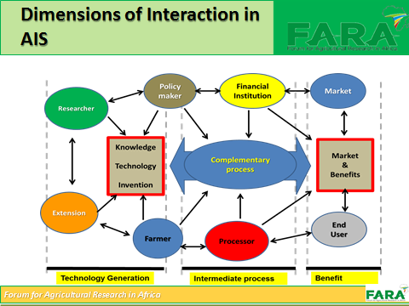
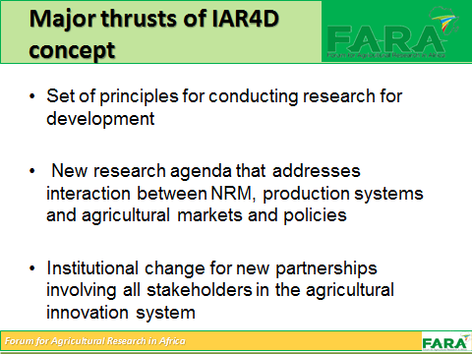
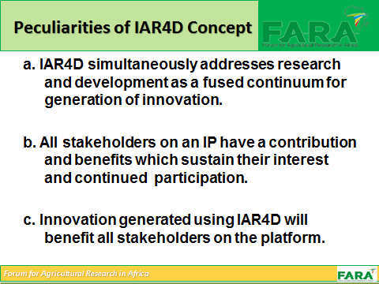
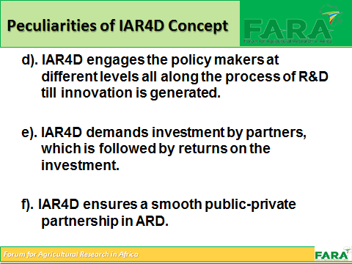
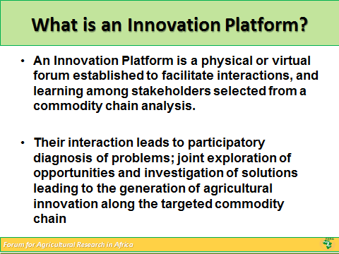
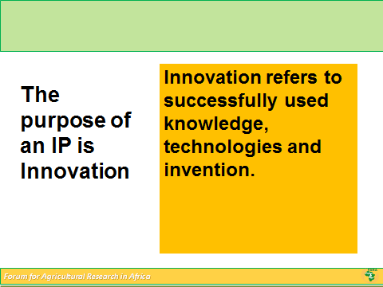
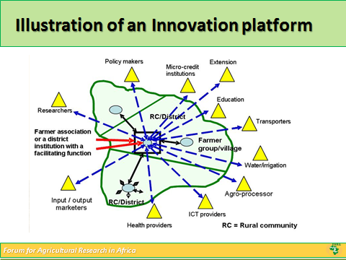

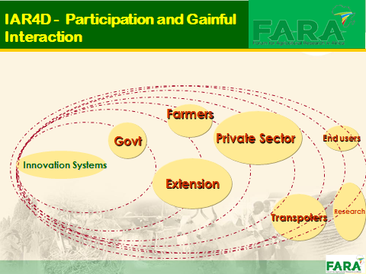
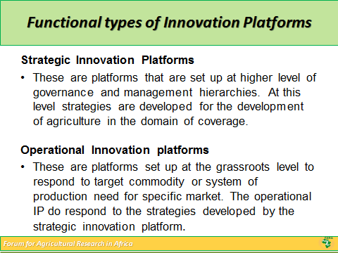
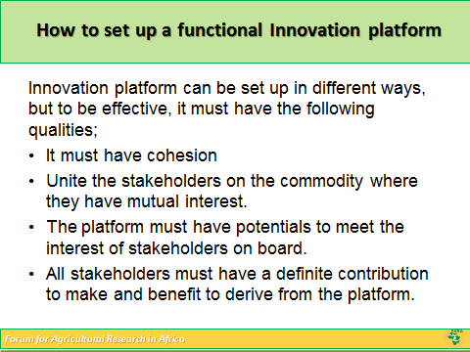
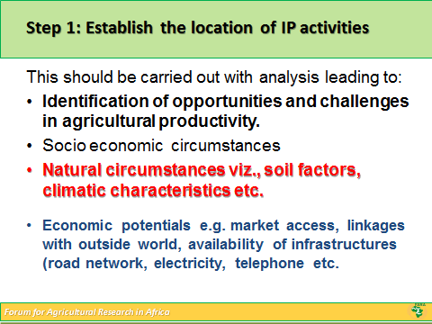
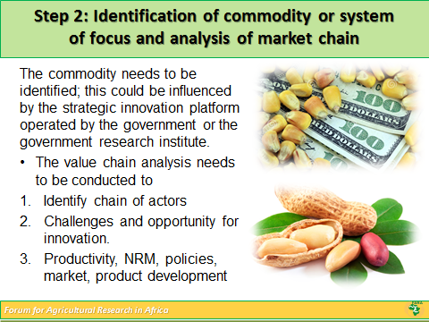
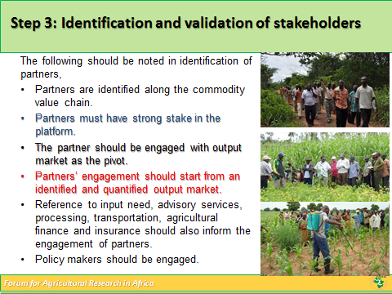
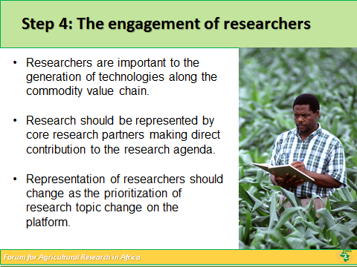
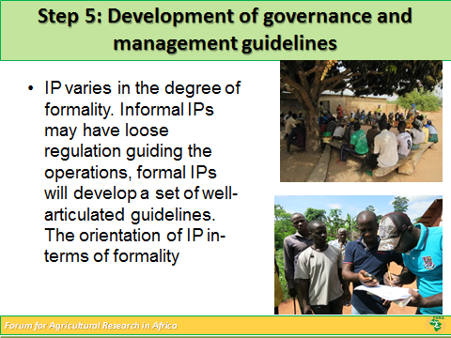
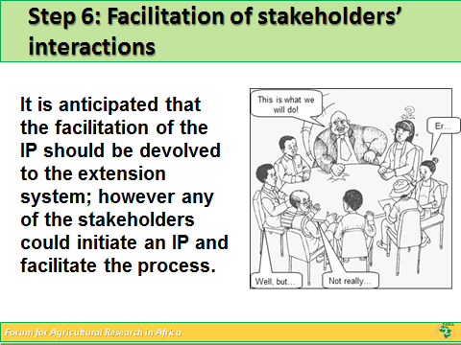
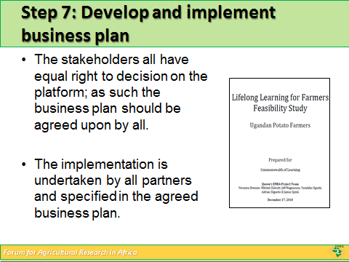

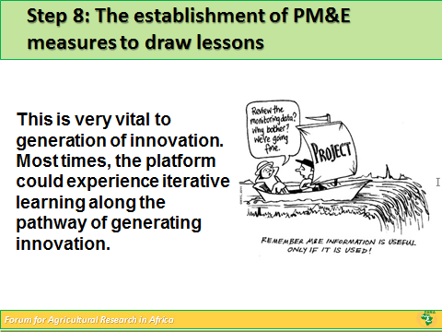
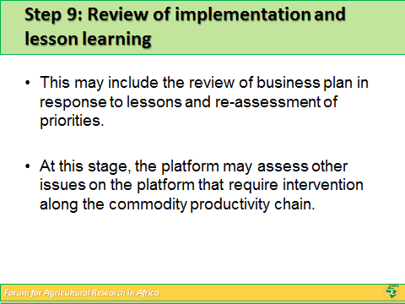
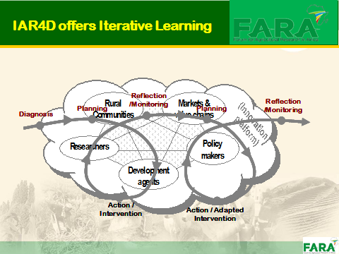
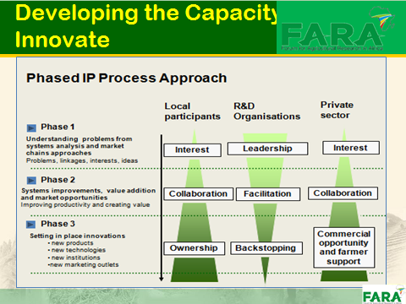
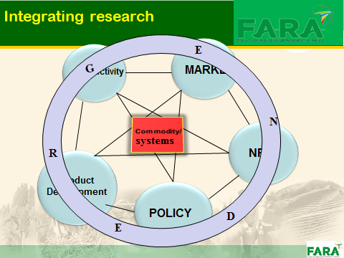
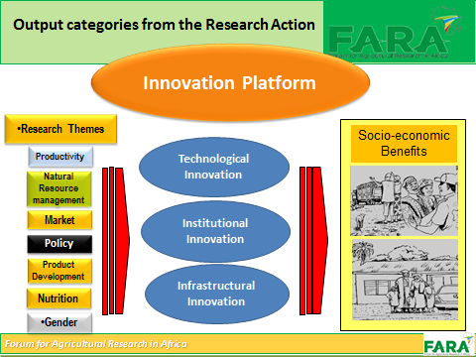
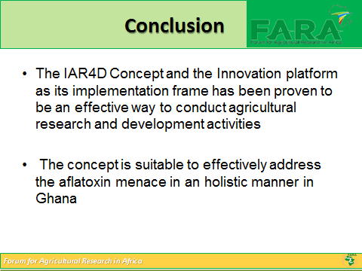
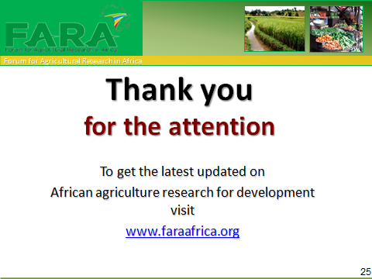

The Forum for Agricultural Research in Africa (FARA) is the apex organization for agricultural research for development in Africa. As outlined in the current Strategic Plan (2014 – 2018), the core functions of FARA are perceived to be: 1) facilitating collective action around the promotion of innovations in Africa’s agriculture; 2) strengthening capacity to enhance the functionality of agricultural innovation systems in Africa; 3) offering intellectual leadership for agricultural research for development (AR4D) in Africa; 4) building and managing partnerships to enhance agricultural productivity, competitiveness and markets in Africa; 5) carrying out advocacy and communication for improved AR4D in Africa; and 6) tracking progress in Africa’s agricultural development. The value proposition of FARA is strengthening Africa’s capacity for agricultural innovation and transformation. A key action under this value proposition is mobilizing, connecting and rallying stakeholders for collaborative and concerted actions around issues and challenges that affect agricultural productivity, food security and trade based on the CAADP framework.

