

**Training 15 -17 October, 2016, on Processes & Practices**

**in multi-stakeholder partnerships in Agricultural Research for Development, Project management, Monitoring and Evaluation**

**Summary report**

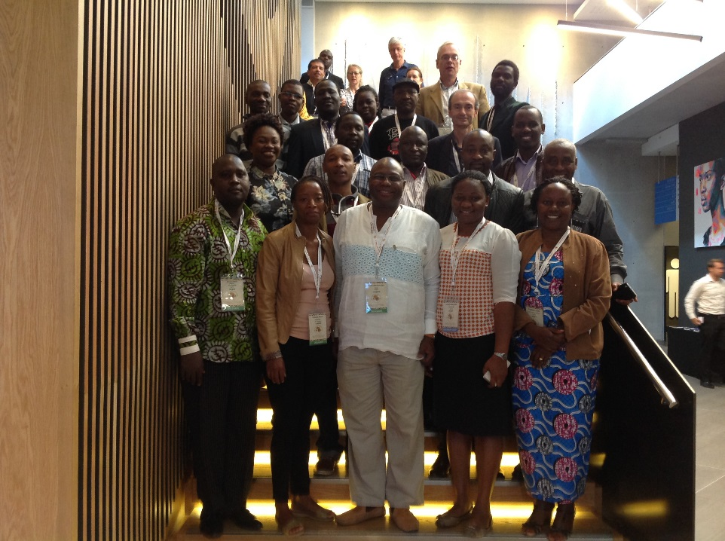

**Laurens van Veldhuizen**

**Royal Tropical Institute**



**Introduction**

PAEPARD is a project supported by the European Commission to build African-European multi-stakeholder partnerships (MSP) in Agricultural Research for Development (ARD). 2017 is the final year of the current project phase.

Over the past years PAEPARD has facilitated the emergence and formation of a great diversity of ARD partnerships using the mechanism available during its different phases. Since 2014 a number of these partnerships have accessed the PAEPARD Competitive Research Fund (CRF).

Following a study assessing PAEPARD partners’ capacity needs conducted in 2014 the project initiated a capacity building programme to strengthen management and analytical skills for the CRF projects. This was to include the cycle of project management as well as a monitoring & evaluation component in its relation to the project’s result framework and associated indicators.

As part of this effort, a 3 day training workshop was organized in Cape Town from 15 – 17 October, 2016, with the following objectives:

* Reflect on PAEPARD partnership processes and draw lessons learnt;
* Engage partners in reflection around the management of projects and consortia with PAEPARD and find ways of overcoming current challenges;
* Increase understanding in result-based management and monitoring and evaluation linked to the PAEPARD result framework.

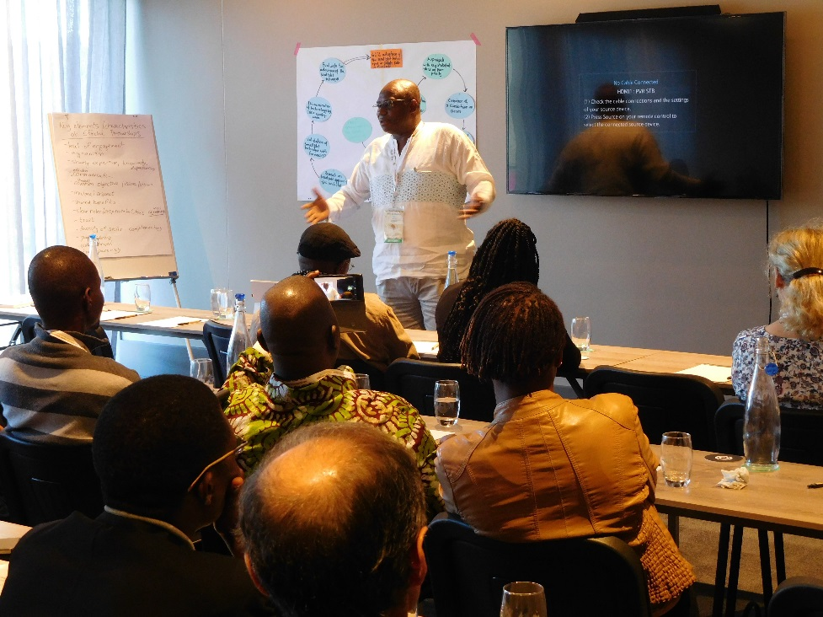

**The training and its process**

Following above objectives, the training was designed to cover three main topics as follows:

|  |  |  |
| --- | --- | --- |
| ***Topic*** | ***No of days*** | ***Resource persons*** |
| Learning on multi-stakeholder partnerships | 1 | Julia Ekong & Mundi Salm |
| Project management | 1,5 | Gerard den Ouden |
| Monitoring and evaluation | 0,5 | Clesensio Tizikara |

In practice the programme was reduced to last only 2,5 days because of late arrival of some participants. The detailed workshop programme as implemented is added in Annex 1. Laurens van Veldhuizen of the Royal Tropical Institute, the Netherlands, supported the overall facilitation of the training process. He also took responsibility for preparing this summary report focusing on notes and observations of relevance for PAEARD beyond the direct training content. Detailed notes on the training content have been shared by the respective resource persons.

The training attracted a total number of XX participants from a wide range of PAEPARD partners (Annex 2). The training process included both formal presentations with question and answer sessions and more interactive learning forms such as practical assignments, drama and group work.

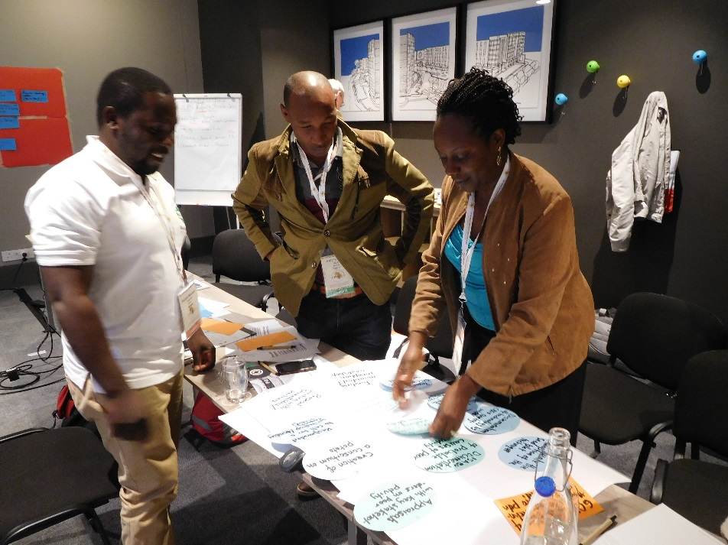

The second and longest training block – on project management – had a brief evaluation session at the end to assess strength and weaknesses of the training process from the point of view of the participants and to identify areas for improvement. The results of this evaluation have been added in Annex 3. Informal feedback from participants received after closure of the training suggests that the final block on monitoring and evaluation (M&E) would have benefitted from the use of a greater variety of training methods, beyond presentation followed by question and answer.

The first block discussing MSP experiences had an in-built tension between its overall purpose of developing an MSP analysis framework and the interest of participants to discuss and solve some of their current MSP facilitation issues. It is now important to consult participants and other MSP coordinating partners to finalize the framework and plan well with them on how this framework is going to be used, probably linked to the capitalization workshop foreseen for 2017. This would take into account that eight MSP cases have been documented in a book that is about to be published, though not to level of detail as in the current framework.

As a relative outsider one would also note the considerable overlap of issues discussed in the block on project management and the one on M&E and results-based management. This could have been avoided perhaps. This would also have created time and space to discuss and work with participants how to improve their current Result Framework (RF) following the important feedback on this in the last slides of the M&E presentation.

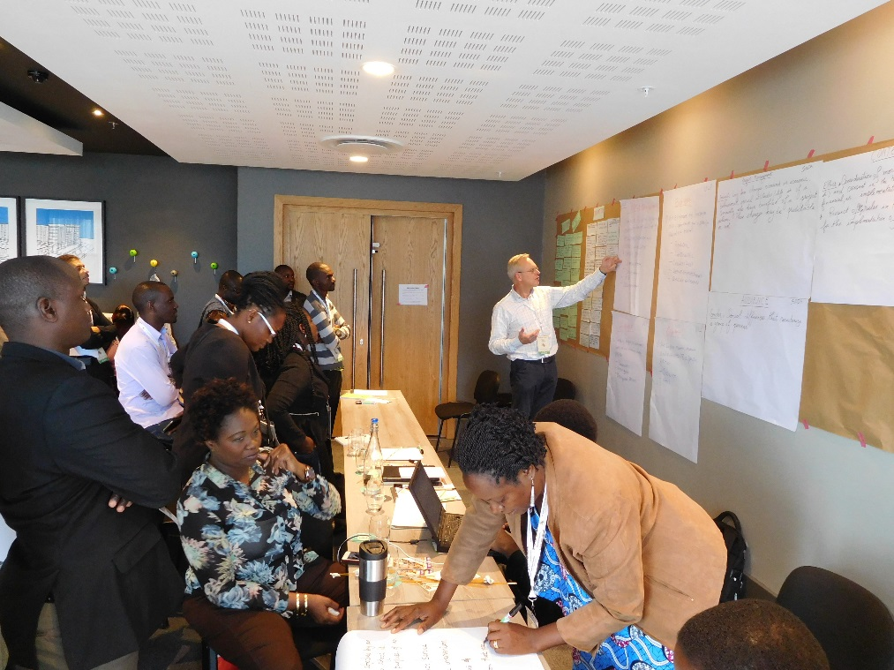

**Important issues emerging from the discussions**

During the training sessions a number of debates and interactions took place on various aspects of the PAEPARD approach to multi-stakeholder research and its coordination and management. This section discusses some of the most important ones from the perspective of the overall facilitator for future reference and follow-up.

*Involving European ARD organizations and researchers remains a challenge*, participants claim. Apart from lack of access to information on who in Europe would be interested in a given topic, commitment from EU researchers is probably limited because of financial paragraphs and perhaps narrow own research interests. Some suggested it would be helpful if European organisations could indicate early in the process funding thresholds for them to be interested. Non-research participants noted that finding good African researchers able to follow ULP lines is often a challenge too.

Having farmer organizations involved in research partnerships is not always a guarantee *for effectively involving (small scale) farmers on the ground* in the actual research. The case of women processors (in soya) was mentioned in this context. It points to either the need to review composition of the partnerships and/or to finding of intermediates to fill the gap and reach the small farmers to become partner in the actual research work.

Referring to *their MSP experience*, participants flagged several important issues:

* The difference in how non-research partners look at data collection and processing as compared to researchers: The latter need publication of results through official channels (research articles) for promotion and also insist on a certain level of rigorousness of data and results before publishing findings. Non-researchers like to share and use initial findings if positive as early as possible. Can a compromise be achieved? Who decides, has “Intellectual Property Rights”?
* Resource allocation can be a strong de-motivating factor. This is often not done fairly. Some (non-research?) actors may get 10% of what others get in the country. EU partner budgets can also be problematic, some feel.
* MSPs take time and resources. Their main advantage according to some researchers is in creation of effective links between them and the realities of farmers. They also help to access relevant expertise if needed (e.g. expertise from WUR on soya milk analysis that was not in the budget), and also access to funds.

*The User-Led Process (ULP)* is quite a unique approach by PAEPARD to develop research and development partnerships based on a bottom-up agenda. PAEPARD should review, analyse and document its ULP experiences and the outcome for both internal and external learning. The limited success rate of ULPs in accessing CRF funding also seems to support the call for such review. In the discussions several issues were raised on the ULP processes:

* The level of flexibility of the UPL process: What if the agenda developed through the ULP process that took quite some time cannot find funding support in the end?
* The role of the trained agricultural innovation facilitators (AIF) has been less than expected. Not all AIFs adequately understood PAEPARD and its approach. They also could only support the ULP process if there was budget.
* Successful ULPs had a good lead organization who developed the proposal before involving other partners. This poses the issue of leadership in MSP. In other ULPs the agreed core group did not function well (e.g. mango waste). Given the time involved in the ULP process some ULPs were not ready yet when the CRF call came.

*Communication* featured high on the agenda during the training. It was often mentioned by the consortia themselves as a weaker part of the MSPs, referring to communication within the consortia but also with the wider PAEPARD family. Yet, the relevant training session showed a strong set of communication tools and channels to be available for their use. While some suggest an information overload others note the lack of exchange. Notes and observations in this context as follows:

* The communication system is complex as it in fact involves the PAEPARD communication system as well as that of each of the consortia and of individual organizations. AFRISOL, e.g., works with many partners and donors and has its own web-site. Partners may thus present news on the consortium web-site and not on the PAEPARD system, not even on the website of own organization.
* PAEPARD has a communication strategy document. Its external communication component, however, is not yet tailored to target the 4 sub-categories of external actors taking into account their power and interest.
* Consortia generally do not have a basic communication plan.
* Some of the E-tools – intranet - remain too challenging for partners because of design and user system. Further training may not overcome this fully.
* There may be a need to agree on a protocol (at different levels) about doing publications. This would clarify who can be authors and co-authors, who needs to be asked permission and who needs to be informed, how quality is controlled?
* Could people have alerts when new things are posted on the web-site?
* Face to face meetings remain important for communication as compared to relying on Email.
* Successful external communication often focuses on selected individuals, often the consortium coordinator. This can create jealousy among other consortium members. Perhaps one can prevent this by using “we” rather than “I” in communications, involve as much as possible other members in PR activities representing the consortium, and always use logos of all members with the same font size.
* It would be useful to finalize the flow chart analysis for communication within PAEPARD started during the training.

Generally the discussion seems to call for a continued, focused and honest review of communication processes and methods within PAEPARD, also taking into account that communication issues can be a symptom of other issues in the partnership. A culture of communication and sharing within the partnership and projects needs to grow and nurtured while reminding each other of the agreed minimum commitments in this.

*Monitoring and evaluation (M&E)* received serious attention in several parts of the training. Selected notes and observations on this important topic as follows:



* Partners are advised to include in their progress reports not just activities done but also results and outcome. Of particular interest would be the comparison of the differences between what was done and achieved as compared to the planning, the results framework. This tells a lot about what is really happening.
* In formulating project results one should try to be as realistic as possible, not raise too high expectations just to please the donor. One should again review the proposal log-frame at project start to make it even more realistic if needed so that one is not killed during external evaluations. Changes made at that stage need to be communicated to the donor of course. That is tricky but doable if changes are explained linked proposal assumptions that have not worked or other objective factors.
* In the PAEPARD partnership the M&E and reporting pathway is long and complex: from farmers, to support partners, to MSP coordinator to PAEPARD main partners or directly to coordination. Added to this the complications caused by the donor requirements. This is an important factor causing late arrival of funds and delays in implementation unless pre-financing is possible. Do we need a plan B how to ensure work continues in case of late disbursement of funds? What can we do in such cases? And what can be done to reduce the problem?

**Conclusion**

The three-day training was well appreciated by training participants. Issues discussed had direct relevance for their work within the PAEPARD partnership and beyond. A lot of issues were also raised that, if dully followed-up, would strengthen the partnership. The training workshop offered a forum for collective learning though experience sharing the rich presentations and discussions.

**Annex 1: Training schedule**

**DAY 1: HARVESTING LEARNING FROM PROCESSES AND PROCEDURES IN MULTI-STAKEEHOLDER PARTNERSHIPS**

|  |  |  |  |
| --- | --- | --- | --- |
| **No** | **ACTIVITIES** | **Responsible** | **TIMEFRAME** |
| 1 | Welcome, launch of the workshop, introductions, objectives and expected outcome of the training | Jonas Mugabe | 14:00-14:20 |
| 2 | Main principles and features of effective partnerships: Buzz, presentation, summary  Group work: success factors and constraints in realizing effective in MSP | Julia Ekong | 14:20-15.15  15.15-1615 |
|  | **TEA BREAK** |  | **16:15-16:30** |
| 3 | Presentation of group work and discussion | Julia Ekong Mundie Salm | 16.30-17.30 |
| 4 | Groups work: looking back at MSP process and enabling and disabling factors. | Julia Ekong Mundie Salm | 17.30-18.45 |
| **END OF DAY ONE** | | | |

**DAY 2: SYNTHESIS AND WRAP UP MSP - PROJECT MANAGEMENT CYCLE**

|  |  |  |  |
| --- | --- | --- | --- |
| **No** | **ACTIVITIES** | **Responsible** | **TIMEFRAME** |
| 5 | Presentation of group work and discussion | Julia Ekong, Mundie Salm | 08.15-09.30 |
| 6 | Address by FARA ED, Dr Ephraim Mukisira | Jonas Mugabe | 09.30-10.00 |
|  | **TEA BREAK** |  | **10:00-10:30** |
| 7 | Focus & objectives of the project management module: presentation, tower building exercise and its review together | Gerard den Ouden | 10.30–11:15 |
| 8 | Project cycle management presentation | Gerard | 11:15-11:30 |
| 9 | Project language: customer-innovation card session, group work on common language, presentation and discussion | Gerard | 11.30-12.45 |
| **5** | **LUNCH** |  | **12:45-14:00** |
| 10 | Project management plan, success factors, presentation | Gerard | 14:00-14:25 |
| 11 | Stakeholder analysis: Presentation, group work forced field analysis, presentation group work and discussion | Gerard | 14:25-15:50 |
|  | **TEA BREAK** |  | **15.50-16:15** |
| 12 | Risk management: Drama project meeting, analysis of play, input FMEP approach  Group work: risk analysis and management plan, sharing and discussion | Gerard  Gerard | 16:15-17:00  17.00-17.30 |
| 13 | Financial management: Drama project team meeting, analysis, summary and wrap-up | Gerard | 15:45-17:00 |
|  | **END OF DAY 2** |  |  |

**DAY 3 Morning: PROJECT MANAGEMENT CYCLE (Continued)**

|  |  |  |  |
| --- | --- | --- | --- |
| 14 | Debriefing Day 1 | Gerard | 09.00-09:05 |
| 15 | Project communication strategy: Discussion PAEPARD system and its practice; Presentation basics of communication strategies | Gerard | 09:05-10:45 |
|  | **TEA BREAK** |  | **10:50-11:20** |
| 16 | Effective communication: Presentation, exercise project statement, discussion. Presentation exercises for back home | Gerard | 11:20-12:45 |
| 17 | Debriefing and evaluation | Gerard | 12:45-13:00 |
|  | **LUNCH** |  | **13:00-14:00** |

**DAY 3 Afternoon: MONITORING & EVALUATION**

|  |  |  |  |
| --- | --- | --- | --- |
| **No** | **ACTIVITIES** | **Responsible** | **TIMEFRAME** |
| 18 | MSP tracking and learning framework | Julia | 14:00-14:30 |
| 19 | Objectives and expected outputs/outcomes of the Monitoring & Evaluation module, presentation. | Clesensio | 14:30-14:40 |
| 20 | Introduction to Managing for Development Results: presentation; Q&A | Clesensio | 14:40-15:10 |
| 21 | Overall RBM Concepts, principles: presentation; Q&A; | Clesensio | 15:10-15:45 |
|  | **TEA BREAK** |  | **16:00-16:30** |
| 22 | The Logical Framework Matrix, M&E and formulation of indicators: presentation; Q&A | Clesensio | 16:30-17:40 |
| 23 | Theory of Change as Basis for Programme Planning, Monitoring and Evaluation: presentation; Q&A | Clesensio | 17:40-18:00 |
| 24 | Feedback on CRF current results framework | Clesensio | 18:00-18:10 |
| 25 | Closure of the workshop | Jonas | 18:10-18.15 |
| **END OF DAY THREE** **& END OF THE TRAINING** | | | |

**Annex 2: List of participants**

|  |  |  |  |
| --- | --- | --- | --- |
|  | **Name** | **Country/City** | **Agenda** |
| 1 | Sewade Lagnon Patrice | Benin | M |
| 2 | Lokossou Ghislain | Benin | M |
| 3 | Savadogo Wendwaoga Claude Arsène | Burkina Faso | M |
| 4 | Sakande Liliane Nomwende | Burkina Faso | F |
| 5 | Tioro Andre | Burkina Faso | M |
| 6 | Limbikani Matumba | Malawi | M |
| 7 | Msowoya Pacharo | Malawi | M |
| 8 | Elizabeth Balyejusa Kizito | Uganda | F |
| 9 | Apolo Katwijukye Kasharu | Uganda | M |
| 10 | Katungisa Kenneth | Uganda | M |
| 11 | Ekong Julia | Uganda | F |
| 12 | Felicte-Zulma Denis | France | M |
| 13 | Timothy Chancelor | France | M |
| 14 | Helmer Thierry | France | M |
| 15 | Engama Mdzeme Marie Joseph Ninon | Cameroon | F |
| 16 | Anderson K. Kipkoech | Kenya | M |
| 17 | Ernest Vyizigiro | Burundi | M |
| 18 | Francois Stepman | Belgium | M |
| 19 | Nunoo Adutwumwaa Vesta | Ghana | F |
| 20 | Mugabe Musabwa Jonas | Ghana | M |
| 21 | Aimee A.E. Nyandanu | Ghana | F |
| 22 | Tizikara Clesensio | Ghana | M |
| 23 | Waswa Moses | RUFORUM | M |
| 24 | Paul Nampala | RUFORUM | M |
| 25 | Denis Mpairwe | U Makarere | M |
| 26 | Casim Umba Tole | U Makarere | M |
| 27 | Gerard den Ouden | Brussels | M |
| 28 | Laurens van Veldhuizen | Netherlands | M |
| 29 | Mundie Salm | Netherlands | F |

**Annex 3: Feedback participants training component on project management**

|  |  |
| --- | --- |
| **What people liked** | **What to improve** |
| *Training content*  Systematic analysis of risks and their management  The issue of communication and its relevance  Topics well selected  Concrete areas for improvement indicated | *Training content*  None |
| *Training process*  The role plays  The tower building exercise directly revealed the planning issues  Use and work on examples from own projects  Very interactive, flexible and engaging process  Applying the theory directly in exercises  Led to team building, therapeutic process | *Training process*  This training should have been given earlier  Time constraint, too long days, people very tired at the end.  Weekends are challenging after long working weeks  Multi-tasking during training (working mobile phones and computers)  Room and seating arrangements  Involvement of the Francophone. |