**Title: Report on the facilitation and moderation of a training write-shop in Entebbe, Uganda (11-15 July 2016) and in Accra, Ghana (18-22 July 2016) in ‘Project development, implementation and impacts’ with a focus on the African Union Research Grant II (AURG) 2016 Call for Proposals**

**Client: RUFORUM, Kampala, Uganda**

**Author: Gerard den Ouden**

**Date: 27 October 2016**

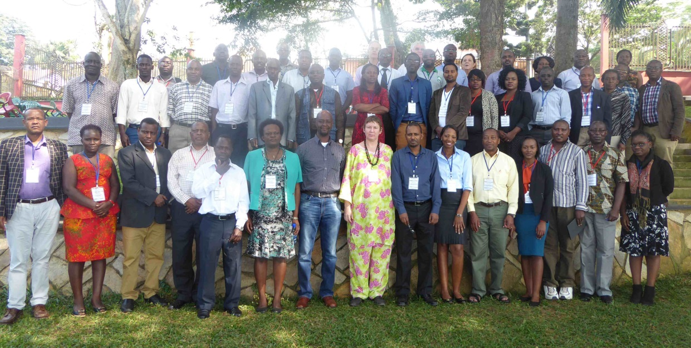

**Write-shop participants at the Imperial Botanical Beach Hotel, Entebbe, Uganda**

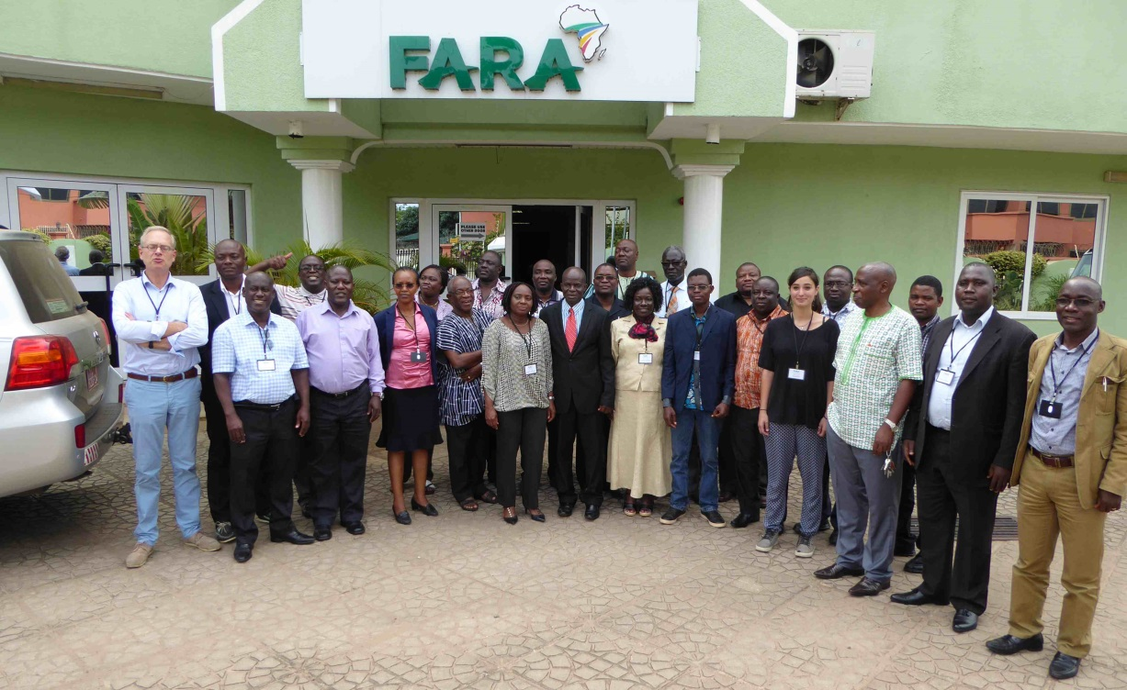

**Write-shop participants at Forum for Agricultural Research in Africa (FARA) Secretariat, Accra, Ghana**

**Table of contents**

**Executive summary 3**

**1. Context of the write-shops 4**

**1.1. Background 4**

**1.2. Objectives 5**

**1.3. Preparation of participants 5**

**1.4. Participants and consortia 6**

**1.5. Material 6**

**1.6. Location 6**

**2. Implementation of the write-shops 8**

**2.1. Programme 8**

**2.2. Introduction 9**

**2.3. Peer review of the Concept Notes**

**2.4. Presentations on the production of proposal development components 11**

**2.5. Production of the proposals 12**

**3. Evaluation of the write-shops 16**

**4. External review of proposals prior to the submission deadline 17**

**5. Particular findings 18**

**6. Conclusions 23**

**Annexes:**

**1. Workshop flyer − Proposal drafting workshop 25**

**2. Participants of the write-shops: Entebbe (11-15 July 2016) and**

**Accra (18-22 July 2016) 31**

**3. Presentation of ICRA on innovation system approach (Entebbe)**

**4. Presentation of AAIN on AAIN (Accra)**

**5. The project groups at work 32**

**6. Analytical overview of reviewed proposals**

**Attachments [1]:**

**1. Presentation ‘Project development, implementation and impacts - AURG Call 2016’**

**2. Photographs from the workshop**

**3. Analysis of AURG 2016 Call for Proposals**

**4. Definitions**

**5. Booklet excerpt of selected proposal AURG Phase 1**

**Executive summary**

RUFORUM (Regional Universities Forum for Capacity Building in Agriculture) in collaboration with FARA (Forum for Agricultural Research in Africa) organised in Entebbe (Uganda, 11-15 July 2016) and Accra (Ghana, 18-22 July 2016) ‘write-shops’ to finalise proposals for submission in the African Union Research Grant II (AURG) 2016 Call for Proposals (launch: 17 May 2016; submission deadline: 17 August 2016) which were facilitated by Gerard den Ouden. The Facilitator (Gerard den Ouden) was assisted by the PAEPARD Coordinator (Jonas Mugabe) and the Work Package Capacities Leader (Paul Nampala) to effectively implement the two write-shops. In Entebbe, 12 teams and in Accra 6 teams participated, coming from Central, Eastern, Southern and Western Africa. The size of teams was between 1 and 7 persons, totalling 68 participants (Entebbe 43, Accra 25), excluding RUFORUM staff (Entebbe 6, Accra 1). Other Research teams that were unable to attend the write-shop were supported virtually via email correspondences.

The Programme of the workshop was organised around group work, plenary presentations by the Facilitator, individual group support by the moderator and RUFORUM staff, and occasional plenary peer review sessions. No agenda was given beforehand, but the proposal development items were brought in depending on the pace of progress of the participants and needs perceived. The preparation prior to the workshops was meagre: only a few groups had prepared parts of the concept note, a concept note based on the PAEPARD template or had only a rough idea about a research topic. Attention was paid to aligning the research ideas with the Call requirements, to improving the contents of the application form, to assure the quality and completeness of information provided, to focus on the uniqueness of the proposal and its partnership, and above all, to producing a logical structure of the project to serve as a basis to populate the several parts of the application form as well as a structure for the project implementation itself. Several tools to assist in the completion of the application form were presented and these were highly appreciated.

The participants came to the workshop with the idea to concentrate on either improving the concept note on which they were already advancing and on getting information on how to improve the quality of their drafts , or to initiate drafting process. The analysis of the Call made them aware of the complexity of both the Call documentation and the eligibility requirements for the applicants and partners. As a result, they modified their initially prepared application drafts and partnerships accordingly.

The expectation discussed in the beginning of each week as to have the proposals fairly ready by the end of the week was not met, but progress was certainly made with specific reference to the technical structure of the proposal. The need to strongly focus on the Call requirements became clear, the partnership structures were reviewed, activities were ordered and described with more precise details, results were viewed with more emphasis on the Call requisites. The production of the administrative parts, which should have been done in parallel by colleagues at the home institutions, that could not attend the write-shop but involved as part of the Research Team, was apparently not initiated as they preferred to do this by themselves. Each team was tasked to follow this up and have this finalised as soon as possible.

The period of responding to this Call for Proposals was short, but with the information generated and the gaps in background information identified during the workshops, there was enough time to further prepare and populate the application form. The calendar of activities to be done – made by each research group – between the end of the workshop and the submission deadline was set up with enough space, but finalisation of proposals was concentrated on the last 2 weeks. An informal proposal review by the moderator and RUFORUM Staff was done on 15 proposals. Out of 23 proposals under preparation, 19 were formally submitted to the AU.

The attendants have certainly improved their skills in developing a research proposal. As part of the follow-up of the workshop, RUFORUM staff stimulated the proposal teams to assure the completeness and correctness of the application form for submission.

**1. Context of the write-shops**

**1.1. Background**

Gerard den Ouden was invited by RUFORUM (Regional Universities Forum for Capacity Building in Agriculture) to facilitate / moderate a ‘write-shop’ in Entebbe, Uganda (11-15 July 2016) and a similar one in Accra (Ghana, 18-22 July 2016) to draft proposals for submission in the African Union Research Grant II (AURG) 2016 Call for Proposals.

The African Union Commission (AUC) has launched Phase 2 of the African Union Research Grants programme (AURG) with an open call for proposals for Research and Innovation in Africa, supported by the European Union (EU) under the Pan-African Programme (PanAf): EUR 17.5 million for 2 calls for research proposals, in 2016 and 2017. Phase I was launched in 2012 and the proposals granted have been published in a booklet which was distributed during the workshops.

The 2016 Call supports the Africa’s Science Technology and Innovation Strategy-2024 (STISA 2024) which addresses the aspirations identified under the AU’s Agenda 2063 and Priority 3 (Human Development) of the EU-Africa Partnership. The Call supports research on Food & Nutrition Security and Sustainable Agriculture (FNSSA) with particular attention on Sustainable Intensification. The AURG provides the needed opportunity to use S&T as a tool for sustainable development, building and strengthening Africa’s S&T capacities.

The theme of the 2016 Call with an envelope of USD 9,000,000 is ‘Sustainable Agricultural Intensification’ with the following priority fields of research: Ecological intensification approaches; Research on animal and crop health, including fish; and Research on appropriate use of soil, water, land and inputs management practices.

The eligibility criteria of the partnership members, as well as the full evaluation criteria and other specificities of the Call are mentioned in Annex 1.

RUFORUM considered the Call appropriate for the PAEPARD consortia, especially since it provides for partnership arrangements that allows for multi-stakeholder engagement with user-led practitioners organisations. RUFORUM consulted and approached various persons from the PAEPARD network in various African countries. They should form (inter)national networks (project groups) amongst them and where possible draft a research proposal for the AURG Call. In order to assist the participants (Annex 2) of the write-shops in grasping the main focus of the Call, Gerard prepared a workshop flyer (Annex 1) which was forwarded by RUFORUM to the Entebbe workshop attendees in the week prior to the workshop, but not made available prior to write-shop to r the Accra attendees.

RUFORUM had organised these workshops in collaboration with FARA. RUFORUM has invited all the participants and paid for their travel, hotel, and meals, complemented by a daily allowance [2]. Logistical support (workshop venue, paper, flip-over charts, pens, markers, beamer, printer facilities, and internet access facilities) was provided by them. In Entebbe, assistance was provided by Paul Nampala, Michael Goobi, Anthony Egeru and Emmanuel Okalany from RUFORUM who took care of all kinds of logistical support and partner search. All RUFORUM staff also participated in the plenary sessions and in drafting/reviewing project proposals. In Accra, assistance was provided by Paul Nampala (RUFORUM) and Jonas Mugabe and Aimee Nyadanu (FARA).

**1.2. Objectives**

RUFORUM and FARA organised the write-shops which focussed on the submission of a research proposal within the African Union Research Grant II (AURG) 2016 Call for Proposals. (budget: USD 9,000,000; submission deadline: 31 August 2016 (see http://au.int/aurg).

The overall aim of the July 2016 workshops was to support project teams invited by RUFORUM and FARA and to enable them to (improve and) write research proposals focusing on the priority domains related to Sustainable Agricultural Intensification. The workshop would put attention on the funding requirements, as well as on the development of the project structure, the development and fine-tuning of the proposal sections, the compliance with the required contents of the application form, the eligibility of activities-partners-budget, project management, and the submission technicalities. These components would be addressed in individual group sessions, plenary sessions and in occasional peer review sessions (see Annex 1). At the end of the workshop, it was expected that each proposal should have a well-developed structure and likewise contents enabling them to easily complete the proposal template in the days hereafter in readiness to submit.

The workshops were held in English (Entebbe, 11 – 15 July, 2016) and French (Accra, 18 – 22 July 2016).

**1.3. Preparation of participants**

RUFORUM engaged its member universities and together with FARA also research organisations and practitioner organisations from the PAEPARD network to prepare for the Call soon after it was launched in mid-May 2016. In the beginning of July 2016 they formally invited all participants to come to the workshops.

In order to assist the participants (Annex 2) of the write-shops in grasping the main focus of the Call, Gerard prepared a workshop flyer (Annex 1) which was forwarded to the Entebbe workshop attendees by RUFORUM (FARA had omitted this for the Accra attendees). The expected preparation of the participants before the workshop was:

* Eligible Partnerships with team members of relevant disciplines and at least 3 team members per proposal..
* Thorough knowledge the Call documents.
* Thorough knowledge of other documents (relevant national, regional and international policies and initiatives in the country/-ies of action).
* Preparatory documents (‘Stakeholder analysis diagram’ and ‘Logical frameworks’ concentrated around the proposal).
* Project title and acronym.
* Fully completed Concept Note and a far as completed draft of the Full Application Form, electronically delivered to Paul Nampala prior to the workshops.
* Having secured own financial contribution to the project.
* Having a team ready at the institutions for working on administrative information.

It was foreseen that the groups would be at different stages of preparation, but all should have a good idea about their objectives, the consortium, who will be involved in the proposal, and a partly completed proposal draft.

Of all the above desired preparatory work, the partnership/consortium structure was prepared and the application forms were populated with some information (Entebbe) or not at all (Accra). A draft version of completed Grant Application Forms was not provided to RUFORUM prior to the workshop. During the introduction on Day 1 of the workshop, it became clear that participants had not internalised the Call for proposals documentation and had an unclear idea what the proposal as well as a complete set of needed documents should be looking like. Only a few draft concept notes were submitted to RUFORUM during the Entebbe workshop, but they were very poor of contents and not always using the official template of the Call. In the Accra workshop, all consortia provided FARA with an old PAEPARD template from years ago which were not at all on line with the official template of the Call.

**1.4. Participants and consortia**

Because of the late invitation, the exact number of participants and project proposals was unknown at the onset of the workshops. Although the majority of the participants arrived in the morning of the first day, a few would leave during the course of the week without notifying the organisers. Overall, a total of 68 people (excluding 6 and 1 RUFORUM staff in Entebbe and Accra respectively) were counted covering 12 proposals in Entebbe and 6 in Accra. The average number of participants per proposal varied between 1 and 7 persons. A list of participants is presented in Annex 2 and contains also the proposal title/topic to which they contributed.

Some groups still had to finalise the composition of the partnership, but they were confident that they would be able to do so at short notice. Additionally, some consortia engaged with the RUFORUM Secretariat using virtual means, particularly email. These groups were not invited to participate in the write-shop, but were fully engaged in writing and prepared to submit.

**1.5. Material**

During the first day, all participants received a folder with general information on the AURG Call (guidelines and application form). The organisers had arranged for paper, flip-over charts, pens, markers, beamer, and a printer. Gerard brought with him large wallpaper, highlighters, markers, cards, paper, glue, tape, computer and a camera. He also prepared (PowerPoint) presentations, handouts, various drawings and cards with information on the Call and on proposal development.

On Day 1, Day 2, Day 3 and Day 5, the participants were given the (PowerPoint) presentations and the wall cards (analysis overview of the Call and some definitions relevant to the Call) from Gerard which they received by e-mail from the organiser’s support staff.

An Internet access facility was installed allowing the participants to search for useful information for the proposals and to be in touch with their colleagues for additional project information.

**1.6. Location**

In Entebbe (Uganda), the workshop was held in the ‘Pearl Hall’ in the garden of the Imperial Botanical Beach Hotel where all the participants were also lodged. In Accra, the workshop was held at FARA and almost all the participants were lodged in the Airport View Hotel.

**2. Implementation of the write-shops**

**2.1. Programme**

The Programme was organised around plenary presentations, group work and individual group support, and occasional plenary peer review sessions. No agenda was given beforehand, but the proposal development items – presented in Annex 1 – were brought in depending on the pace of progress of the participants as well as on needs perceived in the following way:

Day 1:

* Opening (presentation participants, presentation RUFORUM / FARA)
* Introduction of the write-shop: presentation of participants, preparation and expectations
* Provision of and discussion on project titles (plenary)
* Presentation (PowerPoint) on writing a proposal for the AURG Call (plenary)
* Call analysis: background, objectives, eligibility, evaluation and submission mechanics (study and plenary)

Day 2:

* Recap of Day 1
* Presentation of AAIN on AAIN (Accra)
* Peer review of Concept Notes (plenary)
* Situation analysis, Needs assessment and Stakeholder analysis: introduction and production
* Presentation of ICRA on agricultural innovation systems (Entebbe)
* Peer review of Situation analysis, Needs assessment and Stakeholder analysis (plenary)
* Production of Problem trees
* Peer review of Problem trees (plenary)
* Review on adapted project titles (plenary)
* Research problem and Research questions: introduction and production (Entebbe)
* Peer review of Research problem and Research questions (plenary) (Entebbe)
* SWOT analysis of the partnership: introduction and production (Entebbe)
* Peer review of SWOT matrices (plenary) (Entebbe)

Day 3:

* Recap of Days 1 and 2, incl. work still to be done
* Research problem and Research questions: introduction and production (Accra)
* Peer review of Research problem and Research questions (plenary) (Accra)
* SWOT analysis of the partnership: introduction and production (Accra)
* Peer review of SWOT matrices (plenary) (Accra)
* Presentation on the Logical Framework and impact pathways (plenary) (Entebbe)
* Production of Logical Framework (group work) (Entebbe)
* Peer review of Logical Frameworks (plenary) (Entebbe)

Day 4:

* Production of Logical Framework (group work) (Entebbe)
* Peer review of Logical Frameworks (plenary) (Entebbe)
* Presentation on the Logical Framework’s Assumptions (plenary) (Entebbe)
* Review on adapted project titles (plenary)
* Presentation on the Logical Framework and impact pathways (plenary) (Accra)
* Production of Logical Framework (group work) (Accra)
* Peer review of Logical Frameworks (plenary) (Accra)
* Presentation on completion Budget worksheets (plenary) (Accra)
* Drafting of text for the application form

Day 5:

* Production of Logical Framework (group work) (Accra)
* Presentation on the Logical Framework’s Assumptions (plenary) (Accra)
* Peer review of Logical Frameworks (plenary) (Accra)
* Presentation on completion Budget worksheets (plenary) (Entebbe)
* Presentation on performance management: partnership, work packages, project management, risk management (plenary)
* Production of Risk management tables
* Peer review of Risk management tables (plenary)
* Continuation of drafting of text for the application form
* Review on adapted project titles (plenary)
* Preparation of calendar per group (tasks, responsibilities, dates) until submission date
* Evaluation
* Closure (RUFORUM / FARA)

In several occasions, a peer review moment was held. The peer review approach aims to help with analysing contextual issues and is useful for strengthening the proposal set-up and contents as well as presenting and defending pertinent arguments, both for the peered ones as well as for the peers. More groups wanted to present their preparation to all groups, but because of a lack of time this was, unfortunately, not possible.

In between the plenary sessions and presentations, Gerard continuously passed each project group to guide them through the process of the proposal preparation, to provide clarifications when required and to critically review their progress. RUFORUM staff was continuously involved in the proposal development and review in the various groups.

Although almost none of the groups had worked on the suggested preparatory documents (stakeholders diagram, logical framework), the attendees agreed on preparing these documents during the workshops as these are key to the project set-up and would provide the information needed to populate various sections in the application form. But they would also provide the basis for the implementation of the project in case of being selected. The other moments of the workshop would then have to focus on other important components (Research problem and Research questions, SWOT analysis of the partnership, Risk management, Budget) and the completion of the application form itself.

In the evenings, all groups were invited to work on the various proposal sections, the budget, logframe and other proposal parts. A daily evaluation on paper was done by RUFORUM, and a plenary evaluation of the workshop was held at the end.

**2.2. Introduction**

Paul Nampala (RUFORUM, Entebbe) and Jonas Mugabe (FARA, Accra) opened the workshops by welcoming everybody and stating the Goal of the workshop. A short presentation on RUFORUM and linkage to the Call for Proposals was given. Everybody was invited to introduce himself by stating his: Name, country, organisation and scientific discipline. The other RUFORUM staff presented themselves too: their role was to assist with logistical matters, partnership composition and in the drafting and reviewing of proposals, as well as guiding the respective teams to submit.

**Reflections on the write-shop**

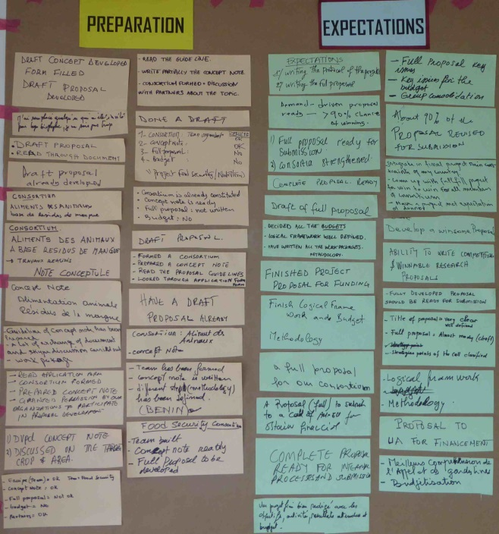The participants were asked to reflect on the following issues:

*What kind of preparations has taken place before this workshop?; What are you bringing into this workshop?*

*What are your expectations by the end of the week?*

Their answers were collected and put on the wall, followed by an analysis how to bridge the gap between the prepared inputs and expected outputs during the 5 days of the workshop. The attendees were confident in reaching the desired situation, but were aware of the limited time available during the workshops.

It was highlighted to the participants that in order to advance during the 5 days, a team back home at their institution should be ready to be fully engaged simultaneously and produce the administrative parts of the application form, whilst they could concentrate on the technical sections.

**Project titles and partnership composition**

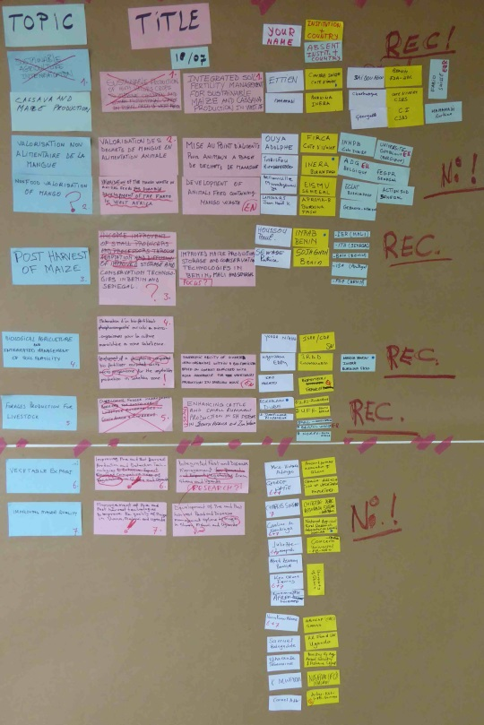The project titles were collected and briefly discussed. The titles of all proposals were reviewed and it became clear that these had to be modified in order to cover the contents of the proposals in a more catchy and clear manner. For example, it is not needed to include the objectives of the proposal. As a result and of intensive discussions, all titles were adapted during the week and even hereafter.

Next to the title cards, the names of the partnering institutions and contact person (present and absent) allowed to verify the eligibility of the partnership. Some teams still had to complete their partnership during the workshop. Because of eligibility criteria, the partnerships was adapted, including the number of partners per partnership.

The final draft project titles and names of the persons involved are presented in Annex 2.

**Presentation on ‘Project development, implementation and tracking of outcomes - AURG Call 2016’**

Gerard gave a (PowerPoint) presentation on how to write and finalise a proposal, focused on the understanding of the background of the AURG and the requirement of the 2016 Call for Proposals. The session was experienced as very useful.

**Call analysis**

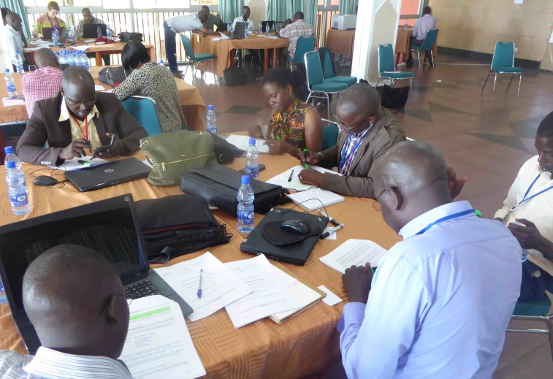On the basis of the Call for proposals guidelines, part of the documentation set of the Call for Proposals, the participants were invited to mark with a green highlighter what they reckoned as objectives and expected activities. Hereafter, in a plenary session Gerard presented these with already prepared cards with the important issues and presented these on the wall (problems, objectives, conditions, definitions). As a result, the structure of the Call was made visual and synoptic at a glance.

It became evident that almost none of the participants had read this document before they arrived at the workshops. Many relevant questions were raised principally with respect to goal-setting, partnership requirements, funding scenario’s, eligibility and evaluation procedures. The session resulted in an improved understanding of the Call for proposals and even in modification of proposal topics and parts of various teams in order to meet the requirements of the funder. In the case of Accra, complete new proposals had to be developed as their initial Concept Note was completely out of the focus of the Call. This also occurred with one group in Entebbe. The group of the University of Ghana even decided not to develop two, but only one proposal because of a partnership eligibility conflict. The session was experienced as very useful.

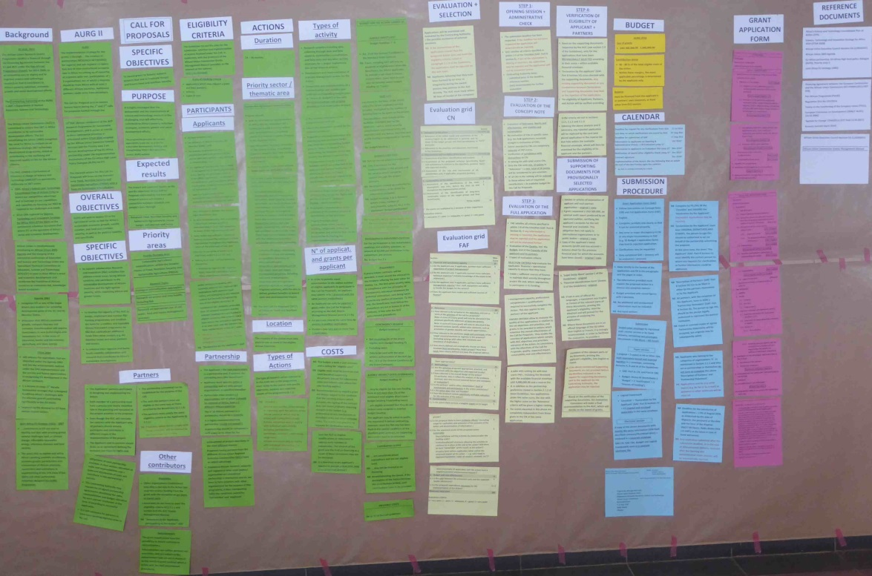

*Analysis of the Call for Proposals*

**2.3. Peer review of the Concept Notes**

All groups were given the possibility to review the concept notes of other groups and complete an evaluation grid provided by Gerard. A few teams had prepared a Concept Note, but without a Logframe. Because the quality of all these Concept Notes in Entebbe was weak, it was decided to use only one version although this was targeted on another Call for proposals. Because in Accra the Concept Notes did not follow the structure of the official template or the research focus of the Call, a total of 3 Concept Notes was reviewed. The reason to do it this way was to have the participants concentrate on the evaluation criteria and to use these to criticise a proposal.

In Entebbe in a plenary session, all groups presented their findings on the selected proposal and the peer groups could add an extra element or disagree with the comments made. The peered group was not allowed to give comments on the review, but was invited afterwards to react on the review comments. As the representative of this group was not involved in the drafting of that proposal, he would forward the comments to the main author (Makerere University). In Accra, only 2 out of the 3 concept notes received a plenary peer review as the review comments were similar and very meagre.

This session was more or less appreciated, but the poor quality or wrong templates used did not allow for a thorough and sufficient learning exercise. However, the review possibilities enabled the participants to more critically draft their own concept notes.

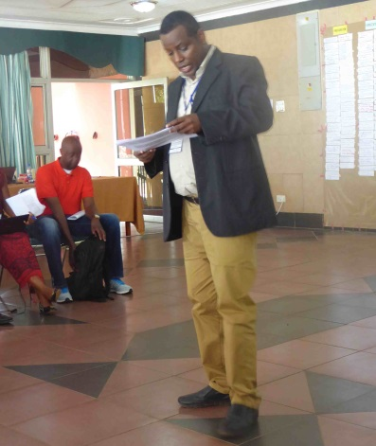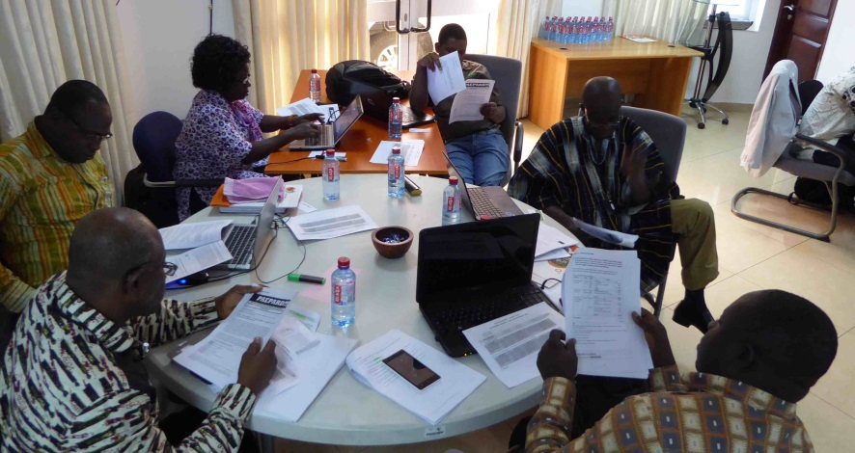

**2.4. Presentations on the production of proposal development components**

At various intervals during the week, presentations of limited length were given by Gerard (see section 2.1) These presentations enabled the participants to focus in sufficient detail on the topics presented which would help them in understanding their importance to project development and their relevance to their proposal, but also in drafting, modifying and extending their text parts, as well as in understanding their value in both the proposal preparation and project execution stages. They were presented as a (PowerPoint) presentation and/or on flip-over charts or cards on the wall (see attachments 1-4). These presentations raised many lively discussions and were considered as very instructive and useful. Copies of these presentations were requested frequently and handed over to RUFORUM for distribution by e-mail to the attendees at a daily level. Some participants have asked for more of these presentations, but because of a lack of time this was not possible. Although several participants have attended such workshops in other occasions, they welcomed the ‘refreshment’ and better understood the necessities of these.

**2.5. Production of proposals**

**Situation analysis, Needs assessment and Stakeholder analysis**

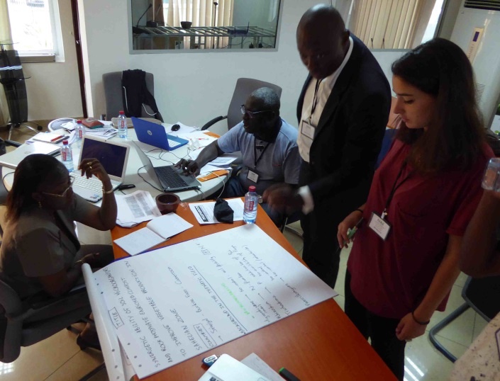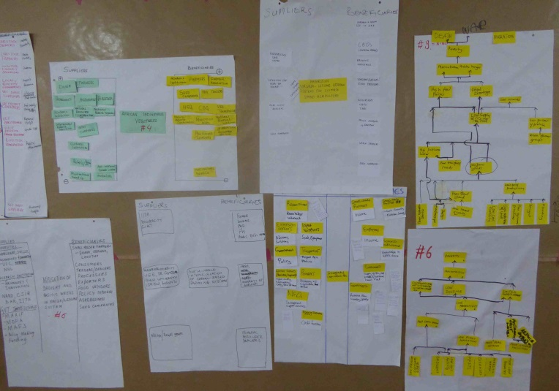After an introduction of the analysis of the current situation around the topic of the proposal, of the needs of the beneficiaries of the project and of stakeholders who are involved in the project theme, each group prepared these analyses on flip-over charts or on the computer. The visualisation of these topics helped the participants in getting an overview of the foundations of the proposal which would help them in populating and adapting various sections of the application form. The produced information was quickly transferred in electronic files. A peer review took place at several groups whereby several shortcomings in the schemes were mentioned. The details in the schemes, however, were of a restricted level and often incomplete. The necessity of these tools was understood, but the level of details needed more research back home. They were aware that the stakeholder landscape around the project theme is not well known by them, nor are their constraints, needs and influences.

**Problem tree**

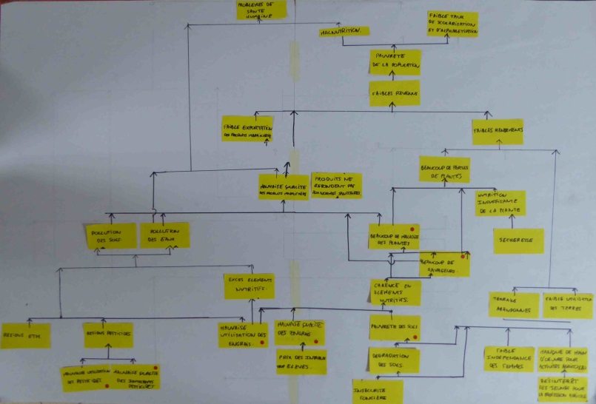All groups prepared their Problem trees. The workshop required a lot of discussion time among the group members on what problems do exist around the project theme. All groups started from scratch. It also took some time before all of them understood how the trees need to be built up, how problems need to be formulated, how problems interrelate, which problems were missing, and how the trees need to be analysed, but once the concept became clear, they appreciated the newly acquired knowledge. They were aware that many problems have not yet been identified, which is certainly related to the fact that they do not know all the stakeholders involved around the project theme and their constraints/needs. In all teams, the identified problems were also of a (too) general nature and a lack of detailed knowledge on the project environment became apparent.

The groups varied their approach of completing the trees. Gerard constantly approached all groups and assisted in the development process as well as in the development of contents. In the middle of the weeks, all trees were finished based on the inputs of the attendees.

**Research problem and questions**

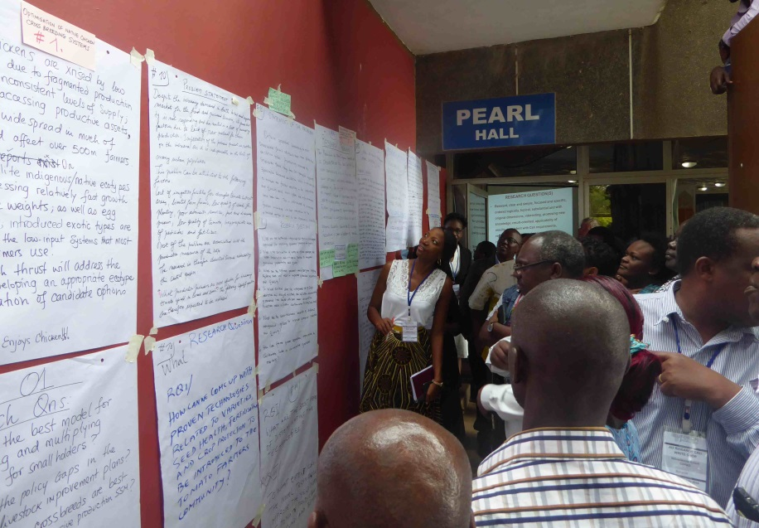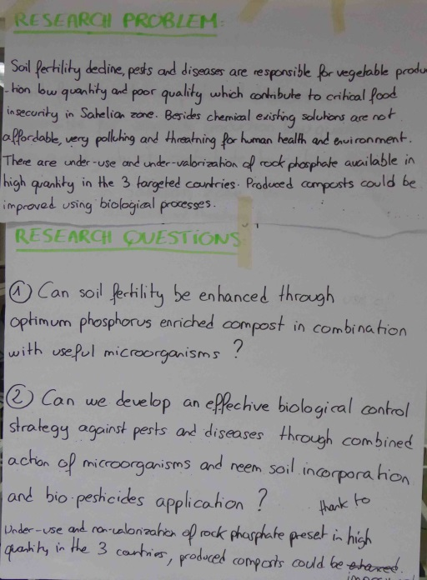All groups prepared their Research problem and research questions which could easily be unravelled from the problem tree. This, however, appeared not to be as easy as it is supposed to be. Sometimes, a research problem was not formulated as a problem, but as a statement. In other cases, the problem was formulated far too general and lacked a focus. This is first of all related to the inadequate detail level of the problem trees and the choice of focus on problem areas being too wide. These observations confirm the above-mentioned lack of knowledge on the stakeholder and project theme environment. Also, the questions were not formulated as research questions or specific enough. One could even get the impression that the attendees were lacking the conceptual skills of mounting a research project. The discussions were very lively among the team members

All groups had to rework on the research problem and questions. Various attempts were needed, but a final phrasing was not achieved and kept for back home.

The peer review sessions were also very lively and especially in Entebbe, all groups insisted on peering and being peered as they found the discussions extremely helpful in properly focusing their research ideas.

**SWOT analysis of the partnership**

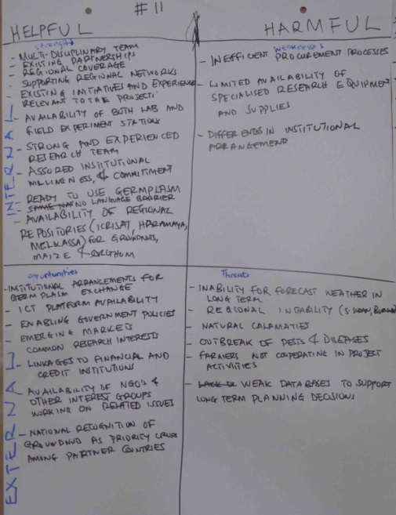The SWOT analysis philosophy was introduced and its relevance within the proposal. It was chosen to produce a SWOT table on the partnership as to understand the internal and external forces that (can) influence the construction of the partnership and the implementation of the project. This would help in describing not only the relevance and quality of the partnership but also of the proposal itself. All groups prepared their SWOT table(s) and performed a more or less critical analysis of the contents.

The groups were keen on showing their SWOT data to others in an internal peer session. In Accra, not all groups could present their table due to a lack of time.

All groups had problems in drafting the diagram, both in completing the correct cells and the type of contents required. Gerard constantly approached all groups and assisted in the development process as well as in the development and review of contents. Once the concept became clear, the participants became aware of the presentation and contents requirements. They would further develop the scheme back home in order to be sure that all items are mentioned and also presented in the application form.

**Logframe**

The necessity and way of completing the Logical Framework (Logframe) was introduced. Although found very interesting and useful, it took considerable time before all of the participants understood the logicality and value of this tool, how a logframe needs to be built up, the level and completeness of detail, and how the cards / items need to be presented. But once the concept became clear, they appreciated the (newly) acquired knowledge.

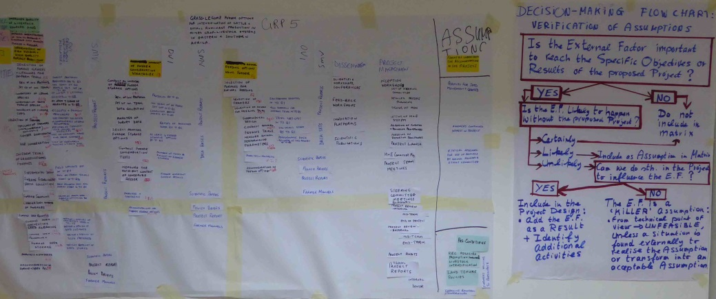

The groups varied their approach of completing the logframes. The majority preferred to work with large sheets of paper, whereas some groups preferred to directly produce these charts in MS Excel, whereby one group afterwards transferred these onto flip over charts.

A peer review was done on several logframes. Every group was keen on showing their logframes, but the level of completion was often not enough for an adequate peer review and time was just too limited to discuss all of them. The discussions though were very lively with many relevant and interesting queries raised as well as suggestions provided. It was observed that research was not always dominant (enough) in some proposals or that the research set-up lacked a sound structure or uniqueness.

Although some participants had already worked on logframes in previous workshops, it was clear that the knowledge acquired was somehow ‘forgotten’, maybe because this knowledge is not applied in-between the workshops (?). All agreed that the matrix had to be completed back home and assured that the information would be fully used in the application form.

**Partnership diagram and Flow chart of work packages**

In order to assist the groups in getting a clear overview of their partnership structure and the role of each herein, the design of an illustration of how this partnership looks like was introduced. Also introduced was the concept of preparing a visual overview of the relation of work packages and their corresponding activities. There was, however, no time to produce this during the workshops, but it was recognised as an important tool to improve and complete the text parts of the proposal with cross-references as well as getting a complete overview of the project components and their interrelationship ‘at a glance’. Especially the flowchart of work packages, i.e. the main activities from the logframe, should/could be used as an illustration in Section 1.5 of the Full Application Form to assist in linking with Section 1.4.

**Production of administrative information at home institutions**

On Day 4, the status quo was checked in the production of the technical and administrative sections of the proposal. The participants were reluctant in giving satisfactory information on the administrative sections, out of which could be concluded that not a lot of work was done back home for a multitude of reasons. These could, among others, be: administrative staff was not (well) prepared by the proposal drafters in the week prior to the workshop; no commitment from the department’s management was arranged to have them preparing the required information; the administrative staff was not well instructed and supervised; there was no engagement of the administrative staff; the proposal drafters had no or only limited mandate to get the people back home delivering the required input to the different sections of the proposal. But more likely was that the proposal drafters wanted to complete these sections themselves.

**Calendar and budgeting**

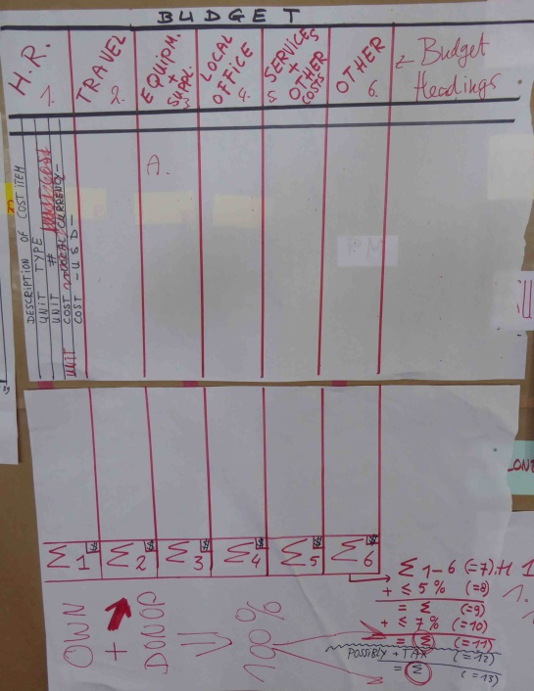Explanations were given as how to set up a calendar of activities and related budgetary means, and how these relate to the log frame. One could choose for a Gantt chart approach or simply use MS Excel worksheets. There was, however, no time to produce this during the workshops.

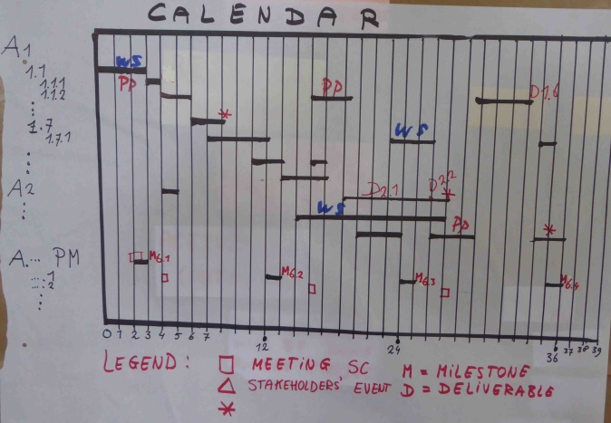

Long and interesting discussions were held as to how to complete the worksheets, the meaning of the various cost items in the template, the calculation of cost items, the currency to be used, the difference between donor and own contribution, the level of detail of cost items, the allocation of tasks and related costs to partners, the difficulties in getting data from partners, the justification of cost items, etc., but also the way how to manage the budget in case of being granted (contractual requirements, reporting, budget modifications…). Many questions were raised and discussed, but at a certain moment these had to be stopped because of limited time left for the other workshop sessions. It became clear that preparing a budget was not something the majority of the attendees is familiar with.

**Risk management**

The issue of risk identification and management was introduced, an item which also has to be presented in Section 1.7 of the Full Application Form. This session was very much appreciated and new to many attendees. Although several projects were of the opinion that their projects did not have any risks at all, a relation was made with the assumptions in the log frame and the threats in the SWOT diagram, and extrapolated to real situations during project execution. This explanation was necessary as to underpin the importance of understanding the project environment as well as of risk management being an integral part of project management. Risks cannot be underestimated and should be embedded in the daily activities of the projects and monitored by all project partners.

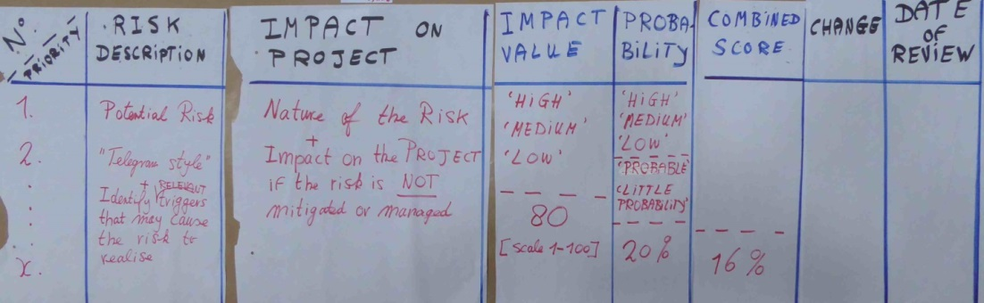

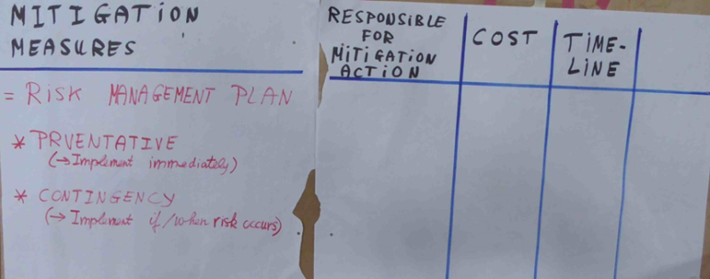

All groups prepared a matrix, but were unable to finalise these during the workshops due to a lack of time. A peer review was held on a couple of them and this was enough to understand the type of contents needed.

**Drafting of parts of the application form**

As of Day 3 various groups were intensively engaged in drafting parts of the application form. This was done directly in a downloaded version of the proposal template. Attention was given to drafting both the technical and administrative parts, but especially the technical part. Ideally, the administrative parts should be completed simultaneously by their colleagues back home or after the workshop when this was not the case. As stated before, the time pressure on getting the application form fully completed with the obligatory information withheld several groups of dedicatedly working on additional information as charts and diagrams which could be used to improve the writing and presentation of the technical part of the proposal.

**Queries to the helpdesk at AURG**

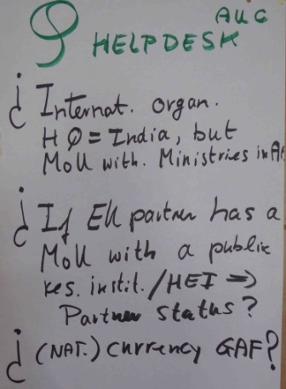Queries were already raised to the AURG helpdesk prior to the meeting by the facilitator and extended with those generated during the workshop. AURG normally reacted within a couple of hours. These concerned the eligibility of institutions and the currency to be used. Answers were provided to the participants electronically.

Organisations as ICRISAT are regarded as eligible as network members are present in eligible African countries. Although some European universities have only a MoU with a research organisation in an eligible African partner and are hence not eligible – as a MoU needs to be made at the level of government or ministry – some teams might still present themselves as a full partner (and not as an associate where these eligibility criteria are absent).

If one studies the type of participants who were selected in the AURG’s 2012 Call for proposals, one gets the impression that the criterion of locally registered or having a MoU with a ministry/government is not applied by the letter. This may possibly be due to the fact that the evaluation committee and the AUC have been tolerant in the selection because of some specific reasons. This does not mean that they will have a same 'mood' this time. So, the interested parties are invited to play safe as discussed during the workshop.

**Summary of deliverables**

At the end of the week, all groups had certainly advanced in completing proposal tools and several parts of the application form, but the degree of advancement could not well be gauged. It was not possible to hold an inventory of the ‘outputs’ at the end of the week as several participants had already left the workshop during the last days or they were still too busy with collecting and generating data for the application form.

In the beginning as well as at the end of the workshops, the participants had mentioned their willingness to finish all proposal parts back home. All groups have stated their confidence in being able to continue with the drafting of the full proposal in the template and to submit their proposals by the submission deadline of 17 August 2016. This includes the annexes of the proposals with the necessary signatures.

**To-do-list**

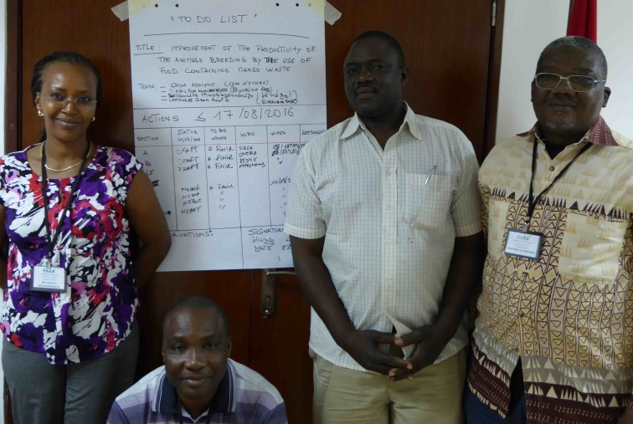In the beginning of Day 5 in Accra, a ‘to do’ list on flip-over charts was produced where each group was asked to write down the actions to be taken before the deadline of 17 August 2016 (information on what to do, by whom and by when). Because of a lack of time and various people having left already, this exercise was not performed in Entebbe.

It was suggested and accepted to introduce up to two rounds of a preliminary review by RUFORUM and the facilitator, but not in the last week before the submission deadline as time would be too short for the proposers to make possible modifications. The reviewers promised to reply within one or two days depending on the number of proposals received on a particular day. Teams would then be able to submit on time, i.e. before the submission deadline.

**Information on upcoming Calls for proposals**

In Entebbe Emmanuel Okalany presented an overview of upcoming calls

* UK - DFID’s Strategic Partnerships for Higher Education Innovation and Reform (Upcoming Calls to be announced soon).
* South Africa - SANBio BioFISA II Programme Seed Projects (Deadline 31 August 2016).
* Finland - Ministry of Foreign Affairs HEI–CI (Deadline 4 October 2016).
* Netherlands - Food & Business Applied Research Fund, ARF (Deadline 6 December 2016).
* EU - Intra Africa Academic Mobility 2016; Erasmus+ (to be released ….).

In Accra, Jonas Mugabe mentioned an upcoming Call from the German Federal Office for Agriculture and Nutrition (BLE):

* The German Ministry for Food and Agriculture (BMEL) promotes the development of Research Cooperation for Food Security with agricultural research institutions in partner countries and in Germany. The BMEL-Call for proposals: "Innovative approaches to process local food in Sub-Saharan Africa and Southeast Asia which contribute to improved nutrition, as well as qualitative and quantitative reduction of losses" was launched on the beginning of August and closes on 1 December 2016. In case of sufficient interest, FARA will consider the organisation of a special write-shop in Accra.

**Closure**

The workshops were closed by Paul Nampala (Entebbe) and Jonas Mugabe (Accra). Emphasis was put on the learning aspects and the good atmosphere among partnership members, but also on the obligation to finalise the drafting of the proposals and to submit on time. Those who are interested to have their final drafts screened by RUFORUM and the facilitator were encouraged to make use of this option.

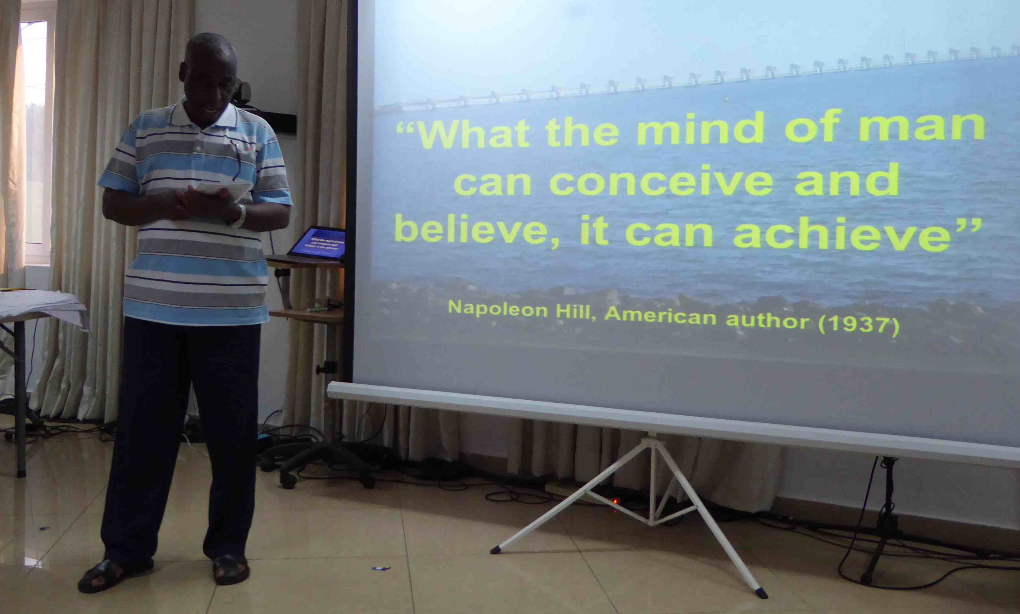

**3. Evaluation of the write-shops**

At the end of every day in Entebbe, the RUFORUM staff and the moderator gathered together to debrief on the day. Issues discussed were the reactions of the participants (positive and negative), the progress made by each group, the questions raised to and replies received from the helpdesk of AURG, queries and concerns from the participants, things which went wrong or good during the day, and items to be improved for the remainder of the workshop.

RUFORUM had also distributed a questionnaire to be completed every day and to be handed over to them before the end of each day.

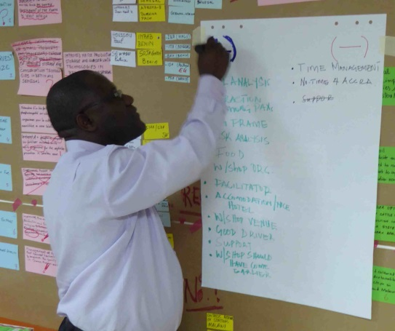At the end of each workshop, a plenary evaluation was held with the participants who were still present. Both positive and negative comments were received and these concerned the logistical arrangements, the contents of the workshops and the technical support provided by both RUFORUM and FARA and the facilitator. The information will be used as feedback for the organisation of future workshops.

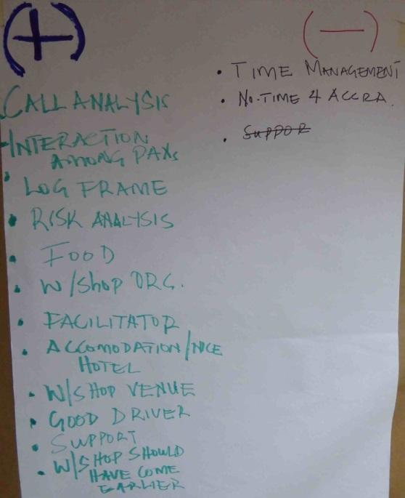

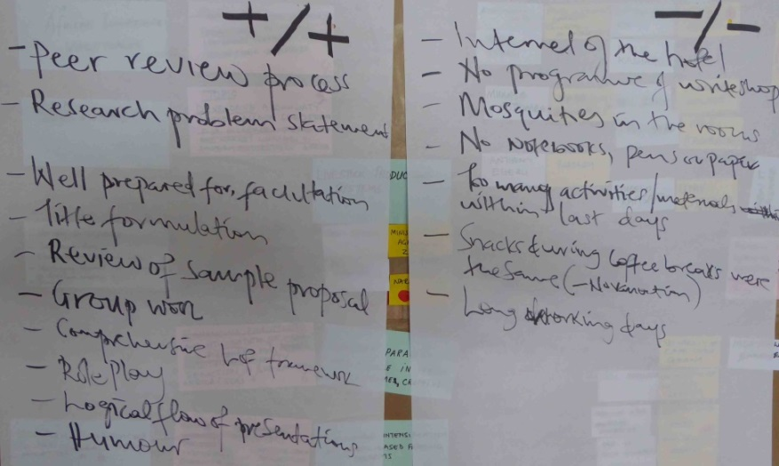

*Entebbe Accra*

**4. External review of proposals prior to the submission deadline**

After the workshop and prior to the submission deadline, some well-developed proposals could be sent to outsiders – the facilitator and the workshop organisers for a so-called ‘screening support’ before the formal submission - for an independent review. 15 groups have used this opportunity and have submitted their final complete/incomplete draft to the facilitator (sometimes more than once) who provided his feedback within a couple of days (see Annex 6). As many groups were very late with submitting their drafts for review, the by the AU extended deadline until 31 August was well appreciated. This allowed more drafts to be screened.

Some research teams submitted a first draft of their proposals in the first week of August which only consisted of a completed Part A (Concept Note). Proposals which were submitted hereafter had also completed other parts of the application form. The following observations can be made with respect to the quality of the Concept Notes:

* The majority of the Concept Notes showed a lack of understanding how to complete the concept note taking into account the fact that the instructions were simply not followed (correctly).
* The scope of research proposed does not always or totally match the call requirements as a lot of attention was paid to post-harvest technologies and the value chain approach.
* There is a lack of knowledge on building a sound research project as many proposals are more ‘development oriented’ and the methods to be applied are often of a non-research nature.
* The problem analysis is clearly un(der)developed where stated problems are very general and not specific at all and whereby the ‘problem holders’ are not known nor analysed other than using superficial qualifications as ‘poor small-holder farmers in sub-Saharan Africa’.
* The stakeholders in the surroundings of the proposed research projects have not been (critically) analysed, but appear to have been ignored. This is also showing a lack of understanding who the actors in the field are with whom the project has to interact if the project wants to be executed successfully.
* The concept of research problem and research questions has been omitted in the problem analysis and therefore, a guidance mechanism for the research project is absent.
* Too little use of (relevant) reference sources to underpin statements.
* The feasibility remains a point of concern as many proposals promise a lot of improvements in agricultural productivity after only 3 years and with a modest project budget. This is partly due to an underestimated sense of reality and a probable limited experience in conducting research projects.
* The logical framework has been incorrectly completed and this hinders the construction and understanding of the project.

Overall, the quality of Concept Notes was (very) weak, because they are not responding to all queries and remain very generic in all aspects. Apparently no information on the target groups and needs and constraints is available or known; a research-oriented set-up is not recognisable, i.e. they appear to be theoretical proposals not based on well-defined justifications and questions nor contain new or innovative aspects; the built-up of the project is weak and incomplete.

Such draft Concept Notes (including the Research problems and questions, the Logframe) serve as good test cases for a peer review at the end of a workshop. It is, therefore, recommendable to reach such a drafting stage on Day 5 of a next write-shop which would require a modification to the architecture of these workshops.

With respect to the completion of Part B (Full Application Form), some critical comments which were shared with the proposal authors were:

* Incomplete sections; sections not fully responding to the questions.
* Unclear phrases; phrases sometimes too long and too general.
* Lack of sufficient emphasising of certain arguments.
* Lack of detailed explanations.
* Insufficient explanation on the need for research and based on what type of problems to be solved.
* Regular repetitions of similar text between Concept Note and Full Application Form.
* Inconsistent use of terminology.
* Unbalanced explanation of the role of each partner.
* Too little examples given of (sub)activities or relevant reference material.
* Insufficient details on the geographical areas where the project will work.
* Lack of structure in the sections 1.4 and 1.5.
* Weak and often incorrectly completed Logframe.
* Insufficient understanding of Preconditions, Assumptions and Risks.

Overall, the quality of the Full Application Form was (very) weak, because they are not responding to all queries and remain very generic in all aspects. Apparently a logical and full built-up of the project is not recognisable, i.e. they appear to be a set of activities not based on a logical structure. Management issues were often not described and when they were, they weak and incomplete.

The Logical framework as well as the Budget worksheet was in all cases incorrectly completed. A full overview of type of shortcomings has been presented in Annex 6.

Half of the reviewed proposals were recommended to revisit their project completely.

**5. Particular findings**

**Preparation towards the write-shop**

The input of the participating groups at the onset of the workshop varied with a very few having already completed some parts of the application form and others nothing at all or presenting an old PAEPARD proposal on another template. In brief, each group presented a proposal which was not yet worked out properly and hardly related to the Call.

The instructions from the workshop flyer (Annex 1) were apparently not followed. Preparatory documents had not been produced. The knowledge on the Call was limited, as was the knowledge on existing policies and relevant initiatives. Overall, the preparation for the write-shop by the participants was of a mixed though limited nature.

**Team composition**

The size of the teams varied from 1 to 7 persons. The one group with only 1 member could do nothing else than working on the computer to concentrate on the drafting of proposal parts and occasionally some diagrams and tables: it was clearly missing sparring partners to critically discuss the proposal set-up and contents. The other groups were active in the development of the proposal by sharing tasks, having discussions or working on illustrations. However, the groups with 2-3 members although active were missing sparring partners too to improve their argumentation and collect more information. Groups with many members had sometimes problems with keeping everybody fully active.

An observation has to be made here that the proposal teams who sent only 1 or 2 delegates to join the workshop might have underestimated the efforts it take to complete the application form and to understand the Call itself, including the submission requirements. A good proposal preparation can only be done with liberating enough staff members to join the workshop to work on technical matters and others to stay at their home institutions to focus on administrative information.

The size of groups hindered a balanced attention from the facilitator towards each group. All groups were frequently visited, but a lot of support could not be given to the one-person group because it could not show a lot of materials and progress, because its attention was primarily on populating (administrative) text parts on the computer.

**Logistical arrangements**

The local organisers in Entebbe had arranged for the Imperial Botanical Beach Hotel. This hotel was located in the vicinity of the international airport of Uganda and in a quiet area with a view over Lake Victoria. All participants stayed in the hotel.

The conference room in Entebbe was very well located in the garden of the hotel, away from hotel guests and with an entrance to a quiet part of the garden. It had ample space, fresh air, enough windows and enough walls and other spaces to show presentation material and produced proposal parts. Use was made of the Pearl Hall and the room beneath. Although the number of participants was high, all preferred to stay in the ‘crowded’ Pearl Hall and a few used the other room occasionally.

The breaks were well prepared with good quality food and drinks. Limitations were: limited drinking water at the tables.

The printing facilities in the workshop were good.

The Internet connectivity was very poor. Although the hotel had not charged for Internet services, the system needs technical improvements and this was discussed with the hotel management. RUFORUM arranged for additional routers to let everybody access the Internet.

There were too little extension cables in the hall; it was also easy to stumble over cables.

In Accra, the participants were lodged at the Airport View Hotel and brought by a bus from FARA to the FARA headquarters where the meeting room was used. The space was just spacy enough to accommodate all participants. The breaks were very well organised. The printing was done by Aimee; internet operated normally; and there were enough extension cables.

**Time management**

Although the days were supposed to start at 08:30h, this was never the case in Entebbe. The first day experienced a ‘classical’ opening with people arriving hours later. Every day, only a very few arrived on time, whilst others walked into the hall at times when it was found convenient to them. At 18:00, the days were closed, but some groups kept working in the conference room. Each day they were encouraged to continue working in the hotel (room) on parts of the proposal in the evening hours. It is unknown if this opportunity has been used. Because in Accra, the participants were brought from the hotel and taken back, all days started at 08:00h and finished around 19:00h.

Although some participants mentioned their concerns about the long working days, this should be seen in relation to their preparation towards the workshop, the complexity of the Call and the produced output at the end. Certainly, advancements were made with drafting of the proposal sections, but not as much as one would have hoped for. This can only be explained to:

* Insufficient study of the Call documents,
* Underestimation of the complexity of the Call.
* Limited availability of time in drafting a proposal prior to the workshop,
* Some groups having too few delegated members (less than 3).
* Late start in the mornings.
* Insufficient collaboration from their colleagues at the home institution to prepare the administrative information.
* Limited knowledge of preparing and analysing SWOTs, logframe, …
* Insufficient knowledge on developing a fully-fledged research project.
* Limited knowledge of mounting a proposal structure with a logical set of project activities.

On the other hand, the information produced and shared during group discussions could easily be moulded into text parts of the application form.

**Workshop methodology**

The components of the workshop: introduction, (PowerPoint) presentations, Call analysis, peer review moments, frequent topical presentations, production of proposal development tools, guidance at group level, and follow-up support were well appreciated. The way how to interpret these components and produce the proposal parts was well appreciated by the participants.

The workshop focused on the technical part of the proposal. However, the introduction of the logframe, one of the basic components which forms the heart of the proposal, was very much appreciated by the groups once they started working on it. The groups which consisted of one member could, unfortunately, not experience this exercise satisfactorily nor the other exercises where other building blocks of the proposals were made. Instead, it has seen the work of other groups who did so and said it would try to work on it back home. Providing relevant information in the various sub-sections of Part A and B should be done by simply responding to the guidance notes, but should also be expanded with the other recommended suggestions provided in the call for proposals’ guidelines which have been presented on the wall. This item was stressed in several occasions.

**Attitude of the participants**

The participants were very eager to learn from the information provided and were very engaged throughout the workshop days. In Accra, the participants claimed a sort of certificate of the workshop because of its high instructive value. This was not part of the original arrangements and RUFORUM and FARA promised to follow up on this request and provide feedback to participants.

The atmosphere was informal with often people walking out of the room and having communications through their cellular phones or laptops.

Time management at the tables was interpreted by each group in its own way. Though they knew they had to deliver a ‘product’ in the form of a more or less advanced proposal text by the end of the week, they started late every day or had moments of less intensity, but many groups succeeded in going home with a sort of developed technical part of the proposal.

Some people who left during the workshop told that they had other commitments to fulfil back home. From others who also left early, no reason could be retrieved as they left without saying goodbye.

**Review of proposals during and after the workshop**

During the workshop, the participants expressed their eagerness to receive an independent review from the facilitator and RUFORUM before the proposals would be formally submitted to the donor. During the workshop week, RUFORUM staff occasionally reviewed proposal parts.

15 out of the 23 proposals were submitted to the facilitator for a review, all of which received a reply within a couple of days. Apparently, many groups had to spend more time than envisaged to prepare their application and, hence, saw no time anymore to have these reviewed by RUFORUM or the facilitator. The majority of the proposals were received very close to the with two weeks extended deadline. This may prove the fact that more time was needed to populate both administrative and technical parts of the proposal than initially thought.

**Understanding of the Call**

Each Donor and each Call for proposals has a specific focus and a specific language with specific jargon and eligibility and submission criteria. It is of utmost importance to grab these items and distinguish these with own perceptions and project ideas. This appears to be quite challenging for all the workshop participants.

As an example, the SWOT analysis appeared to be a real brainteaser. This is partly due to the limitations of knowledge of this tool as well as a lack of knowledge of the institutional and other relevant policy and regional plans.

The multidisciplinarity in expertise present at the workshop was limited as was the presence of ladies during the workshop (20%).

Because of the complexity of the structure of the Call documentation, it was seen as a necessity to put sufficient attention on the production of preparatory documents, such as problem analysis, research queries and a fully-fledged logical framework. The production of the Research Problem and Questions and the Logframe was considered as very useful. Other illustrative documents such as the partnership diagram and the flowchart of activities were also needed to understand the project set-up and an easy and quick comparison with the Call requirements and objectives, but there was no time to produce these tools.

The multitude of documents needed (sometimes with signatures) to accompany the application form was carefully explained and the time needed to complete and collect these from the several partners was emphasised.

Ample time was reserved to explain budgetary issues and the submission mechanism. In particular the discussions on the Budget were detailed, but not long enough to tackle all queries.

**Quality of the proposals**

All of the above concerns will have a strong effect on the success rate of the proposals submitted.

The production of some illustrations has proven to be very helpful in visualising certain project components as well as in understanding and describing certain sections of the proposals.

Whilst analysing the partnerships proposed, it became clear that some groups needed to revisit the eligibility criteria of some European partners.

It was surprising to perceive the weakly developed proposals during the review stage taking into consideration the learned components from the write-shop. Because this is the first time in the write-shop series held so far that the majority of the proposal teams have submitted their draft for review, a good impression could be obtained about the state of progress and overall quality. One might get the impression that participants continued to populating the application form in their own ‘classical’ way not taking (enough) on board the (newly) acquired knowledge. Or maybe the time input was too little to produce a well-developed draft or the agreed time input by the participants was not realised due to other commitments at the home institutions. Where the input-output of the write-shop week was seen as a critical factor in workshop achievements, similarly the workshop output – proposal input has become a concern too.

**Overall Facilitators Assessment**

This workshop has proven to be encouraging to the participants with respect to thinking about a project and developing relevant and quality components for a proposal. Some of them even mentioned that several techniques applied during the workshop will also be introduced by them in their own teaching environment.

In relation with all the comments made above, the concept of defining and understanding the interaction with target groups, beneficiaries and suppliers, and focusing on relevant results and impacts, as well as the concept of mounting a proposal – either starting from scratch or hooking up on an existent idea – can in general be characterised as underdeveloped by the workshop participants. Although research is seen as a daily business, the knowledge about and application of the full chain of events (from needs assessment to societal impact) is perceived as an ‘uncultivated’ or only partly ‘cultivated’ domain.

**Submission of proposals**

Of the 23 proposals that were prepared, 19 were formally submitted. Reasons for the 4 proposals that were not submitted are:

***Intensification of soybean production in Western and Eastern Africa*** – At the very last stage of submitting the proposal the coordinator INRAB (Benin) withdrew because it preferred the submission of another proposal with INRAB as coordinator. The persons involved in the proposal, including the foreseen project leader, were very surprised of this decision and frustrated as well. The reasoning behind this decision is that if more than one proposal with the same coordinators passes through the final evaluation step, only one of these could then be awarded a grant (evaluation criterion). However, an organisation is free to submit more than one proposal in which it is the coordinating institution as long as it consists of a partnership with other partners. INRAB may have interpreted the rule that only one applicant can submit ‘one proposal with the same consortium’ in such a way as to feel more at its ease with only submitting one proposal with them acting as the coordinator. Attempts to replace the co-ordinating rome by INRAB from Togo failed as time was too short. The disappointed consortium has as such missed the opportunity to receive the evaluation outcomes and even a grant possibility. But they should now prepare for the next round of the AURG Call, probably in 2017, with a focus on Food and Nutrition Security which may be a call more suitable to all partners.

***Developing farmer led and commercial viable innovations to boost tomato production in Burundi and Benin*** – INERA (Burkina Faso) declined to lead the proposal, maybe because they lack experience in the subject. The remaining partners could not show evidence of being able to manage an international research project, so nobody was able to replace INERA. As a result, they decided to stop with further proposal drafting. It is not known if they have discussed on modifying the partnership structure. It is a pity that they did not consult with FARA or RUFORUM to find a way to mitigate the effect of the leaving coordinator or to convince them to stay on board.

***Synergistic ability of soil microorganisms as biopesticides and biofertilizer agents combined to rock phosphate enriched compost to improve vegetable production in Sahelian zone*** – The team was unable to finalise the proposal.

***Validating cassava virus management options in low input production systems of eastern and southern Africa*** – The team was unable to finalise the proposal.

~~When changes to partnership structures occur, mechanism should be applied to mitigate possible negative effects in collaboration with FARA and RUFORUM. As the workshop organisers may get the feeling of lost investments (attendees are covered for costs of transport, accommodation and meals), such mechanisms should be developed at short notice. In future workshops, attendees should be informed on their willingness in participating being automatically related to submitting a full proposal to the donor.~~

~~This experience together with other observations seeing slow, incomplete and inaccurate proposal production should be used to evaluate the proposal-support-mechanisms applied so far and come with recommendations for improvement towards future initiatives.~~

**6. Conclusions and recommendations**

The write-shop was overall well appreciated by all participants in terms of contents, learning and facilitation. At the start of the workshop the input level of the participants was of a varied but low level and the production of the expected material for the proposal proved not to be achievable. Although several participants have been present in previous write-shops, the correct understanding of the Call and the proposal development mechanisms were still required in the workshop, consuming c.2 days of plenary activities. However, some foundations of the proposal (SWOT analysis, partnership structure, logframe, calendar, budgeting, research analysis) were considered as a need to start or improve the already started drafting of the full application. Because by the end of the week, advancements were made in the draft of the proposal templates (the degree varied per group), it was hoped that the groups would be able to finalise the full proposal back home with enough quality. All groups had promised to submit their proposal by the calls’ deadline. By the time of writing this report, RUFORUM stated that 18 out of 23 groups had submitted their proposals (see Annex 2). 5 teams failed to submit due to a variety of reasons.

Although the (local) organisers had well organised the workshop weeks and were very supportive prior, during and after the event, the preparatory stage (timely invitation, overall programme and inputs) should deserve more attention in the organisation of future workshops in order to have all participants enter the workshop well prepared and have them sharply focused on the process and the end-product of a workshop. Start-products should be received by the organisers in advance, allowing them to make the necessary copies and study the material critically. In addition, the participants’ team composition should be balanced with sufficient mix of expertise, a balanced participation of men and women, and a sufficient geographical coverage.

The weak level of developed proposals presented during the review stage is an issue of concern. Where the ‘input-output of the workshop’ was seen as a critical factor in the workshop achievements because the input level of the participants was too low, similarly the ‘workshop output – proposal input ‘has become a concern too because the participants have insufficiently used the transferred knowledge or have put too little time in producing inputs. Although the flyers which are given beforehand mention these details, these are not met in practice. To overcome these challenges, future workshops must be orchestrated differently with an emphasis on input-output requirements:

* Early-enough invitations to workshop attendees with the obligation to submit ‘workshop inputs’ in advance could be linked to financing participation (‘no input no pay’). Even if the quality of these inputs is weak, the facilitator and RUFORUM must have been able to screen these and provide recommendations at the onset of the workshop. So, time management becomes an important factor for both the organisers and the attendees, as well as for the facilitator.
* The write-shop design needs to be adapted accordingly whereby the recommendations provided to the proposal teams are being used to modify the proposals during the workshop itself and whereby the output of the week should be a well-developed Concept Note (or another key document depending on the Call specificities). Items as a full Stakeholder analysis, Logical framework, Work package structure (inputs, outputs), Research questions, Methodology and Impact pathways, should be in a very advanced stage too.
* The quality of the proposal drafts submitted for an informal review prior to a formal submission must follow an agreed timeline.
* In addition, it could be considered to have participating organisations of a workshop write and sign a sort of ‘Letter of commitment’, providing the names of the attendees, in which time input (prior, during and after the workshop) and the obligation to submit (a) proposal(s) and inform on evaluation outcomes are determined.

As donors more and more require proposals to be result oriented, so have the workshops to be set up too. As such, both organisers and attendees are aware of expectations and can monitor achievements accordingly.

It is clear that many components of the proposal development and drafting process require further training, e.g. needs assessment, stakeholder analysis, activity set-up, sustainability, results and impacts, but also on research development, project management, monitoring and evaluation. However, in-depth focusing on these elements requires a smaller group of workshop participants (see comments below).

***Furthermore:***

It must be emphasised that the Call documentation must be consulted at all times during the proposal development and drafting stages in order to verify the matching between the proposal section drafts and the requirements. This tracking is primordial to steer the proposal towards the donor’s objectives and to be in a better position to be positively evaluated.

It would be a good gesture of RUFORUM and FARA to send out a letter to all participants expressing their thankfulness for the active participation of all groups at the write-shop and encouraging them to closely follow the donor’s communication and keep RUFORUM informed on these.

RUFORUM should also develop a database with the information on all groups invited, workshop attendees, proposals (not) submitted, the findings on the submission process itself, and the evaluation outcomes and related correspondence. This information is useful for the preparation of future similar events, to gauge the results of all its investments in these events, and to inform their member universities of progresses made.

In case write-shops might be split into several weeks, depending on available funding and time, future workshops for proposal drafting should remain well defined with input and output levels:

* Before a first ‘proposal development workshop’, the partnership, project idea and possible Call for Proposals should be known.
* At the end of this first workshop, a proposal structure should be the output including a full Logframe (prepared on the basis of problem and objective trees, and situation and stakeholder analyses, need assessment…) and a full Concept Note. At the end of this workshop, the groups should be explained how to produce a Gantt chart and budget.
* Between this and a second workshop (‘write-shop’), the groups should be encouraged to draft all parts of the proposal. It could be argued to draft the full proposal first, followed by the concept note or proposal summary / abstract.
* But either way, the second workshop (the ‘write-shop’) should be focused on the text, the proposal structure, relevance and its consistency. The peer review approach would here be a powerful tool to help the groups improve their text.
* The possibility may also be studied to have three instead of two workshops, being the first to concentrate on the logframe, a second on further development of the proposal contents, and a third one on project management (including risks, impacts, results, and grant management) and fine tuning of the full proposal. But such a series of workshops is only feasible when resources are available, participants have time to come, and the submission period is long enough. These workshops should, however, be organised in such a way as to make maximum use of the available submission period. But still, taking into consideration the knowledge level of the participants in developing a proposal, the status of the desired end-products must not be seen in absolute terms, but in terms of varying production stages. In these workshops, the concept of group working and partnership modalities should also receive adequate attention.

From a logistical point of view, all participants should stay in the same hotel in a quiet area outside a town. Access to a swimming pool, gym or to a garden to also train the muscles or relax is appreciated. The workshop venues must be equipped with good printing facilities, a good-working Wi-Fi internet access. The latter will allow the participants to search for useful information for the proposals and to be in touch with their colleagues for additional project information (who should be prepared to be at stand-by whilst their colleagues are at the workshops). It is, therefore, a prerequisite that venues are Wi-Fi-guaranteed by the hotel or other host.

If it is desirable for the facilitator to critically review the development of a proposal during a workshop and not only focusing on the proposal development process, the number of participating groups in one workshop should ideally be no more than 5-6.

Reflecting on the observations made throughout this report, the complexity in understanding and providing the required information, the equivocal character of the home institutions towards being supportive to act as a back-office, and the absence of logical project development skills, may well be the causes of the limited production of the application form by the end of the workshop. Although attention was primarily focused on populating the application form, their sense of quality input and check was put at a low temperature. But at the end of the week, the combination of group work, individual group reviews and plenary sessions were very much appreciated by all participants.

In future occasions, RUFORUM should always consider a timely organisation of such workshops, with providing timely instructions to potential attendants, stressing the preparatory stage prior to the workshop, monitoring the state of preparation, and assuring the commitment of the parent organisations of the proposal drafters.

Similarly, where proposal groups are inviting to take part in the workshops and they accept to participate therein, they must feel it as an obligation to form an eligible partnership and to submit a full and complete proposal. Copies of these proposals need to be forwarded to RUFORUM for follow-up actions (database, case studies) and for analysing their investments in these events.

Having observed some (fundamental) weaknesses in the mounting of a proposal and in the appreciation of conceptual thinking, it may seem interesting for RUFORUM to think about performing training events on such topics for their network members.

When changes to partnership structures occur, mechanism should be applied to mitigate possible negative effects in collaboration with FARA and RUFORUM. As the workshop organisers may get the feeling of lost investments (attendees are covered for costs of transport, accommodation and meals), such mechanisms should be developed at short notice. In future workshops, attendees should be informed on their willingness in participating being automatically related to submitting a full proposal to the donor.

This experience together with other observations seeing slow, incomplete and inaccurate proposal production should be used to evaluate the proposal-support-mechanisms applied so far and come with recommendations for improvement towards future initiatives.

**Annex 1. Workshop flyer − Proposal drafting workshop**

**Proposal drafting workshop ‘Project development, implementation and impacts’ for the African Union Research Grants’ 2016 Call for Proposals – Entebbe, Uganda, 11-15 July 2016**

**Preamble**

The PAEPARD initiative, the Platform for African European Partnership on Agricultural Research for Development, supports research collaboration between a wide range of organizations in Africa and Europe. Currently in its second phase, PAEPARD II aims at building joint African-European multi-stakeholder partnerships in agricultural research for development (ARD) contributing to achieving the Millennium Development Goals (MDGs). It is coordinated by the Forum for Agricultural Research in Africa (FARA) and supported by the European Union (EU) through its Food Security Thematic Programme of the 7th Framework Programme (FP7). RUFORUM (Regional Universities Forum for Capacity Building in Agriculture) is leader (with ICRA, International Centre for development oriented Research in Agriculture, as co-leader) of the Work Package ‘Capacities’ of the second phase of the PAEPARD project (PAEPARD II), which is focused on enhancing capacities of African actors to mobilise, facilitate, participate, lead and evaluate joint multi-stakeholder ARD innovation partnerships with Europe.

One of the PAEPARD activities is to identify relevant Calls for proposals for which it encourages African and European partners to collaborate jointly in the submission of well-thought and relevant research proposals with the aim to learn to develop strong proposals and to win grants to implement strong projects.

**African Union Research Grants, Open Call for Proposals - 2016**

**Call specificities**

**Funding body:** European Union (EU)

**Implementing body:** African Union Commission (AUC), Department of Human Resources, Science and Technology (DHRST)

**Call for Proposals:** African Union Research Grants, Open Call for Proposals - 2016

**Submission deadline:** 17 August 2016 – 17:00h GMT+3. Proposals must be written in ENGLISH

**Website:** <http://au.int/aurg>

**Overall total Budget:** USD 9,000,000

**Abstract:** The Call for proposals is open to a variety of – public and private – organisations primarily from Africa, but also from the EU, which are active in research relevant to ***‘Food & Nutrition Security and Sustainable Agriculture (FNSSA) with particular attention on Sustainable Intensification’***.

Applications must be submitted to AUC in accordance with the conditions and timetable defined in the Call for proposals.

The applicant institution – from the AU or EU – submits the application on behalf of the partnership, which must be composed of minimum 3 and maximum 5 organisations from at least 2 African countries and preferably from different African Union Regional Economic Communities (RECs). In addition, associates may be included, but are not considered as members of the partnership.

The selected projects – expected to start in December 2016 – will receive a grant between USD 0.5-1.0 Million for a period of 24-36 months to cover the costs of the research undertaken in the eligible African countries that will eventually lead to reduced hunger and improved well-being.

**Summary:** The African Union Commission (AUC) launches Phase 2 of the African Union Research Grants programme (AURG) with an open call for proposals for Research and Innovation in Africa, supported by the European Union (EU) under the *Pan-African Programme (PanAf).* This Call supports the Africa’s *Science Technology and Innovation Strategy-2024 (STISA 2024)* which addresses the aspirations identified under the AU’s *Agenda 2063* and *Priority 3 (Human Development) of the EU-Africa Partnership*. The Call supports research on **Food & Nutrition Security and Sustainable Agriculture (FNSSA) with particular attention on Sustainable Intensification**.

The AURG is one of the programmes within the Department of Human Resources, Science and Technology (DHRST) to support a Pan-African research and development through grants and direct funding. The AURG provides the needed opportunity to use S&T as a tool for sustainable development, building and strengthening Africa’s S&T capacities. The AUC - through the EU support of EUR 17.5 million under the EU Pan-African Programme - launches 2 calls for research proposals in Africa: 2016 and 2017.

***The 2016 Call for proposals:***

**Priority thematic area**  =

Sustainable Agricultural Intensification

**Research Topics**  =

Ecological intensification approaches;

Research on animal and crop health, including fish;

Research on appropriate use of soil, water, land and inputs management practices.

***The Proposal :***

E**ligibility criteria**  =

Applicant and Partners must:

- Be legal persons; *and*

- Be nationals of Africa Countries, EU Member States; *and*

- Be registered locally in (or have a memorandum of understanding in relevant research areas, with) an African Country prior to the publication of this Call; *and*

- Have at least a 3-year record in the formulation and/or implementation of research activities in Africa; *and*

- Be directly responsible for the preparation and management of the action with their partners, not acting as an intermediary; *and*

- Be able to demonstrate their experience and capacity to manage activities corresponding in scale and complexity to those of the grant requested; *and*

- Have stable and sufficient sources of finance to ensure the continuity of their organisation throughout the implementation of the proposed action; *and*

- Belong to consortia of scientists active in the action (see partnership below); *and*

- Belong to at least one of the following categories:

(a) National or regional S&T organisations, research institutions, universities, government ministries or public and private institutions dealing with scientific research including regional S&T institutions, with separate legal status, not belonging to any national system but formally recognised by one of the eligible countries; or

(b) Established S&T networks provided that: all network members and the network headquarters are located in eligible countries; the network has a legal status; the network is applying in its own right; and the network has been registered for a minimum of 2 years.

Partnership composition:

- At least 3 organisations out of which 2 should be national of Africa countries. There is no upper limit, but it is highly recommended that partnership should not to exceed 5;

- The number of African countries in a partnership should be a majority;

- A partnership should be composed in such a way as to allow for the achievement of project objectives in the most efficient manner;

- Proposals having partners from the different AU Regional Economic Communities (RECs) have an added advantage.

Examples of activities covered by the action:

- Research activities including data-collecting through desk and field research, stakeholders consultations and field visits, etc.;

- - Development and implementation of a proper management system for the action;

- - Preparation and implementation of a communication and visibility plan;

- - Laboratory equipment needed for the empirical processes;

- - Preparation and implementation of a monitoring and evaluation (M&E) plan for monitoring the action and to carry out periodical evaluations;

- - Attending annual stakeholders meetings organised by the Contracting Authority, in principle in Addis Ababa;

- - Publication / dissemination of the research project outcome to stakeholders in Africa;

- - Minor capacity building components.

**Grant size** = USD 500.000 - 1.000.000; possible EU co-financing is 50-80%

**Duration** = 24 - 36 months

**Indicative start of project** = December 2016

**Submission documents**  = Concept Note + Full Application Form; both in one package

**Selection criteria** = Financial and Operational capacity

**Award criteria** = Relevance and Quality (= Effectiveness and Feasibility, Methodology, Sustainability, and Budget and cost-effectiveness)

**Workshop details**

**Dates:** 11-15 July 2016

**Place:** Imperial Botanical Beach Hotel, Entebbe, Uganda

**Agenda:** The workshop is divided into plenary sessions, topical presentations, peer review and group work around proposals:

- Block I – Introduction (general presentations); Analysis of the Call for proposals

- Block 2 - Peer review of Concept Note; Critical discussion on proposal ideas

- Block 3 – Situation analysis; Needs assessment; Stakeholder analysis; Problem analysis; Objective analysis

- Block 4 – SWOT analysis of the proposed partnership

- Block 5 – Logical frameworks of the Proposal; Impact pathways; Calendar; Risks

- Block 6 – Logistics; Staffing; Partnership co-ordination; Costs

- Block 7 – Completion Grant Application Form; Submission mechanism; Peer review of Proposal sections

- Block 8 – Analysis of completion status Grant Application Form; Follow-up

**Organisation:** RUFORUM

**Facilitation:** Gerard den Ouden

**Preparation participants prior to the workshop - mandatory**

|  |  |
| --- | --- |
| **Project team** | **Documentation ready** |
| * Partnerships * Eligible Partnerships must be ready/established, consisting of Applicant, Partners and, if relevant, Associate Partners. * Team members at the workshop should be of relevant disciplines, with a specific focus on female participation, and represent the full partnership. * At least 3 team members present, including the Applicant. | * Preparatory documents * Flip-over charts with fully detailed ‘Stakeholder analysis diagram’ and ‘Logical frameworks’. * Listing of all existing problems around the project theme (compiled with all stakeholders). * Project title and acronym. * Concept Note (Part A of the Grant Application Form) – ***fully completed*** * Full Application Form (Part B of the Grant Application Form) - ***partly or fully completed*** * The draft completed Grant Application Form electronically delivered to Paul Nampala by ***7 July*** (see below). |
| **Reference information** | **Also important…** |
| * Call documents * Having thoroughly read the Call documents (***bring hard copies***). * Other documents * Thorough knowledge on relevant national, regional and international policies and initiatives (***bring copies***). | * Other * Any enquiries on the Call should be directed to [research-info@africa-union.org](mailto:research-info@africa-union.org) * Having secured financial contribution from own institution or other (non-EU) donors. |

**Time input participants until submission – recommendable / mandatory**

* Staff
* The submitting institution **MUST** deploy several staff on getting all supporting documents; drafting the attachments; drafting the proposal sections; liaising with partners and other institutions.
* Similarly, staff at the partner institutions must be ready to provide information, draft proposal parts and review the proposal at every moment until submission, hence also **DURING** the workshop.

**Contact person**

**Paul Nampala**

Regional Universities Forum for Capacity Building in Agriculture (RUFORUM)

Plot 151 Garden Hill, Makerere University; P.O Box 7062 Kampala- Uganda

http://www.freeiconspng.com/uploads/email-icon-clip-art--royalty--31.png [p.nampala@ruforum.org](mailto:p.nampala@ruforum.org); https://pixabay.com/static/uploads/photo/2013/07/13/10/30/icon-157358_960_720.png +256-414-535939; https://image.freepik.com/free-icon/cellular-phone-with-small-antenna_318-35778.jpg +256-772-468-919, +256-701-468 919

**Annex 2. Participants of the write-shops**

**Entebbe (11-15 July 2016)**

|  |  |  |  |  |
| --- | --- | --- | --- | --- |
| **No** | **Potential Partners** | **Country / Region or REC** | **Contact person** | **No** |
| **1** | **Optimisation of native chicken cross breeding systems for smallholder farmers** | | | |
|  | Gulu University | Uganda / EAC | Marion Okot |  |
|  | Makerere University | Uganda / EAC | **Donald Kugonza** | **1** |
|  | Deogratiuos Opolot |  |
|  | Lilongwe University of Agriculture and Natural Resources (LUANAR) | Malawi / SADC | **Edith Gondwe** | **2** |
|  | *Associate Partners:* |  |  |  |
|  | Wageningen University | Netherlands / EU |  |  |
|  | Research and Education Agency (?) | ?? |  |  |
|  | Popular Knowledge Women Initiative (P’KWI) | Uganda / EAC | Norah Asiyo Ebukalin |  |
|  | Women of Uganda Network (WOUGNET) | Uganda / EAC | **Apio Mercy** | **3** |
|  | National Rural Poultry Centre (NRP) | Malawi / SADC |  |  |
|  | Chick Masters Limited | Uganda / EAC | Kaaya Harunah |  |
| **2** | **Soil health monitoring as a decision making support tool for sustainable crop production (SHMASA)** | | | |
|  | Makerere University | Uganda / EAC | **Aminah Zawedde** | **4** |
|  | **Raymond Mugwanya** | **5** |
|  | Tenywa Moses |  |
|  | Agnes Namutebi |  |
|  | University of Zimbabwe | Zimbabwe / SADC | Mpepereki Shunesu |  |
|  | National University of Lesotho | Ghana / ECOWAS | Botle Mapeshoane |  |
|  | *Associate Partners:* |  |  |  |
|  | Women of Uganda Network (WOUGNET) | Uganda / EAC |  |  |
| **3** | **Optimising tools and strategies for improved diagnosis and control of transboundary animal diseases (COTAD)** | | | |
|  | University of Nairobi | Kenya / EAC | **George Gitau** | **6** |
|  | Makerere University | Uganda / EAC | **James Okwee** | **7** |
|  | **Sylvia A. Baluka** | **8** |
|  | National University of Rwanda | Rwanda / EAC | Francis Mbuza |  |
|  | University of Zambia | Zambia / SADC | B. M.Hang'ombe |  |
|  | International Food Policy Research Institute (IFPRI) | Mali / ECOWAS | Sokona Danako |  |
| **4** | **From landrace to variety: Development of African indigenous vegetable seed systems** | | | |
|  | Uganda Christian University | Uganda / EAC | **Elizabeth Balyejusa Kizito** | **9** |
|  | Université d’Abomey-Calavi | Benin / ECOWAS | **Achille Assogbajo** | **10** |
|  | Lilongwe University of Agriculture and Natural Resources (LUANAR) | Malawi / SADC | **Abel Sefasi** | **11** |
|  | Chain Uganda | Uganda / EAC | **Apolo Kasharu** | **12** |
|  | *Associate Partners:* |  |  |  |
|  | Asian Vegetable Research and Development Center (AVRDC) - World Vegetable Center | Uganda / EAC | Sylvia Namazzi |  |
|  | RUFORUM | Uganda / EAC |  |  |
| **5** | **Validating cassava virus management options in low input production systems of eastern and southern Africa** | | | |
|  | Makerere University | Uganda / EAC | **Ass.Prof. Mukasa-Settumba** | **13** |
|  | Mikocheni Agricultural Research Institute (MARI) | Tanzania / EAC | Fred Tairo |  |
|  | National Crops Resources Research Institute (NaCRRI) | Uganda / EAC | Robert Kawuki |  |
|  | Lilongwe University of Agriculture and Natural Resources (LUANAR) | Malawi / SADC | Abel Sefasi (2) |  |
|  | *Associate Partners:* |  |  |  |
|  | University of Catania | Italy / EU | Carmelo Rapisarda |  |
|  | Popular Knowledge Women Initiative (P’KWI) | Uganda / EAC | Norah Asiyo Ebukalin |  |
|  | Women of Uganda Network (WOUGNET) | Uganda / EAC | **Moses Owiny** | **14** |
|  | RUFORUM |  | Paul Nampala |  |
| **6** | **Mitigating the effects of drought and parasitic weeds in maize-legume cropping systems** | | | |
|  | University of Cape Coast | Ghana / ECOWAS | Aaron Asaare |  |
|  | National University of Lesotho | Lesotho / SADC | **Motlatsi Eric Morojele** | **15** |
|  | National Semi-Arid Resources Research Institute (NaSARRI) | Uganda / EAC | **Emmanuel K. Mbeyagala** | **16** |
| **7** | **Optimising synergies and trade-offs in livestock-cereal farming systems of post-conflict zones of Africa** | | | |
|  | Makerere University | Uganda / EAC | Dr. Martin Taulya |  |
|  | Université Evangélique en Afrique | DRC / ECA | Katcho Karume |  |
|  | ISABU | Burundi / ECA |  |  |
|  | Gulu University | Uganda / EAC | Okot Marion |  |
|  | *Associate Partners:* |  |  |  |
|  | RUFORUM |  |  |  |
| **8** | **Development of a 'fit-for-purpose' crop-livestock-fish (CLIF) integrated system for Sub-Saharan-Africa** | | | |
|  | Lilongwe University of Agriculture and Natural Resources (LUANAR) | Malawi / SADC | **Emmanuel Kaunda** | **17** |
|  | **Msekiwa Matsimbe** | **18** |
|  | **Priscilla Longwe** | **19** |
|  | University of Eldoret | Kenya / EAC | **Julius O. Manyala** | **20** |
|  | Boaz Kaunda |  |
|  | . Geraldine Matolla |  |
|  | University of Cape Coast | Ghana / ECOWAS | **Emmanuel Acheampong** | **21** |
|  | Denis Aheto |  |
|  | *Associate Partners:* |  |  |  |
|  | Natural Resources Institute (NRI) - University of Greenwich | UK / Europe | **John Linton** | **22** |
| **9** | **Optimising rice-early maturing legume cropping on smallholder farmlands in Semi-Arid Areas** | | | |
|  | University of Zimbabwe | Zimbabwe / SADC | Edmore Gasura |  |
|  | Makerere University | Uganda / EAC | **Bernard Obaa** | **23** |
|  | **Drake Mirembe** | **24** |
|  | National Semi Arid Resources Research Institute (NaSARRI) | Uganda / EAC | **Robert Amayo** | **25** |
|  | University of Cape Coast | Ghana / ECOWAS | **Aaron Asare** | **26** |
|  | *Associate Partners:* |  |  |  |
|  | Women of Uganda Network (WOUGNET) | Uganda / EAC | Dorothy Okello |  |
|  |
|  | RUFORUM | Uganda / EAC | Paul Nampala |  |
| **10** | **Developing farmer led and commercial viable innovations to boost tomato production in Burundi and Benin** | | | |
|  | Institut des Sciences Agronomiques du Burundi (ISABU) | Burundi / ECA | **Astere Bararyenya** | **27** |
|  | Université d’Abomey-Calavi | Benin / ECOWAS | . Flora Chadare |  |
|  | *Associate Partners:* |  |  |  |
|  | Excel Hort Consult Ltd | Uganda / ECA | **Anke Weisheit** | **28** |
|  | University of Wageningen | Netherlands / EU | Leon Marcelis | **29** |
|  | Confédération des Associations des Producteurs Agricoles pour le Développement (CAPAD) | Burundi / ECA | **NDAYIZEYE François** | **30** |
|  | **NDUWIMAMA Anicet** | **31** |
|  | Semences de pomme de terre (SETRA) | Burundi / ECA | **KEZITEKA Joseph** | **32** |
| **11** | **Optimisation of groundnut productivity and quality through soil fertility, water and crop management options** | | | |
|  | National Semi-Arid Resources Research Institute (NaSARRI) | Uganda / EAC | **David Okello Kalule** | **33** |
|  | Haramaya University | Ethiopia / EAC | **Abdi Mohammed** | **34** |
|  | **Bulti Tesso** | **35** |
|  | **Tesfay Lemma** | **36** |
|  | **Jemal Yousuf** | **37** |
|  | University of Zambia | Zambia / SADC | **Alice Mweetwa** | **38** |
|  | International Crops Research Institute for the Semi-Arid Tropics (ICRISAT) | Malawi / SADC | **Sam Njoroge** | **39** |
| **12** | **Rethinking crop variety upscaling methodologies for smallholders in Sub Saharan Africa** | | | |
|  | Lilongwe University of Agriculture and Natural Resources (LUANAR) | Malawi / SADC | **Limbikani Matumba** | **40** |
|  | **Naomi Loma** | **41** |
|  | National Semi-Arid Resources Research Institute (NaSARRI) | Uganda / EAC | David Okelle Kalule (2) |  |
|  | University of Cape Coast | Ghana / ECOWAS |  |  |
| **13** | **Harnessing Sorghum-legume cropping systems for Climate Smart Agriculture in Semi-Arid and Arid Areas of Sub Saharan Africa** | | | |
|  | Rongo University College | Kenya / EAC | Samuel Gudu |  |
|  | National Semi Arid Resources Research Institute (NaSARRI) | Uganda / EAC | **Moses Biruma** | **42** |
|  |
|  | Ministry of Agriculture, Zambia | Zambia / SADC | **Sally Chikuta** | **43** |
|  | Institut National de la Recherche Agronomique du Niger (INRAN) | Niger / ECOWAS |  |  |
|  | *Associate Partners:* |  |  |  |
|  | Participatory Ecological Land Use Management (PELLUM) | Zambia / SADC |  |  |
|  | Popular Knowledge Women Initiative (P’KWI) | Uganda / EAC | Norah Asiyo Ebukalin |  |

**Accra (18-22 July 2016)**

|  |  |  |  |  |
| --- | --- | --- | --- | --- |
| **No** | **Potential Partners** | **Country / Region or REC** | **Contact person** | **No** |
| **1** | **Optimizing soil fertility and water management for sustainable cassava and maize production in West and Central Africa** | | | |
|  | Centre Suisse de Recherches Scientifiques en Côte d’Ivoire (CSRS) | Cote D’ivoire | **Ettien Jean Baptiste** | **1** |
|  | **Georgette Konana A.** | **2** |
|  | **Nindjin Charlemagne** | **3** |
|  | University of Ghana | Accra, Ghana | **Alfred A. Boakye** | **4** |
|  | Université d’Abomey-Calavi | Benin |  |  |
|  | Institut de Recherche Agricole pour le Développement (IRAD) | Cameroon |  |  |
|  | Institut de l'Environnement et des Recherches Agricoles (INERA) | Burkina Faso |  |  |
|  | *Associate Partners:* |  |  |  |
|  | Fabio (?) | Switzerland |  |  |
| **2** | **Grass-Legume Fodder options for intensification of cattle and small ruminant production in mixed crop-livestock systems in Eastern and Southern Africa** | | | |
|  | University of Fort Hare | South Africa | **John Fisher Mupangwa** | **5** |
|  | International Livestock Research Institute (ILRI) | Harare, Zimbabwe | **Sikalazo Dube** | **6** |
|  | Agricultural Research Cou (ARC) | South Africa |  |  |
|  | National Emergent Red Meat Producers' Organisation (NERPO) | South Africa |  |  |
|  | *Associate Partners:* |  |  |  |
|  | East African Farmers Federation (EAFF) | Kenya |  |  |
|  | Southern African Confederation of Agricultural Unions (SACAU) | South Africa |  |  |
|  | University of Bristol | UK |  |  |
| **3** | **Synergistic ability of soil microorganisms as biopesticides and biofertilizer agents combined to rock phosphate enriched compost to improve vegetable production in Sahelian zone** | | | |
|  | Institut de l'Environnement et des Recherches Agricoles (INERA) | Burkina Faso | **Ouedraogo Rohomaoli** | **7** |
|  | **Sanon Kadidia** | **8** |
|  | Institut de Recherche Agricole pour le Développement (IRAD) | Cameroon | **Eddy Ngonkeu** | **9** |
|  | *Associate Partners:* |  |  |  |
|  | Bioprotect-B | Burkina Faso | **Claude Arsène Sauadogo W.** | **10** |
|  | Biophytec | France | **Iris Mulato** | **11** |
| **4** | **Multilocational evaluation of improved soybean varieties in Western and Eastern Africa** | | | |
|  | Institut National des Recherches Agricoles du Bénin (INRAB) | Benin | **Paul Houssou** | **12** |
|  | Université d’Abomey-Calavi | Benin | **Mathieu Ayenan** | **13** |
|  | **Aliou Saidou** | **14** |
|  | Makerere University | Uganda |  |  |
|  | *Associate Partners:* |  |  |  |
|  | SOJAGNON | Benin | **Patrice Sewade** | **15** |
| **5** | **Improvement of the productivity animal breeds by use of food containing mango waste** | | | |
|  | Institut de l'Environnement et des Recherches Agricoles (INERA) | Burkina Faso | **Tuisilfau Kozndrebeoso** | **16** |
|  | **Youga Niang** | **17** |
|  | Fonds Interprofessionnel pour la Recherche et le Conseil Agricoles (FIRCA) | Cote D’ivoire | **Ouya Adolphe** | **18** |
|  | Ecole Inter-Etats des Sciences et Médecine Vétérinaires (EISMV) | Senegal | **Bellanciee Musabyemaria** | **19** |
|  | *Associate Partners:* |  |  |  |
|  | APPVONA-B (?) | Burkina Faso | **Jean Noel Lamoukri** | **20** |
|  | Aide au Développement Gembloux (ADG) | Belgium |  |  |
| **6** | **Exploiting the full potential of biological pesticides and crop manipulation in pests and diseases management in vegetable cultivation** | | | |
|  | University of Ghana | Ghana | **Kwame Afreli Nuameli** | **21** |
|  | Kpong, Ghana | **Ken Okwae Fening** | **22** |
|  | Chitedze Agricultural Research Station (CARS) | Malawi | **Charles Singano** | **23** |
|  | Abrono Organic Farming Project (ABOFAP) | Ghana | **Nana Kwaw Adams** | **24** |
|  | National Agricultural Research Laboratories (NARL) | Uganda | **Carolina Nankinga** | **25** |
|  | *Associate Partners:* |  |  |  |
|  | Ghana Vegetable Exporters Association (GAVEX) | Ghana |  |  |
|  | KK Fresh Produce Exporters Ltd (KK Foods) | Uganda |  |  |
|  | National Smallholder Farmers Association of Malawi (NASFAM) | Malawi |  |  |

***Support***

|  |  |  |  |  |
| --- | --- | --- | --- | --- |
| **No** | **Name** | **Organisation** | **Workshop venue** | |
| 1 | **Adipala Ekwamu** | RUFORUM | Entebbe |  |
| 2 | **Moses Osiru** | RUFORUM | Entebbe |  |
| 3 | **Paul Nampala** | RUFORUM | Entebbe | Accra |
| 4 | **Egeru Anthony** | RUFORUM | Entebbe |  |
| 5 | **Emmanuel Okalany** | RUFORUM | Entebbe |  |
| 6 | **Michael Goobi** | RUFORUM | Entebbe |  |
| 7 | **Julia Ekong** | ICRA | Entebbe |  |
| 8 | **Jonas Mugabe** | FARA |  | Accra |
| 9 | **Aimée Nyadanu** | FARA |  | Accra |
| 10 | **Gerard den Ouden** | Facilitator | Entebbe | Accra |

*Notes:*

* *The names are based on the information presented by RUFORUM.*
* *Attendees’ names are put in bold*

**Annex 3. Presentation of ICRA on innovation system approach (Entebbe)**

|  |  |
| --- | --- |
|  |  |
|  |  |
|  |  |
|  |  |

**Annex 4. Presentation of AAIN on AAIN (Accra)**

|  |  |
| --- | --- |
|  |  |
|  |  |
|  |  |
|  |  |
|  |  |

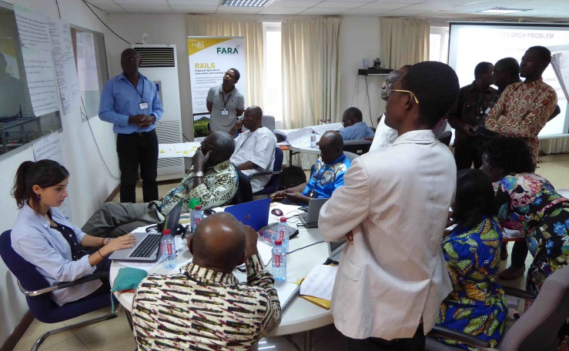**Annex 5. The project groups at work**

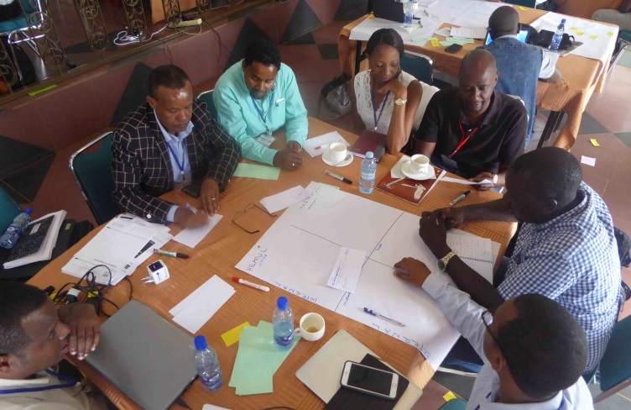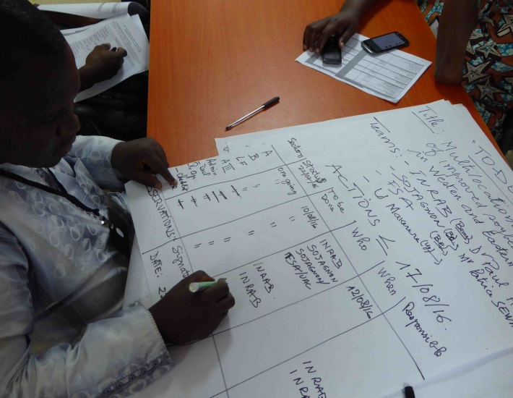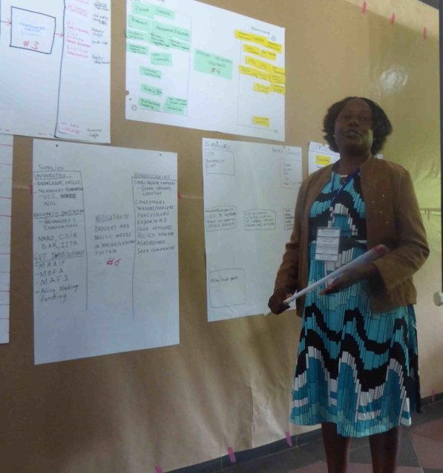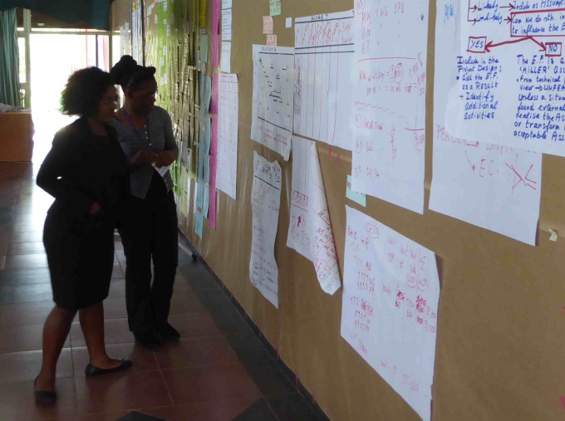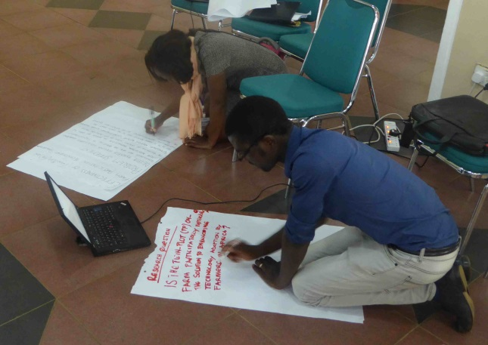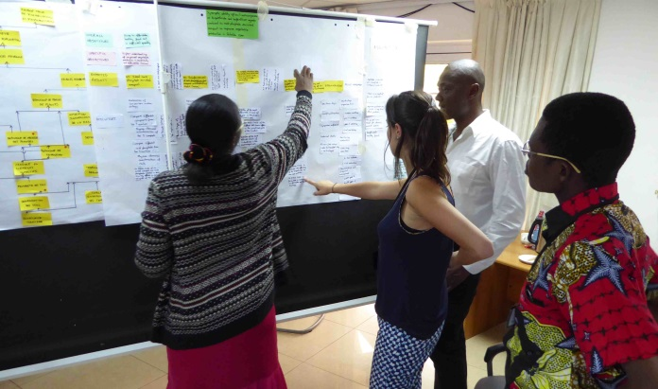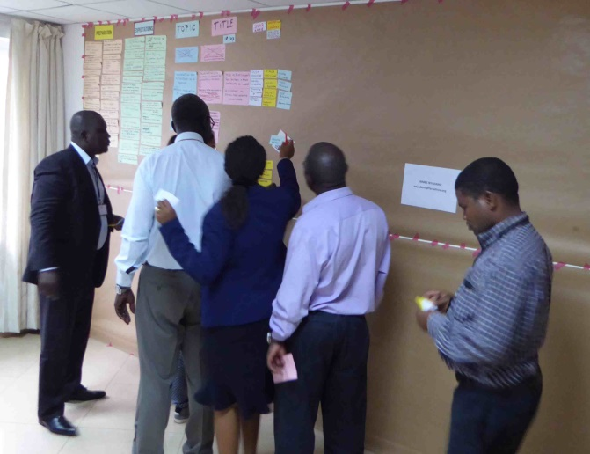

**Annex 6. Analytical overview of reviewed proposals**





1. These materials were distributed to all participants during the write-shops
2. A few participants financed their own travel and accommodation costs (Haramaya University…)