The PAEPARD Write-shop Experiences
Side Event at the 5th African Higher Education week

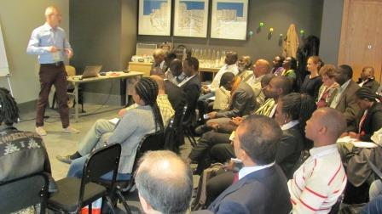

Cape Town 18th October 2016
Summary report

Laurens van Veldhuizen
Royal Tropical Institute
Amsterdam, the Netherlands
Introduction

PAEPARD is a project supported by the European Commission to build African-European multi-stakeholder partnerships (MSP) in Agricultural Research for Development (ARD). 2017 is the final year of the current project phase. Over the past years PAEPARD has facilitated the emergence and formation of a great diversity of ARD partnerships using the mechanism available during its different phases. Since 2014 a number of these partnerships/consortia have accessed the PAEPARD Competitive Research Fund (CRF).
To support above partnership-building and the functioning of the consortia and their handling of the CRF resources, PAEPARD has implemented a capacity building programme based on its capacity building strategy developed in 2011 and refined in 2014. One of its major activities have been so-called write-shops, to build capacities of partners in realizing and developing proposals responding to calls launched by donors. Nine formal write-shops have been organized by PAEPARD. While documentation of these write-shops is a continuous process there was a need to generate feedback from those who participated in the write-shops as well as others inside and outside PAEPARD on their implementation and outcome.
PAEPARD therefore organized a 2 hour side event during the fifth Africa Higher Education Week in Cape Town, South Africa, 16 – 20 October 2016 attended by many partners and other organizations interested in the topic. Apart from increasing visibility of PAEPARD and its mandate and approach, this side event had the following objectives:
- Review the implementation of the write-shops and analyze the challenges faced when preparing and facilitating them;
- Collect feedback on the outputs/outcomes/impacts of PAEPARD write-shops such as on the capacity in competing for grants, on awareness on funding opportunities, on partnership management and other related benefits.
- Assess the implementation and use of knowledge acquired during the write-shops.

The side event and its process
Given above purposes the side event was designed around two main forms of inputs on the write-shops as part of PAEPARD’s capacity building strategy: a structured presentation on the rationale, implementation and outcome of the write-shop followed by focused interventions from four panellists who had been involved in one or more write-shops and shared their views on process and outcome. They included three PAEPARD partners and one outside the direct PAEPARD partnership. A copy of the structured presentation has been added at the end of this report as Annex 2.
The above presentations were preceded by an introduction into PAEPARD and its work while the plenary discussion was concluded by a wrap-up by the vice-president of Agrinatura and closing remarks by the executive director of FARA. The full schedule of the side event and details of all speakers is found attached as Annex 1.

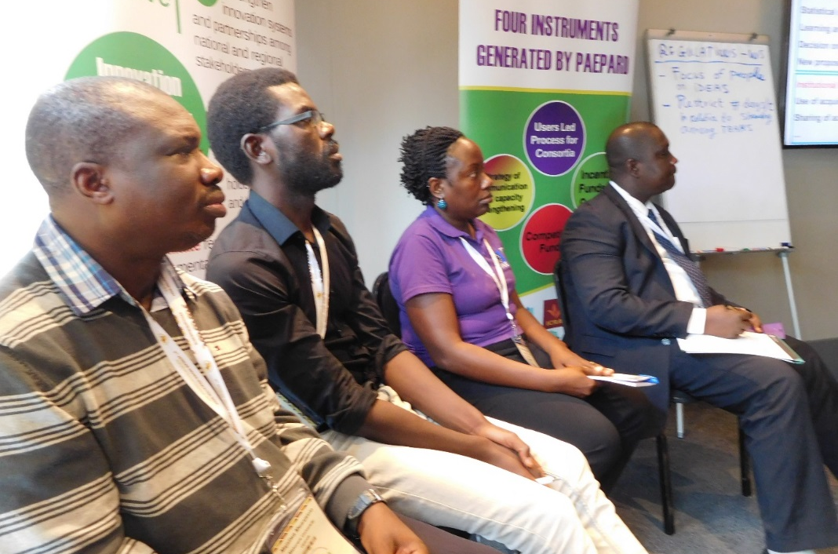
Panellists had been asked to focus their inputs on the following key questions:
- What are important lessons on the implementation of the write-shops, what worked well and what not?
- Have there been outcome and impacts of the write-shops (direct and indirect, short and medium term). Which are they?
- In short had their expectations on the write-shops been met?
During the second part of the side event there was ample opportunity for the audience to respond to the presentations, challenge findings and also share own experiences with write-shops. The main observations and findings from the panelists and the plenary discussion are captured in the next chapter of this brief report.
All in all the side event went very well. It took little less than 2,5 hours and attracted at least 60 people around 50% of whom indicated by show of hands to be directly linked to PAEPARD. Most participants (at least 75 %) indicated to be researchers. Laurens van Veldhuizen from the Royal Tropical Institute (KIT), the Netherlands, handled the facilitation of the event.

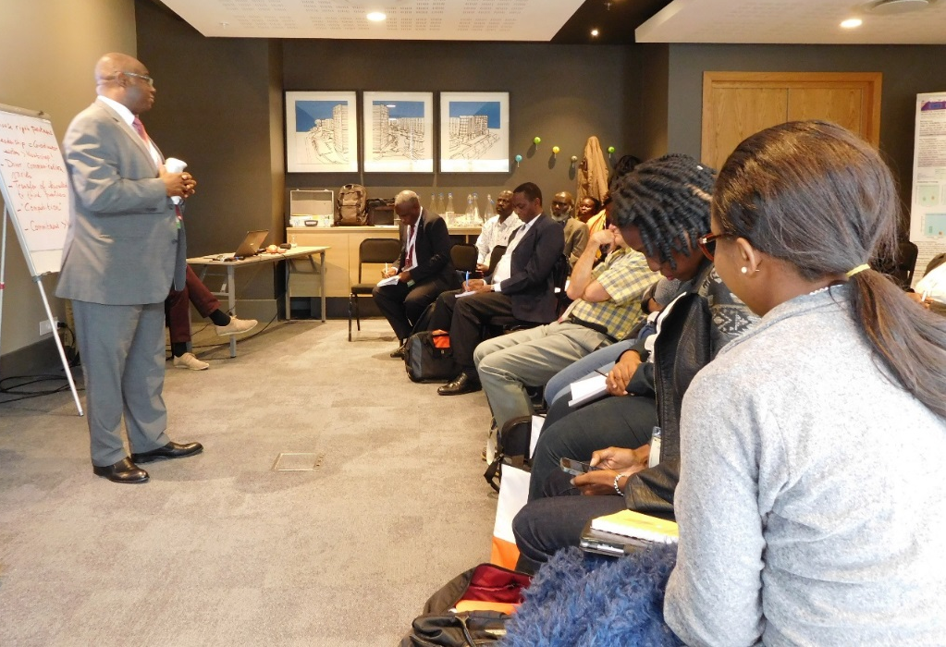
Questions and notes from the panelists and the discussion
Following the presentation introducing PAEPARD participants asked questions for clarification on a number of issues:
- Dgroup was explained to be a web-based communication tool that allows sharing of information to a large group of people through Emails.
- Gender is not a separate area of work of PAEPARD but gender concerns are integrated into all the work; in addition PAEPARD has supported partners to participate in capacity building events on gender and share the learning in their organisations.
- The history of PAEPARD was explained and audience was informed that PAEPARD has no new calls so organizations interested to link-up are advised to link with the consortia that exist to explore ways of collaboration. They can also join the Dgroup to be part of the 7 thousand members receiving information from PAEPARD on different opportunities.
From all the inputs and discussions on the write-shops a number of important issues emerged:
Preparation of the write-shops
- Selection of the right partners is crucial for forming a committed partnership for writing a proposal where tasks and responsibilities can be distributed in confidence.
- The total number of participants of the write-shops have been between 25 up to 50 people. This seems a lot – particularly for the sharing sessions - but with good organization of the process it is manageable. The number of participants per team writing a proposal should not be less than 2 and not more than 4 or 5. Individual participants working on a proposal found it very hard to follow the full write-shop process.
- If participants do not prepare themselves well enough for the workshop (read the call docs, develop initial ideas) this slows down the write-shop process a lot.
Implementation
- Feedback shared indicated that the implementation process of the write-shops and the interactive methodology is appreciated very much. Receiving training in proposal writing and planning while working on an own proposal is working well.
- One comment noted that it is important to have enough time at the end of the write-shop to work on the budget.
- Responding to questions from the floor write-shops participants confirmed that proposals can be developed, designed and even written by a team and do not have to be done by one or two people.
- Timing of the write-shops in one case coincided with the holiday season in Europe and availability of European partners to join was thus a problem.
- As often within PAEPARD the issue of language (French and English) has been a challenge in some cases as it is not possible to do the write-shops fully in two languages.
- A challenge mentioned by the panelists is around “ethics”: the possible competition among write-shop teams as they prepare for the same call, the same source of funding. In one case a team gave-up its own project idea, took most of the ideas and initial work from another team and got this funded “at the expense” of the other team. The lesson learnt from this case is that from the start the write-shop should be done in a spirit of mutual respect for the “IPR” of each team, participants should be asked to focus on their own ideas and sharing between teams could perhaps be done less or in less detail.
Follow-up to the write-shop
- Reduced energy levels post write-shop has often been witnessed, but that is not unusual for workshops in general.
- Importance of project leadership within existing the PAEPARD consortia to take the process forward was noted. Agreement is needed on who would lead the follow-up, what next steps are, and who should do what. Decisions on leadership may depend on the call (donor requirements) and requires institutional support.
- A challenge in proposal writing is to organize all the institutional support through the relevant documents (annexes). It is important to start organizing these as soon as possible and not wait till the proposal has reached its final stage.
- The write-shops are not stand-alone activities but are part of the wider capacity building and support cycle from PAEPARD.
Outcome
- Participants first of referred to outcome of the write-shops in terms of proposals written that had been approved and received funding. In some cases 3 out of 5 proposals succeeded. In other cases success rate has been lower. For PAEPARD overall 23 out of almost 70 proposals developed with support of write-shops or other-wise have been successful so far.
- Unfortunately feedback from donors on unsuccessful proposals varies in quality and quantity but is often rather limited making it difficult for participants to learn from those cases.
- A very basic outcome mentioned is the awareness among participants of their shortcoming still to write effectively; a good starting point for learning.
- Several of the panelists explained how the learning from the write-shop has been applied more widely; e.g. by advising and helping others in writing proposals thus transferring the knowledge to them, or in own university work to help improve master students to write better proposals and reports.
- It would be important to collect more information on the outcome of the write-shops.
- The above needs to be put in the context of the resources required to run the write-shops, approximately USD 300,000 for 9 formal write-shops. This is a serious investment and the current process to review and further strengthen the write-shop process is thus very relevant.
Wider relevance of the write-shop approach:
- The floor noted that it is generally not easy if not impossible to use the write-shop approach to capacity building within universities given the strict character and policies of and around university curricula and teaching. It would perhaps be possible in some case to use some principles, e.g. to directly link and integrate theoretical training or lectures with students working on concrete products or projects.
- Other organisations have used the write-shop approach to write-up and document development experiences and case studies. In one example mentioned from the floor a two-day write shop was done to capture 2 page stories on using video for documenting farmer innovation.

Wrap-up and conclusion
To conclude, the vice-president of Agrinatura recalled that the write-shops are a step in processes that should lead to the identification and formulation of sound research proposals for innovation. PAEPARD is expected to find efficient ways of achieving this in the context of users-led processes. It should highlight all lessons learned from these experiences, in order to contribute to the general knowledge about innovation in agriculture and how stakeholders’ organizations can support this. The side event has generated important additional ideas on this.
The discussion shows that capacity building is a process. The concept and ideas with the stakeholders have may change during this capacity building process and even during implementation.
It is important to document and analyze the function and outcome of the write-shops. How effective have write-shops been in changing the ways of addressing the problems that PAEPARD was resolving?
Beyond the good ideas about how to handle a write-shop to produce a convincing written proposal, it will be interesting to look at this process as a mean to question, revise, and modify the research itself.

Annex1: Side event programme and details of speakers

Nº | ACTIVITIES | Speaker | Position | TIMEFRAME
1 | Welcome remarks | Dr Jonas Mugabe | PAEPARD Coordinator | 9:00-09:05
2 | Introduction into PAEPARD | Dr Jonas Mugabe | PAEPARD Coordinator | 9:05:09.25
3 | Presentation write-shops and their outcome | Dr Gerard den Ouden | Independent consultant | 9:25-10:00
4 | Feedback write-shop participant | Dr Elizabeth Kizito | Uganda Christian University | 10:00-10:05
5 | Feedback write-shop participant | Dr Patrice Sewado | Sojangon, Benin | 10:05-10:15
6 | Feedback write-shop participant | Dr Majalewa | Makekere University, Ug. | 10:15-10:20
7 | Feedback write-shop participant | Dr Limbikani | Longwe Uni. of Agriculture and NR, Malawi | 10:20-10:25
8 | Buzz groups and plenary discussion | All |  | 10:25-11.05
9 | Wrap-up | Dr Didiet Pillot | Vice-president Agrinatura | 11.:05-11:15
10 | Closing remarks | Dr Yemi Akinbamijo | ED FARA | 11.15- 11.20

Annex 2: Presentation on the PAEPARD write-shops and their outcome

