Programme
SEMINAR
“Stepping up Africa-EU cooperation in agriculture and
the recommendations of the Task Force for Rural Africa"
6-7 March 2019
*********

Visit Organisers and Logistics
Name Heike Libbach, Cornelia Smet
Directorate-General Agriculture and Rural Development
Address: European Commission, Rue de la Loi 130, B-1049 Brussels
Telephone +32(0)2 29-53290
GSM +32 (0)460 76 65 24
E-Mail AGRI-MEDIA@ec.europa.eu
Number of visitors up to 30
Conference rooms 6 March: L102 (rue de la Loi 102, 1000 Brussels)
7 March: BERLAYMONT (200 rue de la Loi, 1049 Brussel)

YOU should ensure to have your identity cards or passports with you at all times, as you will be asked to show them when entering Commission buildings.
In case of delay please call your visit organisers.

Security control: Please note that you will be asked to pass through an obligatory control (x-ray machines and walk-through detectors) when entering the building.

1 = Hotel, 2 = Meeting place 6 March, 3 = Meeting place 7 March

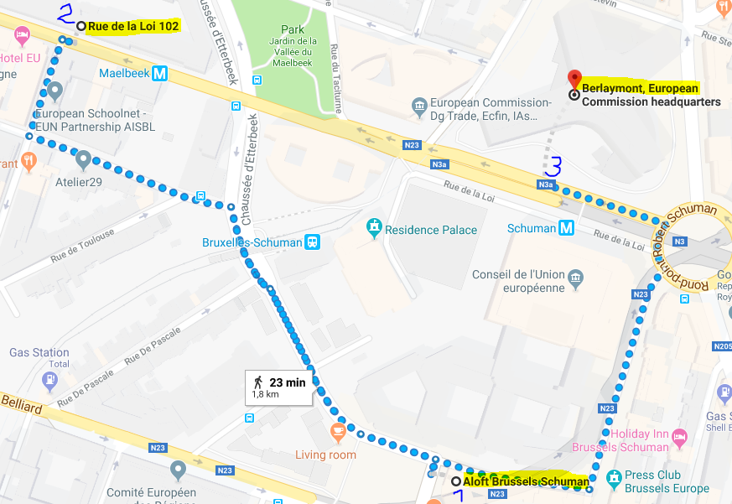

Time | Programme
Wednesday 6 March 2019
morning | Arrival and check in at the hotel – Aloft Brussels Schuman  Place Jean Rey, 1040 Brussels, tel. +32 2 800 08 88
14:00 | Check in at the entrance of meeting venue  Meeting room: rue de la Loi 102, 1049 Brussels  We will meet at the reception and accompany you to the meeting room
14:30 – 14:40 | Introduction and welcome address  L102, auditorium  DG AGRI.B.1
14:40 - 16:10 | Africa-EU cooperation in agriculture: state of play  Willi Schulz-Greve - head of unit DG AGRI.A1  Leonard Mizzi - head of unit DG DEVCO.C1  Agnieszka Romanowicz - DG AGRI.B2  Remco Vahl – DG TRADE.D2  Moderator: Mike Mackenzie - DG AGRI.C1  Qs&As
16:10 – 16:30 | Coffee break
16:30 – 18:00 | The business experience on the ground  Oluwabunmi David Ajilore - Strategic Foresight/International (Agriculture) Development Consultant, Nigeria  Graciano Julio Francisco - Zambezia Province rural development authorities, Mozambique  Baudouin Michel - Operations director African Parks Network, South Africa; Director de l‘Ecole Régionale Postuniversitaire d’Aménagement et de Gestion intégrés des Forêts et Territoires tropicaux ‐ UNESCO, DRC  Moderator: Mike Mackenzie - DG AGRI.C1  Qs&As
19:30 – 21:30 | Networking dinner – place tbc  Hosted by DG AGRI.B.1

Thursday 7 March 2019
8:30 | Check in Berlaymont building  Rue de la Loi 200, 1049 Brussels
9:00 – 10:20 | The EU and FAO cooperation to achieve food security for all: experience on the ground  BERL -1, Aquarium 4, 200 rue de la Loi, 1049 Brussels  Rodrigo de Lapuerta - director Liaison Office FAO with the EU and Belgium  Leonard Mizzi - head of unit DG DEVCO.C1  Moderator: Willi Schulz-Greve - head of unit DG AGRI.A1  Qs&As
10:30 – 11:00 | Press point: the final report of the TFRA  VIP press corner – BERL, 200 rue de la Loi, 1049 Brussels  Phil Hogan - Commissioner for Agriculture and Rural Development  H.E. Josefa Leonel Correia Sacko - Commissioner for Rural Economy and Agriculture of the African Union Commission  Tom Arnold - Chairman of the TFRA (and members of the TFRA)
11:00 – 11:45 | Technical briefing: the recommendations of the Task Force for Rural Africa (TFRA)  Press room – BERL - 200 rue de la Loi, 1049 Brussels  Willi Schulz-Greve - head of unit DG AGRI.A1  Leonard Mizzi - head of unit DG DEVCO.C1  Members of the TFRA  Moderator: Daniel Rosario – Spokespersons’ service of the European Commission  Qs&As
12:00 – 13:00 | Farmers’ organisations: experiences and perspectives in Africa  Aquarium 4 - BERL, 200 rue de la Loi, 1049 Brussels  Kees Blokland - Managing director, Agriterra  Regis Meritan, DG DEVCO.C1  Pirkko Suhonen - Managing director of Vaalan Juustola  Moderator: Eleftheria Vounouki - DG AGRI.A1  Qs&As
13:00 | End – journalists leave for airport

