Mitigating the Effects of Aflatoxins in Agricultural Value Chains in Ghana using Innovation Platforms
The Forum for Agricultural Research in Africa (FARA) convened a one-day stakeholder consultative meeting on the “Formation of Innovation Platforms for Aflatoxin Management in Ghana” at the FARA Secretariat Conference Hall located in Roman Ridge, Accra, Ghana. The meeting was attended by about 45 participants representing various stakeholders mainly in the Ghanaian agricultural and trade sectors including the Ministry of Food and Agriculture, farmer-based organizations, researchers, agribusiness, and development partners.
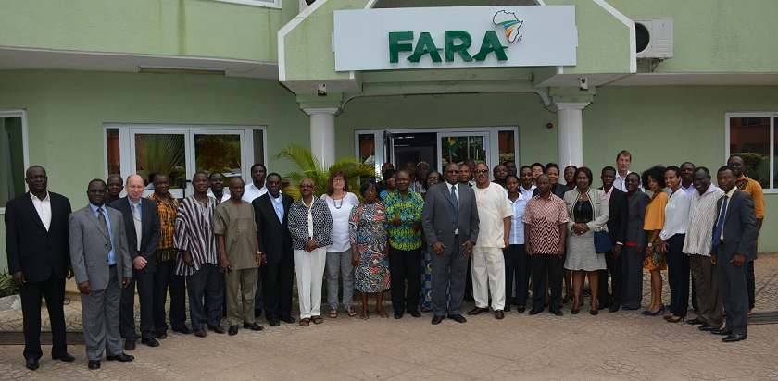
The meeting was officially opened by the Chairman of the Parliamentary Select Committee on Food and Agriculture, Hon. Gabriel Assilfie, who is also the Member of Parliament for Shama Constituency, Western Region, Ghana. Addressing the participants during the opening session, Dr. Oseyemi Akinbamijo, FARA’s Executive Director, reiterated that the issue of aflatoxins is important as it contributes to enormous economic losses through its adverse effects on food security, human health and trade in agricultural products. Dr. Yemi observed that technologies to mitigate pre- and post-harvest produce contamination are available while some are still being developed by researchers around the world. He added that these technologies need to urgently reach farmers, processors and traders. “One way of doing this” he said “is through innovation platforms.”

As a stakeholder organization, FARA mobilizes, connects and rallies stakeholders for collaborative and concerted actions around issues and challenges that affect agricultural productivity, food security and trade based on the CAADP framework. In view of its relevance to FARA’s value proposition, congruence with continental aflatoxin management strategy articulated by the Partnership for Aflatoxin Control in Africa (PACA), and importance in Ghana’s key agricultural value chains, the FARA Secretariat deemed it fit to host an initial brainstorming workshop towards the formation of an innovation platform for aflatoxin management in Ghana. This was at the request of the Ghana Federation of Agricultural Producers (GFAP).
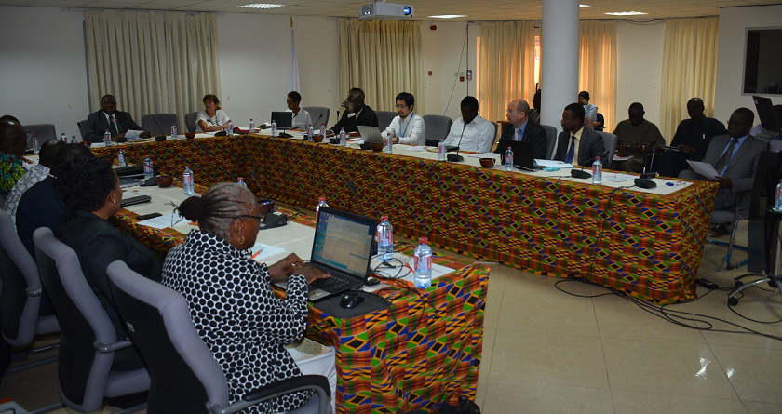
The workshop identified strategies for local awareness creation on the aflatoxin problem, aflatoxin mitigation approaches with potential for immediate adoption by farmers and other value chains actors, institutional arrangements and partnerships for aflatoxin management in Ghana, and modalities for funding local activities on aflatoxin management. Moreover, specific steps and actions in setting up an innovation platform for aflatoxin management were delineated. The innovation platforms will be set up around issues bordering on awareness creation, training on good agricultural practices, facilitating private sector participation in provision of services, certification and market linkages, policy and advocacy, and research.
Aflatoxins are naturally occurring harmful toxins produced by the fungi Aspergillus flavus Link ex Fries and Aspergillus parasiticus Speare, which are highly toxic to humans and animals. Aflatoxin-producing fungi affect cereal grains (e.g. maize), legumes (e.g. groundnuts) and other food crops, which are important dietary staples in Ghana and other African countries. Thus, millions of people living in Africa are exposed to high, unsafe levels of aflatoxins through their diet. When animal feeds are contaminated with aflatoxins they reduce milk and egg productivity in dairy and poultry, respectively. Aflatoxins also cause a number of human and animal health problems such as immunosuppression, kwashiorkor, impairment of liver function, and reduced growth rate or stunting. They are also potent liver carcinogens. On trade, farmers miss out on export opportunities since their products do not meet international food safety standards.

