AFRICANA FLAVOURS 2018
Vegetarianism in African Food cultures
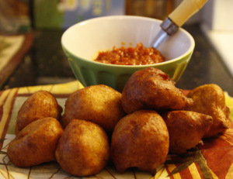Picture by Afrolems  Mosa Plantain puff-puff  INGREDIENTS  1 very ripe plantain  4 heaped tablespoon flour  2 teaspoons fast action yeast  Salt to taste  1 tea spoon chilly powder or fresh bell pepper (optional)  Half teaspoon ginger powder or fresh ginger  Half teaspoon nutmeg powder  1 fresh egg (optional)  100 ml warm water  Sunflower oil  METHOD  Peel and blend the plantain into a smooth purée.  Pour the pureed plantain into a bowl. Add the rest of the ingredients with the warm water and yeast. Mix all the ingredients thoroughly until you get a medium consistency.  Cover the bowl and leave in a warm place for about 15minutes  Heat some sunflower oil in a frying pan and add the mixture one tablespoon at a time. You can fry in batches, but be careful not to overcrowd the pan. Fry on medium heat, turning over once or twice to brown both sides. Remove from the oil onto some kitchen paper, then and serve.  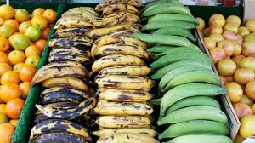  Green (unripe) and yellow (ripe) plantain are very popular African cuisines. Picture from food and nutrition.org  Moi moi (Beans pudding)  Ingredients  500g of brown beans  3 Red long paprika peppers  1 bonnet pepper  150 grams ground Crayfish (optional)  1 large onion  3 Eggs (optional)  1 medium sized makerel (optional)  100ml vegetable oil  2 large bouillon cubes  Method  Dehusk the beans, by sprinkling water on the beans until it is all covered. Then wash to remove the thin outer coat by picking handfuls of beans, rubbing and squeezing them between both hands.  Wash the beans to remove the outer coat, keep squeezing, washing and sieving till you are left with the smooth white beans. You can also buy partially dehusked beans in African shops, which takes less time to wash.  Clean, cut and season the makerel. parboil, debone, break into small pieces and set aside. Blend the beans, onions, paprika and pepper,with 200 ml of water in a blender until you get a very smooth paste.  Add more water (or fish stock)if the mixture is still thick (you need a medium consistency, not thick and not watery too)  Pour mixture into a big bowl,add the vegetable oil, eggs (optional), pieces of fish(optional), bouillon cubes, salt and mix. You can always taste with a drop of the mixture, to be sure you have the right amount of ingredients. |  | 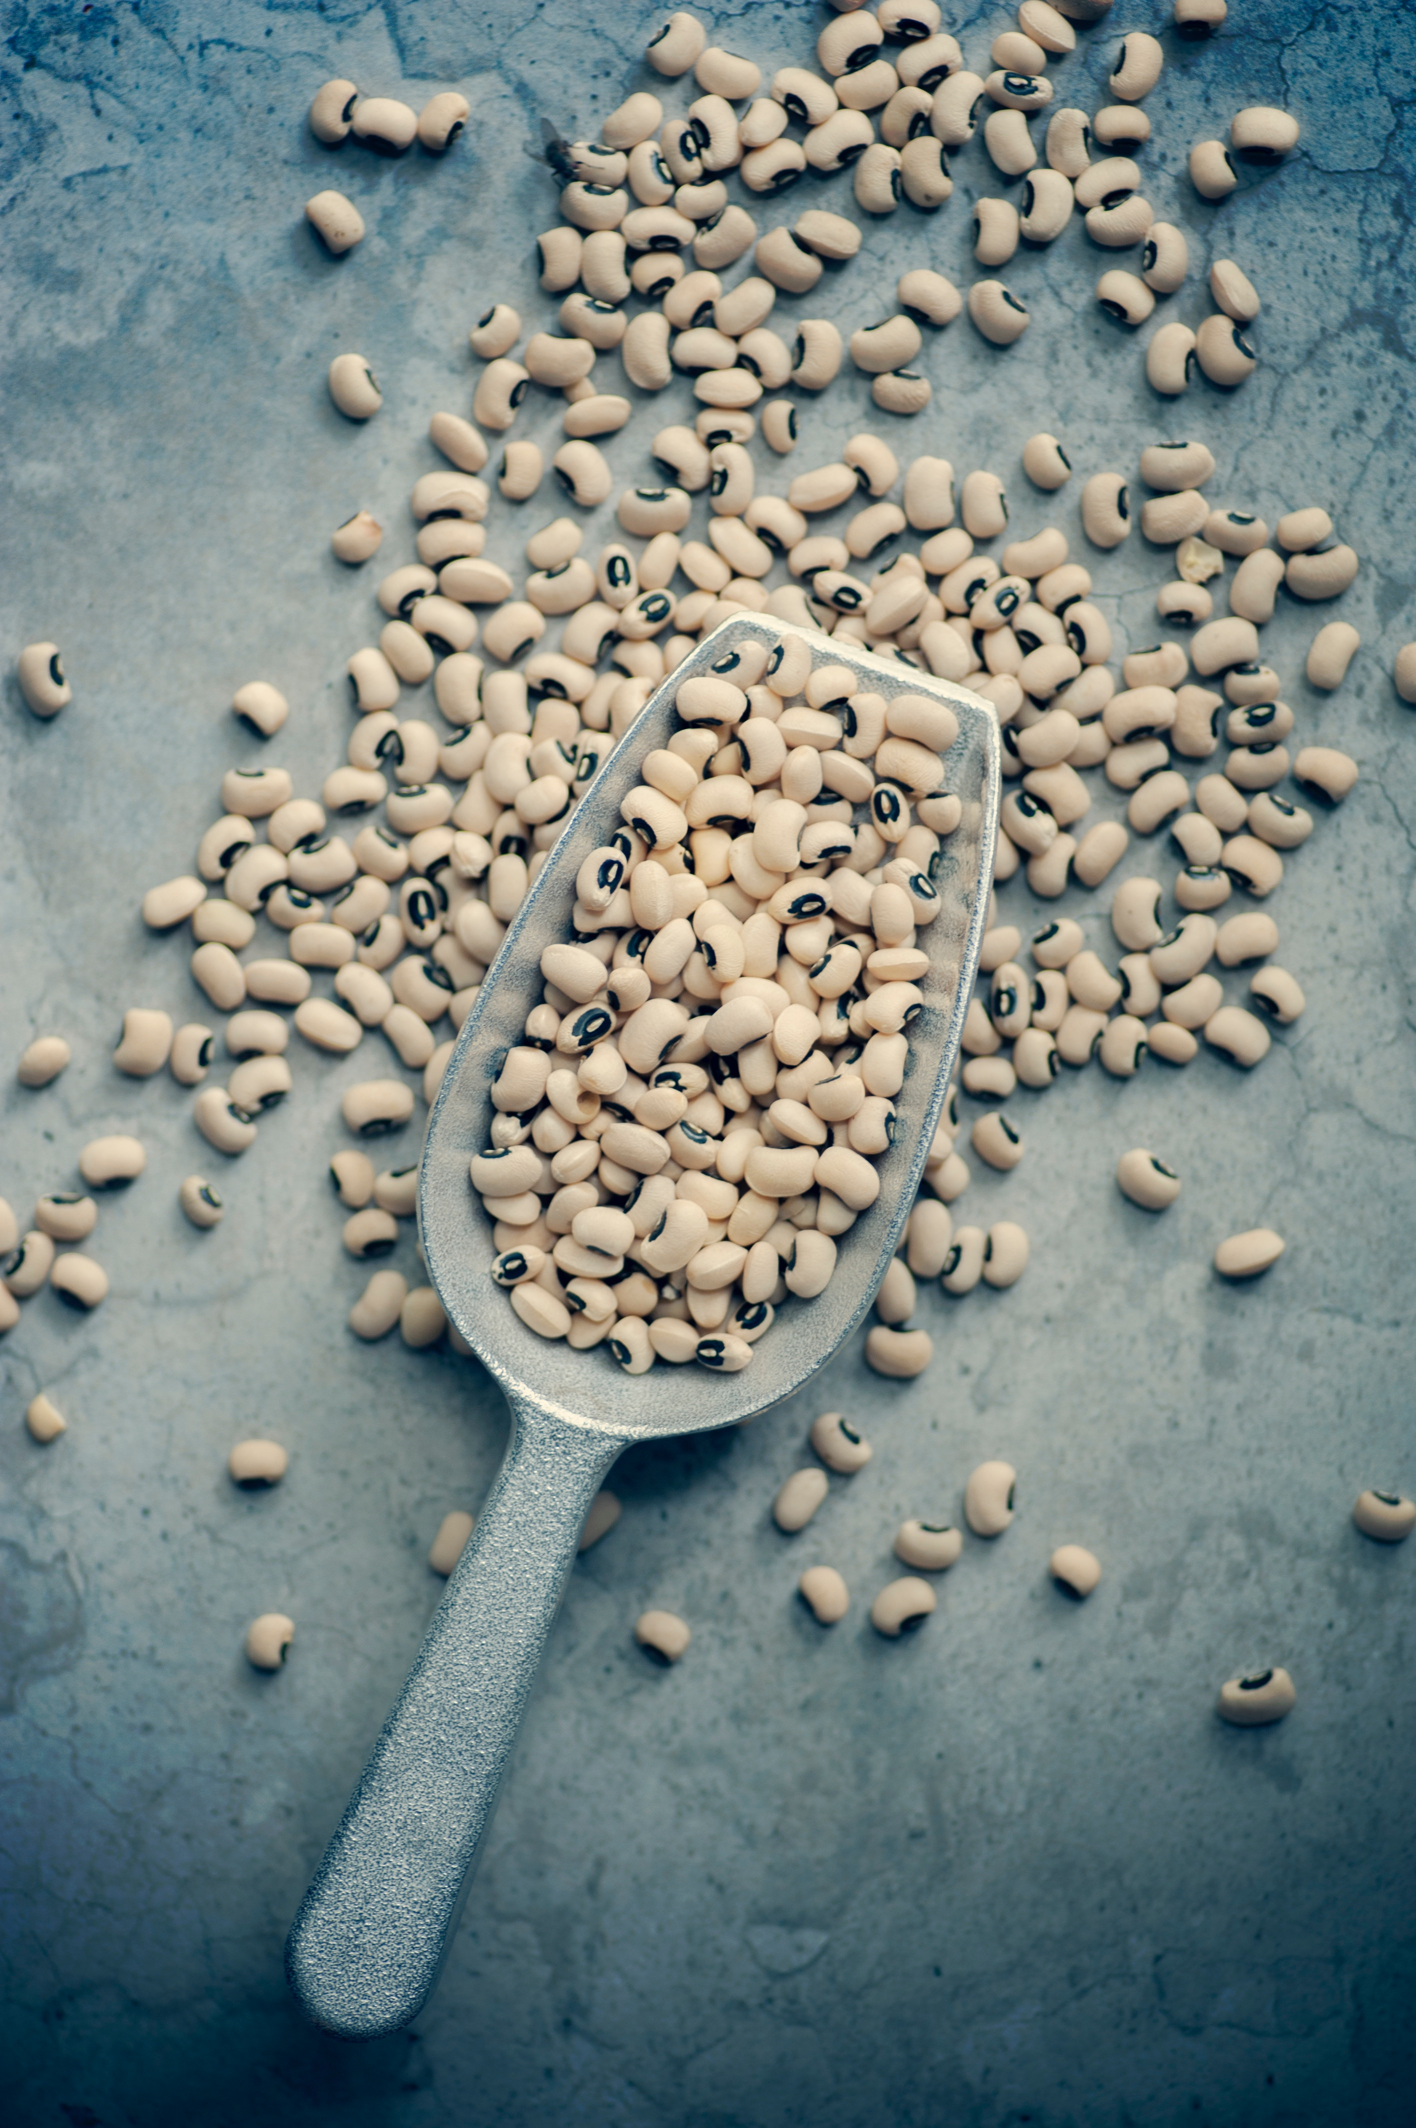Black eyed beans, a very nutritious staple in many African cuisines. Picture courtesy of Jasmine Waheed  How strange is vegetarian (and vegan) diets in the African food culture?  Welcome to the 4th edition of Africana Flavours. We always choose themes that highlight not just the African food culture, but also lead to discussions about the different components of African food systems. Vegetarianism (or vegan) is one word that many still think is not synonymous with the African cuisine. However, like most trends or lifestyles across the globe, vegetarianism is gradually becoming a part of the African food culture. This is more prevalent though, in diaspora communities and urban areas of Africa. Although some argue that African diet has always been predominantly vegetarian, others are keen to point out that Africans eating plant based diets in most cultures, is not a choice but a necessity because they lack the means to acquire meat. We intend to start the 2018 Africana Flavours with a discussion on "how strange is vegetarian (and vegan) diets in the African food culture"? We are hopeful that all the participants will take part in this interactive evening of activities and discussions. Picture from Nellisfoods Heat 300ml of water in a fairly big pot, the aim is to steam and not to boil. You can also line the bottom of the pot with pieces of wood. Put portions of the beans mixture in 100ml aluminium or plastic bowls. You can also use moi moi leaves, which look like banana or large lily leaves. Put the bowls or wraps in the pot, staking them on top of each other. Once you have all the bowls in the pot, cover it tightly. This part of the cooking needs close monitoring because the water in the pot must not be above the first bowl, it needs to be topped up at intervals. Allow the moimoi to cook for about 45 minutes. Check it is well cooked by dipping a knife into a bowl and checking how sticky it is. Once your moimoi is cooked, you can enjoy it alone or serve with custard and rice dishes Drop the bowls in the pot and add water simultaneously making sure it doesn't top the first bowl. Then cover tightly and cook for about 30 to 50 minutes adding water at interval to avoid burning or too much water that would run into the bowls. Participants will be presented menus with and without meat, asked to choose and explain why they made their choice. We will note the responses under –Health, environment, culture, animal welfare or money. This will be followed by presentations by Jutta Kleber- the BigPicnic Project, Steve Ngabo- testimony of an African vegan, Nancy Kawaya – O’marche and Maureen Duru, The Food Bridge vzw. The next session will be the presentation of the recipes for the evening’s menu. After which we will dine, drink and discuss some more. Thanks for joining us. Kolanut – cola acuminata and cola nitida This caffeine filled nut is indigenous to tropical regions of Africa. It is used for welcoming rites but has ritualistic, economic, social and cultural values in sub Saharan Africa. Black Eyed Beans Sauce Ingredients 400 grams black eyed beans (you can use the brown beans too) 400 grams chopped fresh tomatoes 100 grams tomatoes puree 250 grams chopped onions 300 grams of fluted pumpkin leaves( you can substitute with spinach or mixed vegetables Ground bell pepper ( use according to your taste) 1teaspoon ground fresh ginger Half teaspoon ground fresh garlic 2 bay leaves 1table spoon curry powder Half teaspoon thyme 2 bouillon cubes Salt to taste 150ml of vegetable oil Method Wash the beans, pour into a pot of water, cook (adding more water intermittently as needed) until the beans are very soft and the water is almost dried up. Turn off the heat and set aside. Heat vegetable oil in a pot on medium heat. Sauté the onions, ginger, garlic and pepper then add the chopped tomatoes and stir. Allow to cook for about 5 minutes Add the tomatoes puree, curry, thyme, bay leaves, bouillon cubes and stir. Taste for salt and add according to your taste. Allow to cook for another 5 minutes Remove the bay leaves and add the cooked beans. Stir and reduce heat, then add the vegetables and allow to simmer for about 3 minutes Note: To reduce the time it takes to cook beans, you may use a pressure cooker pot or soak the beans in water for at least 2hours before cooking.
Garden Egg – S. gilo

Garden egg is an important crop in several African countries and is indigenous to sub-Saharan Africa.
There are two popular types of garden eggs, the green garden egg, which has a slightly bitter taste, and the milky coloured garden egg.
It can be eaten raw (with fried ground nuts/ groundnut butter) or used for sauces.
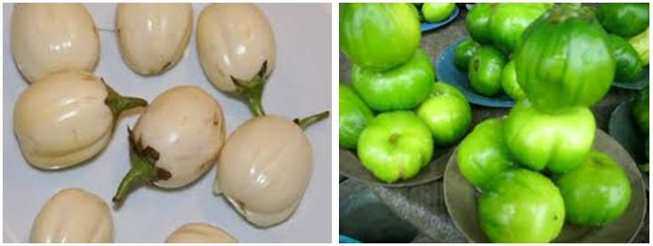
Milk coloured garden eggs |  |  |  | Green garden eggs
African pear (Ube, Safu)  African pear - D. edulis is a fruit, which can be eaten raw, cooked in salt water or roasted. The cooked flesh of the fruit has a texture similar to butter. It is a tropical fruit found in Africa especially in the West, Central, East and parts of south African countries such as Nigeria, Cameroon, Congo, Sierra Leone, Angola etc. It has for centuries been an important nutritional and medicinal plant. Research is still ongoing to document fully, the benefits of the fruit and plant. African pear and sweet corn Ingredients - 4 African pears - 2 cobs sweet corn - Salt Method Boil the sweet corn in salted water until cooked. Turn off the heat, remove the corn from pot and add the 4 pears to the hot salty water. Cover for about 2minutes or until the flesh is soft. Remove the pears from the hot water and serve with the corn. Eat the soft pear flesh with your corn.  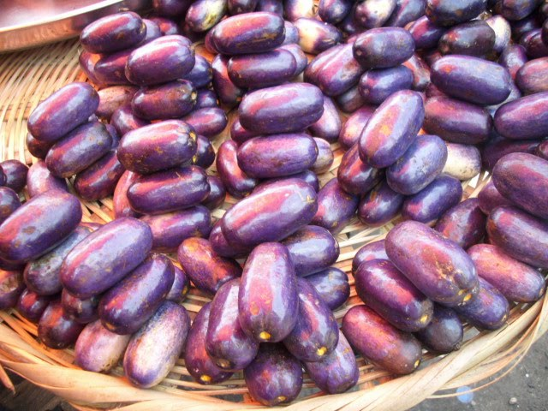 |  |  |  | Sweet corn in African pear boats  Ingredients  - 5 African pears  - 1 small tin of sweet corn  - 1 long red paprika  - 1 table spoon of olive oil  Method  Wash the pears and cut into halves  Boil water and put the pear pieces in the hot water to soften  Take out the pears from the hot water, gently remove the seeds and seeds cover from the pear  Wash, deseed and dice the paprika  Drain the tinned sweet corn  Mix the sweet corn, diced paprika and olive oil  Scoop the mixture into the African pear boats and serve
Bitter kola - Garcinia kola

This brown nut like seeds are from West and Central Africa. The seeds are valued as very important in many African cultures.

Although it tastes bitter, the benefits of bitter kola are wide ranging, as it has been an important component of traditional African health and medicinal practices.

NOTE:
If you are interested in exploring food history, food cultures and the global food system, why not volunteer for us. We are a small nonprofit organization with great ideas but limited resources. For our 2019 projects, we need volunteers with expertise or good experience in communication, photography/video/film, translation and marketing.
If you also love culinary adventures and experiencing new tastes, you are welcome. Send us an email – info@thefoodbridge.org

Yam Dishes
Fried yam  Ingredients  I medium sized Fresh yams (Dioscorea species)  Salt  Oil  Method  Cut and peel the yam (just like potatoes but you will need a sharp knife)  Wash the yams and on a chopping board, cut it into desired sizes.  Cover the yam slices with water and leave it for about 30 minutes.  Drain the water and season with salt.  Heat oil in a fryer, pot or frying pan until medium hot.  Add portions of the yam slices to the hot vegetable oil. Be careful when you do this, because the oil will sizzle and spatter everywhere.  Let it fry until golden brown or crispy on the outside and soft on the inside, and then it is done. Serve with fried eggs and tomatoes omelette or spicy tomatoes sauce  Note: Be careful though, some people react to the fresh yam or yam peels, coming in contact with their bare skins. |  |  |  | Beans and yam  Ingredients  - gm brown honey beans or black eyed beans  100ml palm oil  150 grams ground crayfish (optional)  1medium onion  Pepper and Salt to taste  1 big bouillon cube  500g Yam (peeled and cut into about 6cm pieces)  Method  Put the beans in a pot and pour water to cover the beans with about 3 cm above the level of the beans and start cooking.  Cook till tender but not mushy soft, adding more water from time to time, if necessary. Keep the water at the same level as the beans, so when the beans is cooked, you will not have too much water in the porridge.  Add the yam pieces and cook for about 10 minutes.  Add the onions, crayfish (if using it), pepper, bouillon cubes, salt and stir.  Allow to simmer in low heat for another 5 minutes, adding the palm oil and stirring again. Cover the pot and turn off the heat. Your beans and yam porridge is ready.  Note:  You can substitute yam with Plantain or Sweet Potatoes

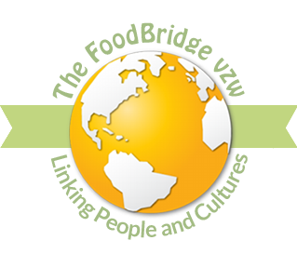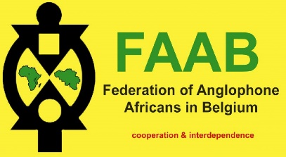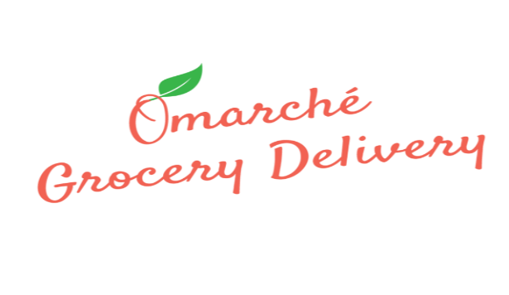
The Food Bridge vzw’s projects  Promoting Food Cultures -  Africana Flavours and Food Talks  Supporting African Entrepreneurship –  African Diaspora Projects Initiative  Promoting conservation of indigenous food crops and plants Network of Indigenous Food Systems  Feeding the homeless and vulnerable –  The Helping Hand Project  Contact: info@thefoodbridge.org  Donations: The Food Bridge vzw  BNP Paribas Fortis  BE33 0017 5988 5346 |  | 2018 has been a busy but fulfilling year for  The Food Bridge vzw. We were able to carry out projects that had positive impacts on people and society because of the support and donations we received.  The caliber of partners, collaborators and volunteers we have, makes a huge difference in our work. We appreciate the support and partnership of VGC, FAAB vzw, GC De Platoo, Gemeente Elsene, Meise Botanic Garden, the BigPicnic Project, Paepard, Entrepreneurs for Entrepreneurs, VITO nv, Thomas More University, University of Gent, Tropentag, Heritage office Brussels (Erfgoedcel Brussel (VGC), Centre for Agricultural History (het Centrum Agrarische Geschiedenis (CAG) and African Diaspora Network Europe.  Thank you all so much and we look forward to more collaborations in the future.

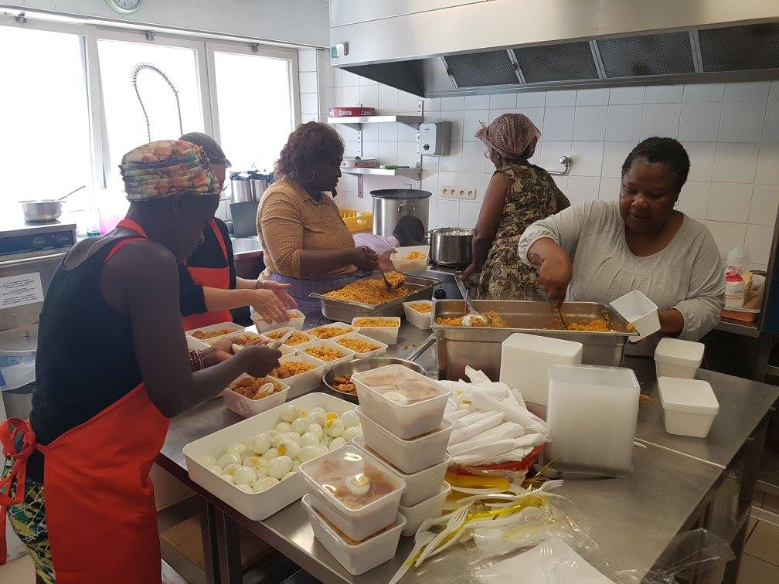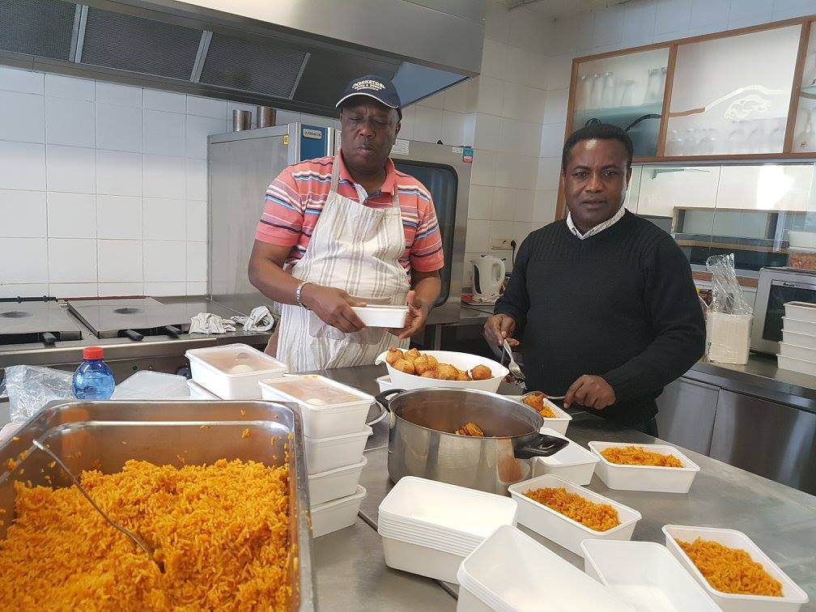
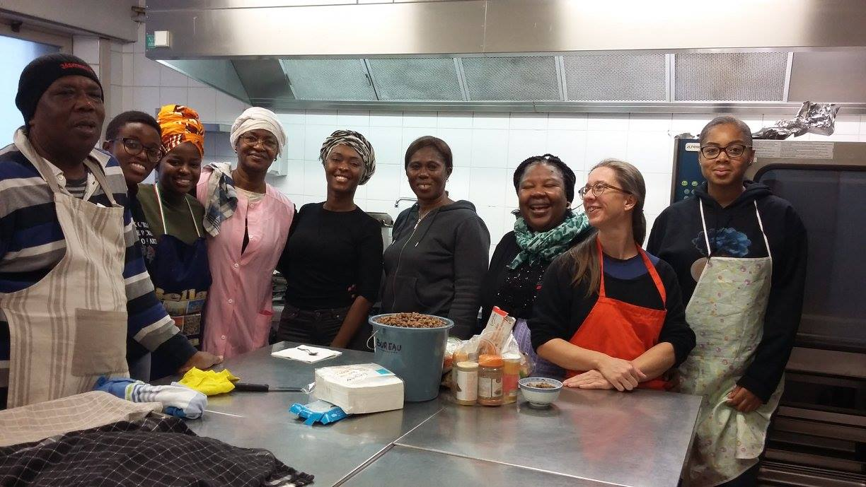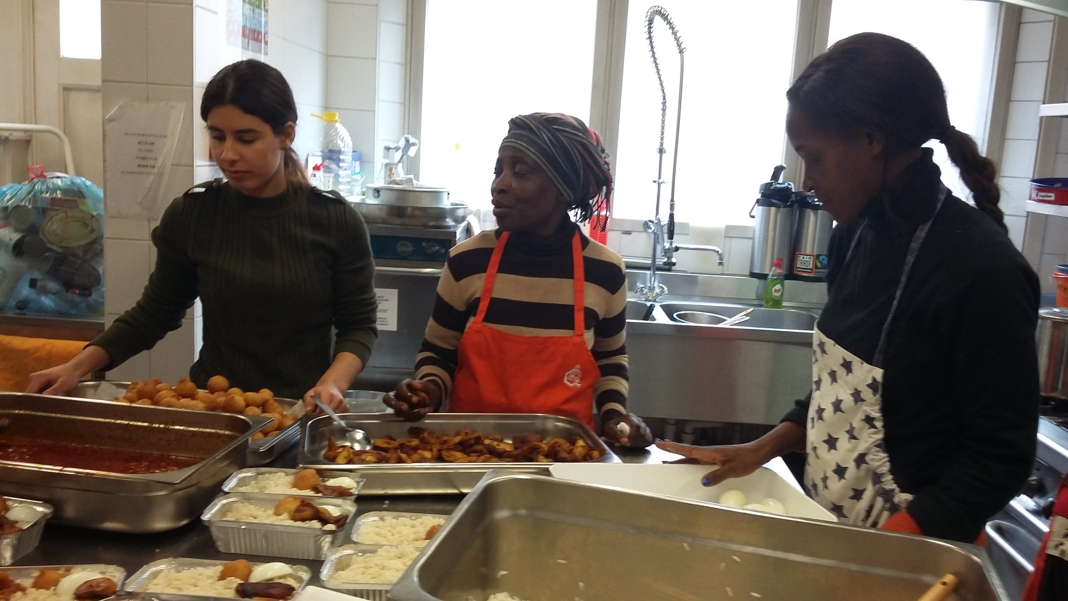
Volunteers of The Helping Hand Project, preparing meals for the homeless and needy. During each session we provide about
120 meals.

We welcome volunteers and donations for this project. Contact us for more details!

