Walking the Talk on Participatory Learning and Action: Butiki Irrigation Vegetable Farmers Driving the AIV Research Agenda
Kasharu¹A.K., E. B. Kizito², M. Masanza², J. Jjagwe³ A. Namutebi⁴
¹CHAINUG, P.O. Box 14364, Mengo Kampala
²Uganda Christian University, Department Of Agriculture and Biological Sciences P.O. Box 4, Mukono Uganda
³ FARM GAIN LTD, P.O. Box 21717, Kampala
⁴ Makerere University P.O. Box School of Food Science and Nutrition, P.O. Box 7062, Kampala

Abstract
Participatory learning and action (PLA) has become a widely accepted strategy for conducting Research and Development (R&D) projects because it eliminates the weaknesses of the traditional ‘top down’ approach to research and development. PLA in particular was adopted in this project because it enabled the team to explain a purpose of creating knowledge that leads to action, and through reflection, to new knowledge and new action. Through group discussions and PRAs a number of positive outcomes emerge in this research; for instance through skilling and empowerment, farmers developed new crop priorities and enterprises. Of the 5 important crops listed at the start of the project only 2 remained on the list by 2017, indeed new ones such Nakati and Jobyo displaced crops traditional important crops like sukuma wiki and Karella. The situation dramatically changes when the aspect of vegetable seed production and marketing is considered. At the time of PRA no member in the community grew vegetables for seed or sold any seed within the community or outside. However, by July 2017, over 5390 packs of 50 gms of several seed types were produced and sold. This positive outcome is attributed to the PLA approach employed in this research as well as the methods deployed by research team to empower and skill farmers in vegetable value Chain participation. The preferred methods by farmers to learn and factors that enabled the project success are show cased and explained in this paper.
1.1 Background
Low household incomes, declining crop productivity and persistent food insecurity are interrelated problems limiting socio economic development of many Ugandans (NRC, 2006). This central problem motivated different organizations and institutions to work together to devise long lasting solution to this challenge. The concerned institutions ranged from academic institutions (UCU, Makerere University & Greenwich University), government institutions (MAAIF & NARO), and Private sector practitioners (FARMGAIN) and development actors (CHAINUGANDA and CARITAS), Farmer organizations ( Namulonge Horticulture, butiki irrigation and Mbale united farmers ), Local governments (Wakiso , Mukono, Jinja and Mbale districts and Local councils) as well as regional networks such as Afrisol, CABI, AVDRC, and IITA. Each of the partners sought to solve or address it its own way and nothing substantive was achieved in individual efforts. After consultations many institutions concluded that AIVs present a great potential of addressing this growing qualitative food insecurity problem. AIVs contain vitamins and minerals which are essential in the absorption and metabolism of food ingested by the body. Although Uganda is home to hundreds of African Indigenous Vegetables, which can supply the required vitamins and minerals such as β-carotene, vitamins C and E, folates, iron and calcium, these vegetables have not been mainstreamed in the staple diets. This has largely been due to; a) seasonality of supply, b) long distances between production areas and potential consumption centres and c) poor post-harvest handling and preservation processes.
Despite the fact that the National Food and Nutrition Policy of Uganda highlight importance of vegetables in diets, there exist gaps in vegetable consumption (NRC, 2006). The average consumption of vegetables and fruits is approximated at 200g/person/day, which is far below the WHO recommended minimum intake of 490g/person/day (FAO, 2013). Over 21% of the population is classified as under nourished and 38% of children malnourished (FAO, 2013). This project, therefore, was instituted to contribute to food and nutrition security by improving post-harvest handling of AIVs.
The project was launched in 2014 with the aim of improving post-harvest handling and processing of African indigenous vegetables (AIVs). This was envisaged that it would prolong AIVs shelf life, smoothen seasonal supply hence increase their consumption in nutritionally vulnerable populations while at the same time increasing revenue for small holder farmers engaged in their production.
1.2 Project overview
Uganda Christian University (UCU) and partners; CHAIN Uganda and FARMGAIN have been implementing a PAEPARD supported project titled’ Enhancing nutrition security and incomes through adding value to indigenous vegetables (AIVs) in East and Central Uganda”. The project was launched in 2014with the aim of improving post-harvest handling and processing of African indigenous vegetables (AIVs). This was envisaged that it would prolong AIVs shelf life, smoothen seasonal supply hence increase their consumption in nutritionally vulnerable populations while at the same time increasing revenue of small holder farmers engaged in their production.
The specific out puts were envisaged to be;
- Varieties of indigenous vegetables with longer shelf life and processing potential identified and profiled. Activities were designed to achieve this result include; participatory identification and collecting of indigenous vegetables good post-harvest traits and desired consumer preferences, characterization and profiling of the collection, establish an information sharing mechanism amongst partners.
- Appropriate processing and handling mechanisms/technologies for indigenous vegetables adopted. The following activities were designed to deliver this result; participatory identification of currently used processing & handling technologies for indigenous vegetables, laboratory testing of existing processing & handling technologies, participatory testing of processing & handling technologies in field with end users, pilot study of selected processing & handling technologies with volunteers
- Appropriate delivery pathways of value-added indigenous vegetables established. To achieve this; demand study were to be conducted on potential market for value added indigenous vegetables, supply chain study on processed indigenous vegetables and integration of value chain actors into appropriate delivery pathways.
- Information sharing mechanisms on utilization of indigenous vegetables established. A number of activities were to be conducted to achieve this result; production and of information products, conducting awareness campaigns on importance of indigenous vegetables in diets (on Radio, TV, Internet, Print media) and production of publications on prolonging shelf life of indigenous vegetables
1.3 Implementation Approach
Right from inception stage, the research team opted to implement this project through Participatory Learning and Action (PLA) approach focused at vegetable farmers. The team made an assumption that adoption of the project technologies and practices could positively be influenced by demonstrating benefits and efficiencies of the AIVs production, processing and handling technologies to vegetable farmers as well as the effectiveness of the processes that generated them. Participation has become a widely accepted strategy for conducting Research and Development (R&D) projects. The research team agreed a common meaning of participatory to refer to involvement of users and communities in all stages of the development process (Narayan 1993) as this would contribute to empowerment of the individuals and communities involved in the AIVs project. Participatory approach was employed because the team believed that this would eliminate the weaknesses of the traditional ‘top down’ approach to research and development. Participatory approaches value the input of the beneficiary and are associated with increasing the respect for and incorporation of indigenous knowledge in all aspects of the project.
Participatory Learning and Action (PLA) was adopted because it establishes a creative avenue for information sharing and learning, and challenges prevailing preconceptions about farmers’ knowledge of their own social reality. The research team opted for PLA because we wanted interactive learning; shared knowledge and flexibility yet structured framework. We were guided by a central tenet that PLA is an active research approach with a clearly defined purpose of creating knowledge that leads to action, and through reflection, to new knowledge and new action.
1.4 Outcomes of Participatory Learning and Action.
A participatory rural appraisal (PRA) was conducted at Butiki, Jinja district with Butiki Irrigation Farmer group by PAEPARD vegetable project team on 2ndDecember, 2014 and another study in July 2017. During PRA, group members identified 5 most important vegetables for the group in the descending order as Amarathus (dodo), Kale (Sukuma Wiiki, Ntula, Aubergine and Katunkuma. By 2017, the proportion of farmers who grew the crops increased when the numbers of farmers who are growing crop are compared to the period of PRA. Indeed even new crops appear on the grown crops list. The list now includes Nakati and Jobyo.
The situation dramatically changes when the aspect of vegetable seed production and marketing in the community is considered. At the time of PRA no member in the community grew vegetables for seed or sold any seed within the community members or outside. However, by July 2017, over 5390packs of 50 gms of several seed types were produced and sold to other vegetable buyers. Farmers after participating in the vegetable germplasm evaluation trials, observing the issues of seed production in the trials; experience sharing with other farmer groups involved growing and selling vegetable seeds. The Butiki farmers experimented with vegetable seeds at their learning centre, participated in the seed fair and realized could not satisfy all the seed request at the fair and decided in their monthly group meeting in April 2017 as a group vegetable seed production and marketing is going to be their main focus of season.
While the project was designed to produce shelf life enhanced products of AIVs, it was never envisaged that farmers would innovatively and incrementally; and in a significant way alter the project products and come up with a superior value added product such as AIVs seed. Instead of the team directing farmers to pursue only the projects outputs as indicated in section 1.2 above, the PAEPARD team allowed this deviant farmer group behaviour to pursue and drive the research agenda to what they thought was important considering their socio-economic contexts. However, this meant loss of initiative on behalf of the project but it improved trust and faith in the participating farmers because they recognised that their knowledge and inputs in the project was respected.
Accepting shifting balance of power from the project team to a farmer group (end users) in PLA is a practical way of walking the talk on participatory research. At the centre of this is the farmer learning concept. This paper examines preferred ways farmers learn to adopt or adapt technologies as well as innovate to respond to an emerging opportunity. Also it explores opportunities of how project teams can learn to humbly accept and incorporate processes involved in change.
2. Methodology
A participatory rural appraisal (PRA) was conducted at Butiki, Jinja district with Butiki Irrigation Farmer group by PAEPARD vegetable project team on 2ndDecember, 2014. This was followed by monitoring and evaluation study and focus group discussion held on 3rd and 5th, July 2017, respectively.
2.1 Research Team composition
The research team was multidisciplinary as it composed of subject matter specialists and experts who included food scientists, to handle food processing and post-harvest handling aspects (from NARO), a socio-economist to handle social, economic and rural development issues from CHAINuganda (NGO)and FarmGain (Private business enterprise), a communication specialist from CABI, a botanist from Makerere university, a breeder from UCU and a crop protection specialist from UCU handle crop aspects. The team partnered Jinja district extension staff, Caritas Jinja (a local NGO) and Butiiki irrigation Farmer group (local CBO) as well the local councils I, II and III officials in Mafubira division of Jinja district.
2.2 The rationale of the study population
The choice of the district was guided by the previous information regarding vegetable production both indigenous and exotic ones. The selected district is leading producer and where a sizeable proportion (over 40%) of vegetable harvest is sold. The underlying principle of this selection is that in locations where there is a reasonable level of commercialization, farmers and traders would be motivated to adopt technologies and value addition propositions that prolong and extend shelf life of vegetables. Overall, 60 participants were mobilized in Butiiki,Jinja district that belonged to 5 farmer vegetable irrigation groups and in particular PRA was conducted at place at Butiiki.
2.3 Research Methods
The methods used to gather data included interviewing, workshops, documentary reviews, participant observation, and group self-assessment. To obtain information about farmer learning and innovation; extended conversational interviewing was applied to this study guided by open ended questions to allow respondents to explain their views within context. In this case, AIVs seed was used as an entry point to understand how farmers learn and innovate on their own initiative. Histories of vegetable seed and associated knowledge flows were the guides for the questions asked. To put the farmers in charge of the conversation, the research team displayed ignorance about the subject of seed business. Feigning ignorance about vegetable seed production put farmers in a position of confidence to narrate the history of AIV seed, in so far as they knew it, and to explain their experiences with the seeds over time. From the position of an inquisitive learner, it was possible to appreciate innovations in farmer practices, and understand knowledge flows leading on to these innovations. Extended interaction with farmers in their gardens put them at ease and increased their confidence to explain issues to show practically what they did and how they did it.
Though the research team was guided by a checklist of issues, unstructured conversational interviews like those described by Bernard (1988) were preferred. Such interviews put the respondent at ease, to tell their stories. Probing questions (some elicited by observations in the field) were used to seek more information and clarification, to help in interpretation and ensure completeness of data. A voice recorder was used to take record of the interviews but field notes were also taken in notebooks. A research assistant helped in taking these notes during the interview, as the principle researcher’s attention was more on interacting with the farmers. At the end of each day, a full account of each farmer’s interview was written up, structured around thematic issues in the checklist. The field notes were used to cross-check accuracy of transcription of the voice records. Some farmers were visited more than once to follow-up on incomplete or unclear information. Also, in many cases, discussions were held in presence of other members of the family, mainly spouses and children, who also chipped in with information to enrich the discussions.

3. Results and Discussions
This section presents results of the concept of having the farmers in the driver’s seat, processes that ensured research responds to farmers’ priorities, effective learning methods and lessons learnt from this interaction between farmers and researchers.
3.1 Farmers in the Driver’s Seat of Vegetable research Agenda
Farmers in the driver's seat’ of AIVs innovations is a principle that Ugandan Vegetable research team believes is central to addressing key challenges in smallholder Vegetable production, utilization and marketing. For too long, farmers have not received sufficient returns to their roles in vegetable value chains (Wennink et al., 2014). There are multiple causes of these low returns, including low productivity and lack of competitiveness in agricultural value chains. One of the main lessons from this project has been the central importance of the market. Interventions in the value chain must respond to business opportunities (Kilimo Trust, 2014). Farmers should increase their productivity targeting a specific market, as opposed to producing first, and then looking for a market later. Farmer organizations need to have an understanding of the dynamics of the market, including the specific quality and quantity requirements of the buyer (Wennink et al., 2014).
From analysis of information of PRA in 2014 and information of field study in July 2017 (Table 1), three issues emerge from the study namely; i) the changing priorities as indicated by rankings, ii) improved rates of adoption as indicated by farmers growing new crops as well as iii) improved market orientation with new opportunities.
In terms of changing priorities, during group discussions; members listed a number of vegetables grown in their community by members. On an ascending scale where 1 is the most important 10 least important, participants ranked the importance of vegetables as food and cash crop (Table 1).Amaranthus (dodo) emerged as number one vegetable, followed by Kale (Sukuma wiki) in all districts in the second position. The third position was occupied by Ntula while eggplants (Aubergine) were ranked number four. The community further ranked Katunkuma in a position five.
The proportion of group members who grew these crops increased when PRA period is compared with M&E study in 2017 (Table1), with exception of Katunkuma, all the proportion of farmers who grew the crops increased when the numbers of farmers who are growing crop are compared to the period of PRA. Indeed even new crops appear on the grown crops list. The list now includes Nakati and Jobyo. As of 2017, 61% and 22% of the farmers are growing Nakati and Jobyo vegetables, respectively. Through Germplasm evaluation trials and demonstration sites, farmers observed Nakati and Jobyo vegetables, experimented with them and decided to adopt them as new crop enterprises. At the time of M&E in July 2017, the priorities had significantly changed and new crops like Nakati had come up and replaced highly prized vegetable such as Sukuma Wiki and Eggplants.

Table 1: Trends of changes in different vegetables grown and status of vegetables from PRA time to date 2017
Crop | Rank (1 -10) | (%) Growing |  | Amount of Seeds (packs of 50 gms) Sold
 |  | PRA (2014) | Now (2017) | PRA (2014) | Now (2017)
Amaranthus (dodo) | 1 | 90 | 100 | 0 | 2840
Kale (Sukuma) | 2 | 20 | 40 | 0 | -
S. aethiopicum Gilo (Ntula) | 3 | 15 | 66 | 0 | 250
Eggplant (aubergine) | 4 | 27 | 48 | 0
S. anguivi (Katunkuma) | 5 | 22 | 22 | 0 | 70
S. aethiopicum Shum (Nakati) | - | - | 61 | 0 | 995
Spider plant (Jobyo) | - | - | 22 | 0 | 400

The situation dramatically changes when the aspect of vegetable seed production and marketing in the community is considered (Table 1). At the time of PRA no member in the community grew vegetables for seed or sold any seed to community members or far away. However, by July 2017, over 5390 packets(Table 1) of several seed types were produced and sold to other vegetable buyers and participants at the national agricultural trade fair in July 2017 and March 2017 Seed Fair in Jinja. Farmers after participating in the vegetable germplasm evaluation trials, observing the issues of seed production in the trials; experience sharing with Namulonge Horticultural Farmers Association who have earned huge earnings from growing and selling vegetable seeds, farmers experimented with vegetable seeds at their learning centre, participated in the seed fair and realized could not satisfy all the seed request at the fair and decided in their monthly group meeting in April that as a group vegetable seed production and marketing is going to be their main focus of season B of 2017.
Box 1: AIVs Seed changed Muwanguzi’s farming fortunes forever.
David Muwanguzi is a long-time member of Butiki Irrigation Farmers Association which is one of the farmer organisations working on AIVs PAEPAERD project in Uganda. The project has been implemented in Jinja district Eastern Uganda since 2015. Muwanguzi has been working on his 4-acre piece of land for over 12 years. He is not new to vegetable crop production; however, he is used to leafy fresh vegetables such as amaranthus (green dodo). On a normal day, with his wife and children while not at school, they harvest in the wee hours of the day to avoid vegetable drying, tie them into bundles and ride them to central market in Jinja municipality. All this efforts used to earn him and his family about UGX 900,000 a season.
All this changed when he became involved with PAEPARD vegetable project and realized life could be different – that through quality vegetable seed production and marketing. Muwanguzi after producing and selling 250 kgs of improved red Amaranthus vegetables seeds was able to secure a high market price in June 2017 with National Farmers Federation which earned him UGX 10,000,000 ($ 2700). Access to capital through sell of vegetable seeds has allowed Muwanguzi to purchase 3 acres of land, a motor cycle to transport his crops, hire field staff, and install a 4-light solar system for his home.

3.2 Processes that Culminated into selection of Vegetable seed production and Marketing
This section presents the progress made by the team in terms of enhancing the capacity of farmers to produce vegetables and vegetable seeds, sell them, promote them and form vegetable networks/ platform (Table 2).Participants learnt aspects such as site selection, land preparation, Vegetable seed handling, planting, weeds, insect pests and diseases management Participating farmers were also taken through a practical session of proper agro-chemical handling and application. The farmers are able to demarcate the gardens, inspect and rogue out off- types, pests and diseases plants, set minimum isolation distances, plant using proper spacing as well as controlling pests and diseases.To run and manage an effective vegetable business, the farmers must have the right skills to manage this business. Skills of running vegetable and seed production as a profitable enterprise covered aspects such as vegetable seed business enterprise, entrepreneurship skills, vegetable business planning and developing a business plan (Table2).
The business training was conducted with lots of exercises which made the participants to fully get involved. The participants were divided into groups where each group was given a current vegetable business challenge to solve. Each group was offered opportunity to pitch their solution to other members. At the end, the participants were allowed to discuss the different solutions and select the winning solution. The participants were asked to give reasons why the most successful group managed to make it. In this way they listed all the skills of a good vegetable entrepreneur. Participants were divided into groups and the groups developed business plans; this imparted skills on developing a business plan which they are using to develop individual business plans for their vegetable business. Participants were further trained in business record keeping and its importance. The aspects covered under this involved developing business ledgers, inventories as well as production expenses.
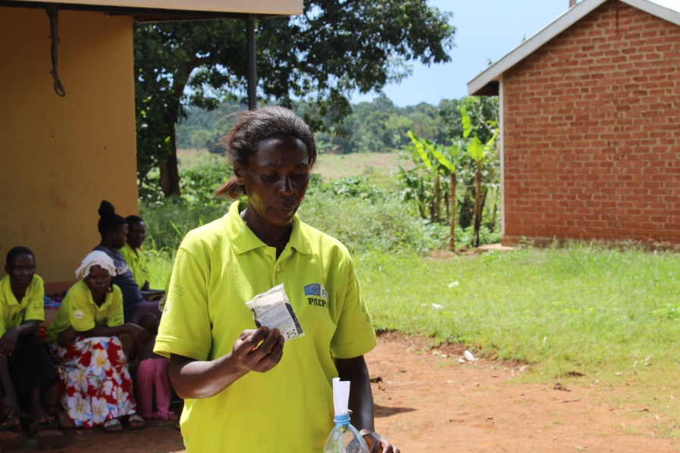
Figure 1 A farmer showing the new seed packs they started using compared to the used mineral water bottles they use to use for packing seed for sale.

Table 2: The trainings number using
Intervention | Number trained | Number using | Ranking | Training Method
Vegetable germplasm collection and conservation | 35 | 14 | 9 | Demonstration
Vegetable germplasm evaluation | 35 | 35 | 7 | Hands on
Vegetable seed bed preparation | 35 | 35 |  | Hands on
Vegetable planting and management | 35 | 35 | 2 | Demonstration
Vegetable seed production and processing | 35 | 8 | 1 | Hands on
Safe pesticide use in vegetables | 35 | 35 | 4 | Hands on
Vegetable storage and handling | 35 | 33 |  | Demonstration
Proper vegetable processing practices | 35 | 18 | 6 | Demonstration
Proper vegetable preparations and cooking | 35 | 35 | 5 | Hands on
Proper packaging and branding of vegetables. | 35 | 18 | 8 | Demonstration
Marketing vegetables and seeds | 35 | 8 | 3 | Hands on

3.3 Effectiveness of the skilling (Learning) method to adopt vegetable seed production and marketing

Commercial vegetable seed production was of interest to the research team because it is a new enterprise for farmers. The uniqueness of these production practices compared to other crops in the farming system incited the teams’ curiosity to understand how farmers learned about vegetable seed enterprise. It was clear that successful production was not the adaptation of indigenous knowledge to a new crop but involved generating new knowledge and practices, yet all this happened amongst farmers.

In Focus Group Discussion (FGD), farmers rated effectiveness of training methods that team used to foster learning and creativity. Several methods were used by the project team to train farmers in this PLA process (Table 3). The methods include; farm visits, on farm demonstration, workshops, radio programs, newspapers, local meetings and classroom style learning.
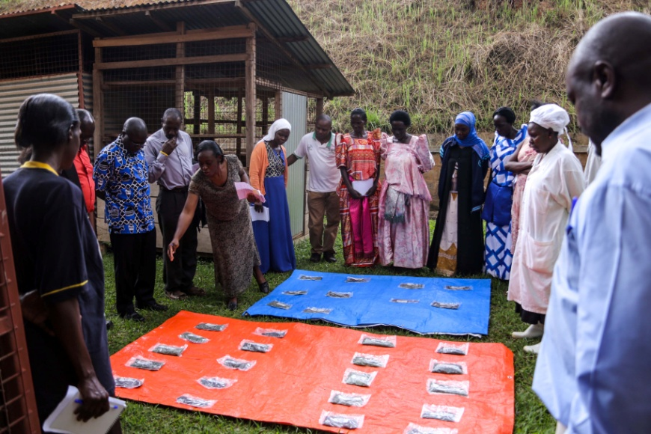
Figure 2 A member of the project team demonstrating the different post harvest handling methods
About 68% of the farmers ranked three effective methods of learning as on farm demonstrations, farm visits and farmer to farmer (Table 3).Indeed, 36% of the respondents prefer to learn from demonstration sites. Again in terms of ranking the five preferred methods of learning are; on farm demonstration, farm visits, farmer to farmer, exchange visits and exchange visits. In all these learning methods there is a common strand and that strand is a farm. As one farmer said ‘seeing is believing’ (Table 4), farmers prefer to learn in a hands on manner. The shift to new crops and enterprises such as this vegetable seed venture is accompanied by demand for new knowledge and technologies. This opens a new window of opportunity for farmers to engage in their own group learning processes commonly referred to as social learning (Kibwika, 2006). Farmers then became the “experts” in vegetable seed production.

Table 3: Rating the Learning method

Learning method | Rank | % Respondents | Effectiveness
On farm Demonstration | 1 | 36 | 5
Farm Visits | 2 | 14 | 4
Fellow Farmer | 3 | 18 | 4
Exchange visits | 4 | 5 | 3
Extension visits | 5 | 9 | 2
Workshops/seminars | 6 | 5 | 2
Listening to radio and TV | 7 | 5 | 2
Reading News papers | 8 | 5 | 1
Class room Style | 9 | 5 | 1

On farm demonstration enhances farmer learning as indicated in Table 4 below. Reasons for preferring learning this way are varied the three most important ones were mentioned as ‘seeing is believing’ followed by the fact that it is practical and there is no need for high formal education to put in practice what is being demonstrated. On farm demonstration enables farmers’ exploration and experimentation. Farmers explored and experimented with different vegetable technologies in a search for effective ways to produce the crop. This self-directed learning turned farmers into “non-professional experts”. They are sometimes called non-professional experts because they are self-made (Kibwika, 2006). As is usually common in social learning, the process was characterised by conflict and other social dynamic factors. While farmers exchanged materials and knowledge, real self-organisation for learning was triggered by conflict (Dewey, 1922; Eshuis and Stuiver, 2005; Heymann and Wals, 2002). The major conflict influenced social learning was a conflict between vegetable brokers and farmers. Farmers did not have direct contact with vegetable consumers. They dealt with brokers who bought the vegetables at less than the prevailing price and sometimes purchased on credit, but often faulted on making payments. Farmers realised they had a problem. The challenge for farmers was how to deal with dishonest brokers. Shared knowledge flows in the farming community through informal (oral) networks. The case illustrate how conflict is beneficial to social learning when it is turned into a shared challenge for which solutions are jointly sought.
Articulation of a shared challenge is a social phenomenon anchored in a common goal (in this case the desire to be wealthy). But harnessing conflict into opportunity for joint learning is easier when stakeholders pursue complementary objectives than when they compete.
Only farmers sharing high levels of social trust dared to visit each other’s gardens for purposes of exchanging knowledge and innovations.

Table 4: Reasons for preferring on farm Demonstration
Reason | Rank
Many farmers learn together thus building closeness with demonstrators | 4
Not much education is needed | 3
They are result oriented and hence the farmers gain a lot of confidence in what they are doing | 5
"Seeing is believing" | 1
Demonstrations help many farmers adopt the technology | 5
Can bring change easily in people's lives | 8
Other farmers are able to learn and adopt | 5
Practical | 2

The capacity for farmers to innovate and share knowledge, and their rationale for doing so was best articulated by Daudi Muwanguzi in the following terms:
“We as farmers, when we face a problem or opportunity, we become creative, we explore, discover and share this amongst ourselves. For example, I was the first one in this village to demonstrate that you can transplant a mature Ntula plant but I also learnt it from my friend in another parish. When there is a good price you can become creative in many things because everyone wants to get more from what they have” (Daudi).
Exchange of knowledge and experiences from experimentation were largely based on personalised interactions among farmers. The motivation for experimentation is sometimes to be well-known and highly regarded in the community. This was clearly stated by another farmer Topista who started growing vegetables at the age of 15:“I was motivated to discover more by producing more but I also strategically located my garden by the roadside to make it an example/demonstration for others to learn from. I do my own research to be outstanding and because of this, I have hosted many farmers from other districts. They come to learn and I also get orders to supply them with vegetable seeds”.

It is not the case that farmers learn from all farmers in the village. Information flows through an interpersonal social network (Conley and Udry, 2001). Social intimacy and values of inclusiveness are fundamental to social learning of the kind just described. Learning is an interactive process that takes place on a platform for exchanging of knowledge and experiences. Here a platform is defined as a forum for interaction to learn, negotiate and/or resolve a conflict (Röling 2002). In learning about vegetable seed production, four platforms were prominent: source of planting materials, radio programme, farmer experimentation and exchange visits, and informal sharing of ideas through conversation and casual contacts

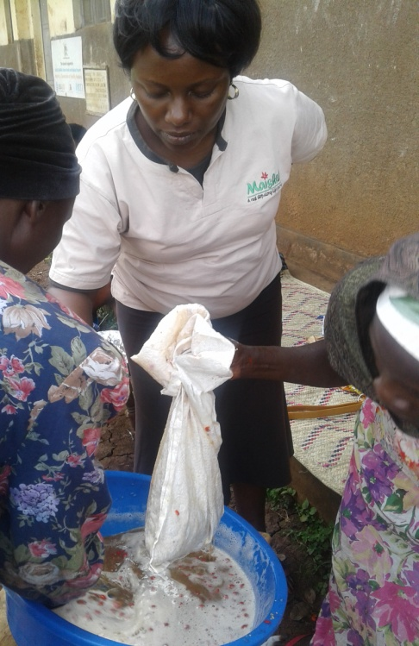
Figure 3 Farmers in a hands on training on seed processing
3.4 Lessons learnt
This sections highlights the success factors, challenges of implementation and conclusion

3.4.1 Success factors

A number of factors helped to make this participatory learning and action approach for implementing the PAEPARD vegetable successful and they include the following;
- Participatory learning is an effective approach for putting farmers in the driver’s seat of research action as this enables farmers to identify research problems, identify priorities and approaches of solving them. This is manifested by farmers choosing seed production over other vegetable shelf life technologies.
- Training methods for farmers especially exposure from farm and exchange visits for farmers was practical and motivating as it fanned the curiosity for experimentation and social learning.
- Multidisciplinary approach of implementing team was appropriate as there was always someone to solve the problem as it emerges. Malnutrition is a multi-dimensional problem requiring different skills.
- Involvement of local leadership encouraged and built a broad support base for the project.
- Experimentation and social learning with local solutions and technologies were simple and easy to use
- Market for the research product namely seed was available especially seed was a major challenge in the community as was highlighted in the PRAs initial challenges.
- Supervision and follow up was adequate and timely.
- Monthly project meetings and quarterly meetings ensured that all partners were up to date with the project progress. This platform provided a feedback mechanism that enabled to resolve issues that require research attention.

3.4.2 Challenges
- Unavailability of some inputs. For example, the project started without AIVs foundation or breeders seed.
- Level of participation is very varied for example farmers joined at point of project implementation but were missing at proposal development stages.
- Short time for implementation of activities; some breeding and institutional building aspects are at infancy stage yet the project is coming to an end. The project was very ambitious with deliverables.
- Some agents/ agencies have different agenda for example local leaders wanted to exploit this for political ends.

3.4.3 Conclusion

It can concluded from this study that given the right support system through participatory learning and action, farmers can set priorities and pursue opportunities such as vegetable seed production and marketing which are high end value added products. Participation in seed production and marketing earns a lot of profits that leads to great success and wealth. Further, farmers prefer to learn in an on farm setting through demonstration gardens and farmer field exchanges. This enables field experimentation and social learning as articulated in the case studies.

References

Bernard, H.R. (1988) Research Methods in Cultural Anthropology, Sage Publications.

Conley, T., Udry, C. (2001) “Social Learning Through Networks: The Adoption of New Agricultural Technologies in Ghana”, American Journal of Agricultural Economics
83(3): 668-673.

Dewey, J. (1922) Human Nature and Conduct: An Introduction to Social Psychology,
London: Allen & Unwin.

Eshuis, J., Stuiver, M. (2005) “Learning in Context Through Conflict and Alignment:
Farmers and Scientists in Search of Sustainable Agriculture”, Agriculture and
Human Values 22: 137-148.

FAO (2013). Save Food. Preliminary report of the Global Initiative on Food Loss and Waste Reduction.
Heymann, F., Wals, A. (2002) “Cultivating Conflict and Pluralism Through Dialogical
Deconstruction”, in Leeuwis, C., Pyburn, R., eds., Wheelbarrows Full of Frogs:
Social Learning in Rural Resource Management, Royal Van Gorcum, Assen, pp. 25-47.

Kibwika, 2006. Learning to make change. Developing innovation competence for recreatingthe African university of the 21st century. Dit onderzoek is uitgevoerd binnen de onderzoekschool CERES Research School forResource Studies for Development

Kilimo Trust (2014) Upgrading Micro, Small and Medium Enterprises. The Potential but underdeveloped anchor for food staple value chains in East Africa

NRC 2006. Lost Crops of Africa: Volume II: Vegetables. National Research Council -National Academy of Sciences. [Online] Available: http://www.nap.edu/catalog.php?record_id=11763 Accessed 1 March 2011.

Röling, N.G. (2002) “Beyond the Aggregation of Individual Preferences. Moving from
Multiple to Distributed Cognition in Resource Dilemmas”, in Leeuwis, C., Pyburn,
R., eds., Wheelbarrows Full of Frogs: Social Learning in Rural Resource
Management, Royal Van Gorcum, Assen, pp. 25-47

Wennink B, Mugoya M, Kimenye L and Posthumus H. 2014. Farmers in the driver’s seat. Innovation in smallholder agriculture in Burundi, Ethiopia, Kenya and Rwanda. Associationfor Strengthening Agricultural Research in Eastern and Central Africa (ASARECA), Entebbe,and Royal Tropical Institute (KIT), Amsterdam.

