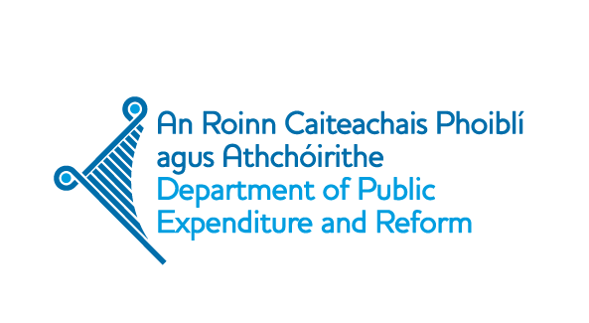

DRAFT AGENDA

Open Government Partnership Europe Regional Meeting

8 - 9 May 2014, Dublin

Thursday 8 May
Time | Sessions
08:30-09:00 | Registration
09:00-09:15 | Welcome and Introduction  Welcome and opening of the meeting by Mr Brendan Howlin T.D., Minister for Public Expenditure and Reform
09:15-11:00 | Plenary: Open Government – a cornerstone of good governance – local, national, European  Keynote government and civil society/citizen speakers discussing local, national and European perspectives  Moderator – TBC  Ms Emily O’Reilly, European Ombudsman  Mr Tom Arnold, Chairman of the Convention on the Constitution  Ms Selima Abbou, civil society speaker,Tunisia  Ms Marylise Lebranchu, Minister of State Reform, Decentralisation and Civil Service, France  Ms Tea Tsulukiani, Minister for Justice, Georgia
11:00-11:30 | Coffee Break
11:30-13:00 | Parallel sessions 1
 | OGP in action -learning from each other  Country groupings will ensure a good mix of geographic and sector focus.  -organised by OGP Support Unit  This session will be 2 hours long. | OGP Working Group on Legislative Openness  -organised by Dan Swislow | Challenges & perspectives for the open data agenda in Eastern Europe  -organised by UNDP  -moderator: Francesco Checchi, Public Accountability and Anti-Corruption Specialist, UNDP | Open government: standards & indicators for measuring progress  -organised by Access Info Europe (Helen Darbishire)  -Transparency and Accountability Initiative to contribute
13:00- 14:30 | Lunch
14:30-16:30 | Parallel sessions 2
 | Nordic Models  Chair: Dr Nat O’Connor, Director of TASC  A number of speakers followed by Q&A | OGP in action -learning from each other  Country groupings will ensure a good mix of geographic and sector focus.  -organised by OGP Support Unit | The EU’s role in promoting transparency & accountability & engagement with the OGP  -organised by Open Society European Policy Institute  - Dr Mechthild Rohen, Head of Unit Public Services, DG CONNECT  -panel discussion | OGP in action-learning from each other  Country groupings will ensure a good mix of geographic and sector focus.  -organised by OGP Support Unit | Centre for budget monitoring and citizen participation  Side-meeting:  To launch a regional European network of civil society organisations working on budget issues.
16:30-17:00 | Coffee Break
17:00-17:40 | Relevance and Importance of the OGP in Europe  Minister for the Cabinet Office, Mr Francis Maude  Ms Veronica Cretu, OGP Steering Committee member  Mr Paul Chaffey, State Secretary to the Minister of Local Government and Modernisation, Norway
18:00-20:00 | Social Event  OGP Support Unit to introduce the Open Government Awards (5 minutes)
Friday 9 May
Time | Sessions
09:00-09:15  09:15-10:30 | Plenary session: Contribution of private companies to supporting Open Government – technology and corporate transparency  Ms Arlene McCarthy MEP – transparency and corporate openness from a European perspective  Panel discussion:  - Chair: Martin Tisne, Omidyar Network and OGP Steering Committee Member  - Benjamin Herzberg, Open Private Sector, World Bank and Private Sector Council Member  - 2-3 private sector speakers  - Closing: Chris Taggart, Open Corporates
10:30-11:00 | Coffee Break
11:00-13:00 | Parallel Sessions 3
 | OGP-GIFT Fiscal Openness Working Group Session  -organised by the OGP-GIFT Fiscal Openness Working Group (FOWG) | Open government and public services  Chair: TBC  -education, health, policing data, Central Statistics Office, local government | Opening up government policy making & implementation – citizen participation  -organised by Tim Hughes (INVOLVE, UK | Lessons learned from the OGP Independent Reporting Mechanism  -Joe Foti - OGP
13:00-14:30 | Lunch
14:30-16:00 | Parallel Sessions 4
 | OGP in action - learning from each other  Country groupings will ensure a good mix of geographic and sector focus.  -organised by OGP Support Unit | Words in action: Whistleblowing & the right to accountability  -organised by Transparency International Ireland | The economic impact of open data  -organised by Open Data Institute (ODI)  - Panellists to include INSIGHT NUIG, start-ups and OKFN TBC | OGP Working Group on Access to Information  -organised by the OGP Working Group on Access to Information | Open contracting: Towards a New Global Norm  -organised by the World Bank
16:00-16:30 | Closing address – Lessons learned for the future of OGP in Europe

